1.

1. What is the basic unit of all living things?

9. Tissues in your body are made up of specific _____.

8. Cells work together to make ______.

7. List the levels of organization of a living thing from smallest to largest.

3. What botanist concluded that all plants are made of cells?

2. What scientist looked at cork under a microscope and named the tiny chambers “cells”?

6. What 3 things does the cell theory state?

5. Which scientist published the idea that new cells are made from old ones?

4. What biologist stated that all animals were made of cells?

1.

10. All living things in the world are referred to as…

And NON-living are…

18. What are the six types of living things?

(all made of cells)

17. How do cells reproduce?

16. Wait! If a virus isn’t living, how can it reproduce?

12. Would something as small as bacteria be considered living?

11. What characteristics are common for ALL living things?

15. What do cells and viruses have in common?

14. If a virus isn’t a living thing, what is it made of?

13. Viruses can make you sick. Are they living?

1.

19. List 3 examples of fungi

27.

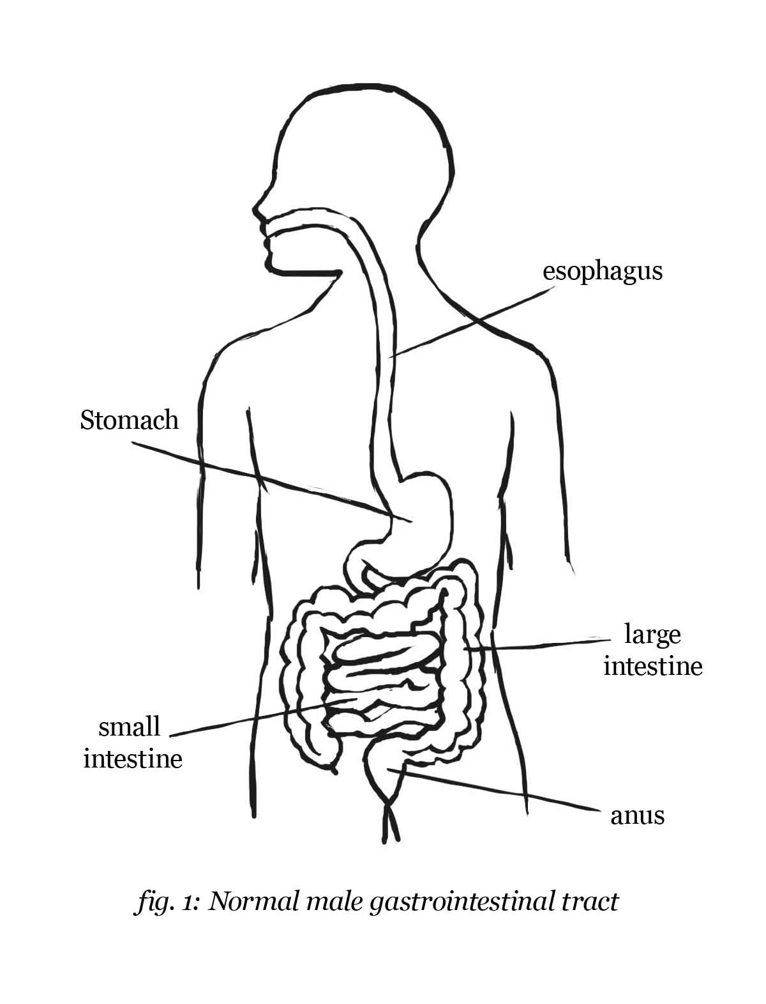

26.

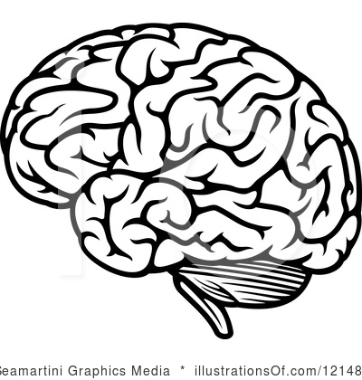

25.

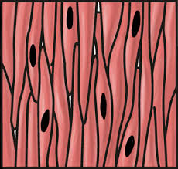

21. List 3 examples of eubacteria…

24. Two examples of homeostasis in humans…

23. When an organism maintains internal physical and chemical conditions it’s called...

22. Does all bacteria make you sick?

1.

1.

9.

8.

7.

3.

2.

6.

5.

4.

20. List an example of a protist…