

Homework

*There is no written homework this week.

*Studying their math facts would be a great idea.

August 17 – 21

Reminders

- Please bring in all **signed forms** for class.

-**Breakfast starts Tuesday**, August 18th.

-Breakfast is free every day from 8:05-8:25.

-**Masks** need to be brought and worn to school each day.

-Please send a **water bottle** with your child’s name on it.

-Please send in a cheap pair of **head phones** for your child to keep in their backpack each day.

-**Dismissal**: Your child’s bus might arrive earlier or later than normally expected.

-**Car Rider:** Make sure your paper on your visor has your child’s first and last name along with their grade.

-Any donated items for our classroom **treasure box** would be appreciated. (individually wrapped candy, pencils, stickers)

-**Timed test**: multiplication facts 0-10 starts next week. (3 minutes 25 problems)

What we are learning…

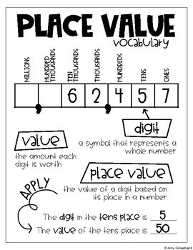

[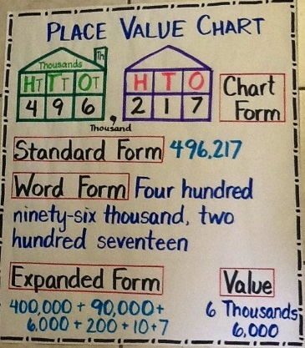](https://www.google.com/url?sa=i&rct=j&q=&esrc=s&source=images&cd=&ved=2ahUKEwiIyIm02_bjAhXhTN8KHX01DJEQjRx6BAgBEAQ&url=https%3A%2F%2Fwww.tes.com%2Flessons%2F-0UC2y37Z43fhQ%2Fplace-value-rounding&psig=AOvVaw0qoZc42SM0j-b98vgKAKir&ust=1565471884710329)

[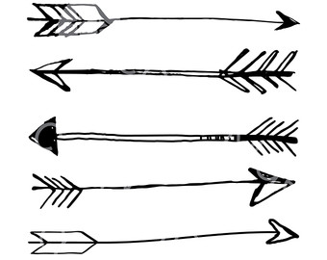](http://www.google.com/url?sa=i&rct=j&q=&esrc=s&source=images&cd=&ved=2ahUKEwjbyMqH2tncAhVGTt8KHRAyARgQjRx6BAgBEAU&url=http://moziru.com/explore/Drawn%20arrow%20transparent%20background/&psig=AOvVaw3O4nvR5-T0PL7ocsxFfq7j&ust=1533688766639822)

Tests/Projects

-**Gap Assessment (math/ELA)** 8/20-21

This is an assessment on 3rd grade skills. It will not count in the gradebook. It just allows us to get a baseline for where each student is starting out the year.