Turn in an assignment in Microsoft Teams
Microsoft Teams for Education
To turn in an assignment, select its assignment card. Depending on the status of your assignment, you may be turning your work in on time, late, or submitting revised work.
- Navigate to the General channel in the desired classroom, then select Assignments. You can also use your search bar to search for an assignment by keyword.
- Your upcoming assignments will show in order of when they're due. Select any assignment card to open it and view the assignment’s details.
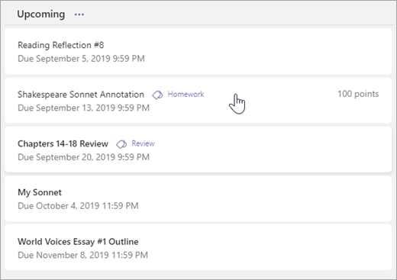
Tip: Select the Expansion icon (diagonal, double sided arrow) to work in full-screen mode.
- If your teacher specified a document for you to turn in or you have other files to attach to this assignment, select +Add work and upload your file. Note: You can attach a file up to 50 mb in size.
Tip: Work on Office files associated with this assignment right from here—no need to leave the app. Older files with .doc, .xls, and .ppt file extensions can only be edited in the desktop versions of those apps. You can copy content into a new file created in Teams to make them editable again.
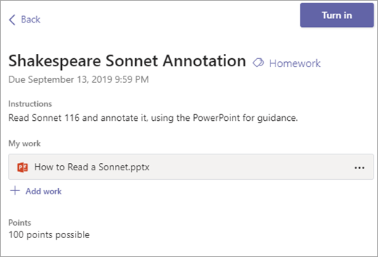
- Select the Turn in button to turn in an assignment before its deadline. The button will change depending on the status:
  - Turn in again if you’re editing an assignment you’ve already turned in and need to submit work again.
  - Turn in late if you’re turning in your assignment after the due date, but your teacher has allowed late turn-ins or asked for a revision.
  - Not turned in if the assignment is past due and your teacher is no longer accepting turn-ins. You cannot turn in work.
  - Undo turn in if you decide you want to edit your assignment before the due date. You'll need to turn it in again after you make your edits.

