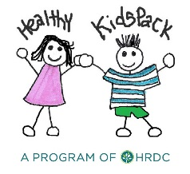

Dear Families,
Boulder Elementary School in partnership with The HRDC is excited to offer the Healthy KidsPack Program this year.

Available to any elementary student, the goal of the KidsPack Program is to assist families by providing children with take home, easy to prepare food at the end of each school week.

Participating children will be provided with free, nutritious, non-perishable, and easy to prepare meals and snacks that they can take home over the weekend. Children that are signed up to participate will be discreetly given a small bag filled with food that they can slip into their back packs to take home with them on Thursday afternoons. Participation is voluntary if you would like your child to participate in this program please fill out the bottom portion of this letter and return it to your child’s teacher.

How will this help your family?
- By providing take-home, nutritious, kid friendly meals and snacks that follow USDA guidelines and recommendations.
- By helping to encourage healthy eating.
- By providing food during times when school meals are not available.

For more information about the program please contact Rochelle Hesford at 406-225-3164 Rochelle.hesford@gmail.com, or Lyra Leigh-Nedbor, at the Gallatin Valley Food Bank (406-586-7600).
If you are interested in supporting the efforts of this program please visit our website: www.thehrdc.org.
---------------------------------------------------------------------------------------------------------------------------------

If you WANT your child to participate in this program, (X) and sign below and return the bottom section to your child’s teacher.

_____ Yes, I wish for my child, _______________________________________, ______________
(child’s first and last name) (locker number)
to participate in the KidsPack Program.

Parent Signature ______________________________________________________

