**Cell phones will be placed in hanging storage. Cell phones out will be taken up and taken to the office. If your phone is stored properly each 9 weeks, I will drop your lowest grade**

[Christiana.helgeson@acboe.net](mailto:Christiana.helgeson@acboe.net)

[Susan.fedusenko@acboe.net](mailto:Susan.fedusenko@acboe.net)

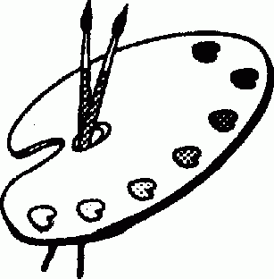

**Art Classroom Rules and Expectations**

1. ALWAYS be in your seat when the tardy bell stops ringing.
2. ALWAYS work quietly within the classroom.
3. ALWAYS clean up after yourself and be responsible for your work area.
4. ALWAYS come prepared for class.
5. ALWAYS put materials back in the proper place.
6. ALWAYS work only on art assignments and use your time wisely.
7. ALWAYS be respectful to others and their artwork.
8. ALWAYS be respectful of our school.

**Grading Policy**

1. Major tests and quizzes will be announced in advance. Point value will vary according to material.
2. The art student is responsible for all class notes given. Notes will be kept in the sketchbook along with the weekly sketchbook assignments.
3. Students who are absent are responsible for missed class assignments.
4. All class assignments are due on the day of the critique. Critique days will be announced ahead of time.
5. Any student with an excused absence will be allowed extra time to complete the art assignment, however this will be done before or after school.
6. Late Projects: 10 points will be deducted from the final project grade for every day late. After day 3 the project will be a zero.
7. Grades for this course will be determined as follows:

65% Projects/ Critiques

35% sketchbook and classroom activities

**Required art supplies**

**Art fee $20.00 due: ASAP**

**2 Rolls of paper towels**

**1 hand soap**

**1 chlorox wipes**

Art 1 is designed to address the needs of young artists who are eager to explore and experiment in creating two- and three-dimensional works of art. Students respond to personal experiences and conceptualized ideas as they learn to manipulate the **elements of art** andthe **principles of design** through the use of a variety of processes, techniques, and media. This course is structured to provide a foundation for the more advanced work in Levels II-AP.

Mrs. Helgeson & Ms. Fedusenko

**PHS Art I Syllabus**