


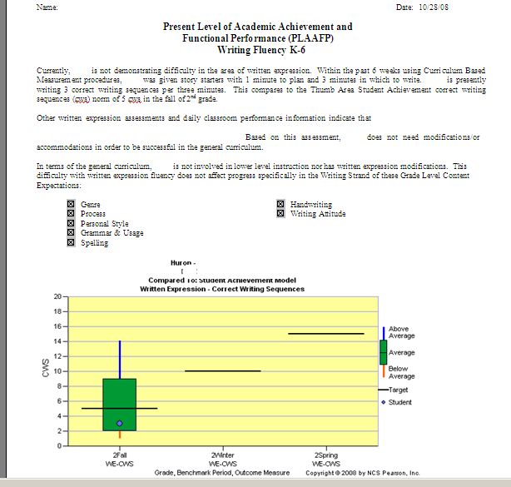
This is what your new PLAAFP pages will look like. They are similar to the old PLAAFP pages but will now include the AIMSweb graphs in place of the older graphs.

To complete the new PLAAFP pages, follow the steps below:

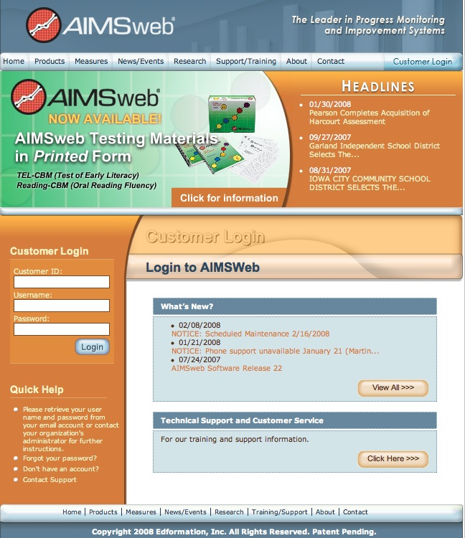
1) Log into AIMSweb at http://www.aimsweb.com

Customer ID: 8390
Username: ___________
Password: ___________

2) From your PRINCIPAL account, select the student’s grade from the drop down list, select the student’s homeroom teacher from the drop down list, and click “Go”

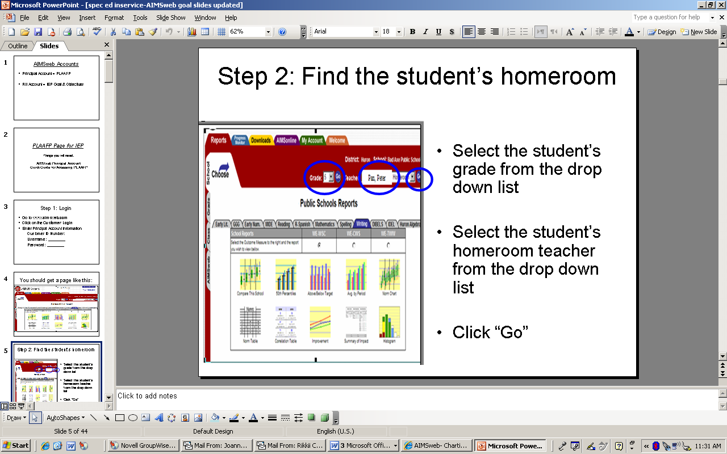

3) Click on the Class Tab along the side of the page

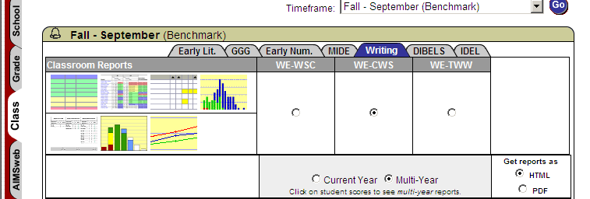

4) Choose the correct timeframe (most recent benchmark screening) and click “Go.” Choose the correct tab, based on the PLAAFP area you are looking to graph. If you
need a writing PLAAFP, choose the writing tab, and select WE-CWS.
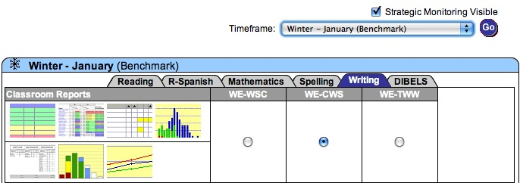

5) To access the Improvement Report (Individual Student Report), first make sure you click on the Multi-Year and HTML buttons. These are important so you can change the comparison group in the next step. Then click on the word Report for the student you need a PLAAFP report for.

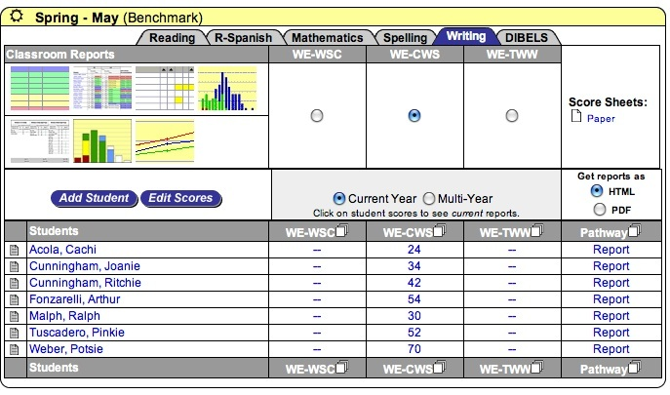

6) Select the appropriate comparison group (Student Achievement Model) and click the display button.

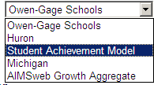
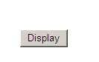

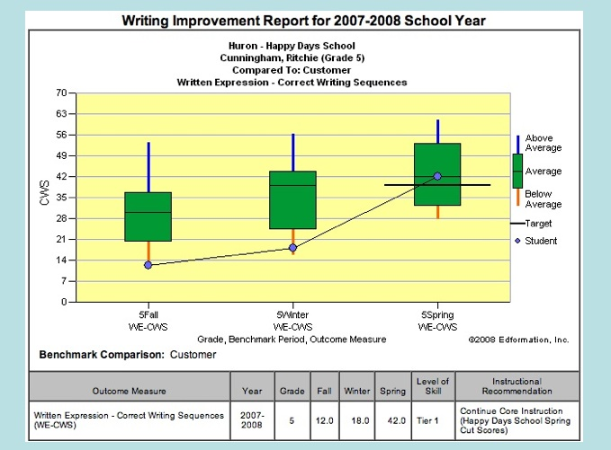
7) The graph that comes up will look similar to the one shown here. Right click, and copy (this will copy the graph but not the chart below which has the actual scores on it).

Write down the latest score on a separate piece of paper.

Next you will go into your PLAAFP page and paste picture into appropriate place (as shown in the 1st example.) Put the score you wrote down into the PLAAFP page and write in your percentile norms, and narratives as usual from your norms chart.

