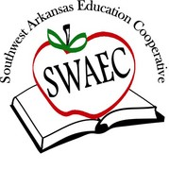
GT Coordinator Meeting
October 16, 2017

9:00 - 11:30
*AAGEA conference
*Curriculum for K - 2/3 Enrichment

11:30 - 12:30
Lunch on your own

12:30 - 2:00
*Program Approval Application process
*TAV
*Chess / QB competitions
*Shark Tank
*Social/Emotional Issues

Attended:
- Kristina Gaylord
- Cindy Hensley (½ day)
- Kenneth Stewart
- Cynthia Ward
- Traci Rucker
- Maci Curtis
- Charlotte McCauley
GT Links

