1. Circle the possessive noun:  cats Tom’s birds  The dog’s bowl is filled with food.  Emma’s shirt is purple.  The frog’s skin is slimy. | 2. Match the names of the 3D shapes:  sphere  cone  cube  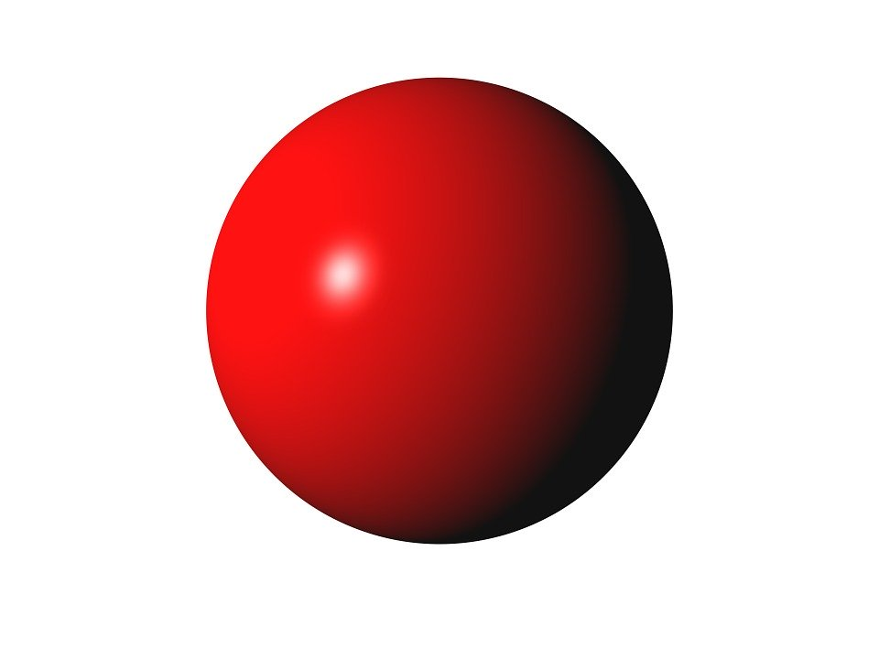
3. Circle the prepositions:  Sarah she it cat  him yellow  jump they we | 4. Look at the shapes:  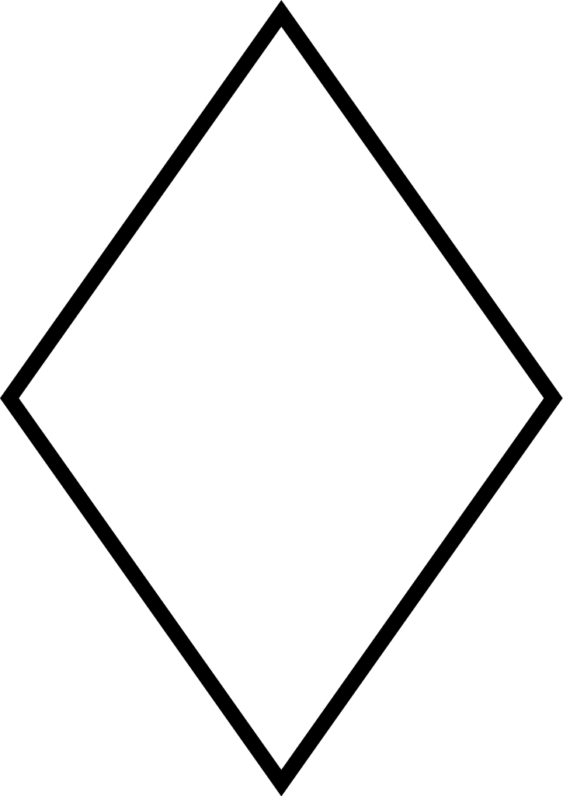  Why are they in the same group?  ___________________________________________________________________________
5. Write 3 verbs:  ______________  ______________  ______________ | 6. Write an example of a good and a service  ______________________  ______________________

