Unit 6: Energy: Conservation of Energy/Energy Transformations
Student Notes

- Introduction to Energy
- Energy is defined as the ability to do work or make things happen. Where do you see energy around you?
- Work is done when a force (N) causes an object to move a certain distance (m).
- Energy is measured in Newton- meters or Joules (J). 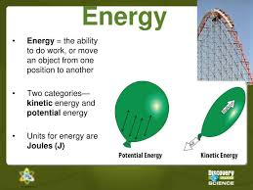

- Types of energy. There are two main types.
- Potential Energy (PE) is energy that is stored in an object as a result of its position, shape, or chemical composition. 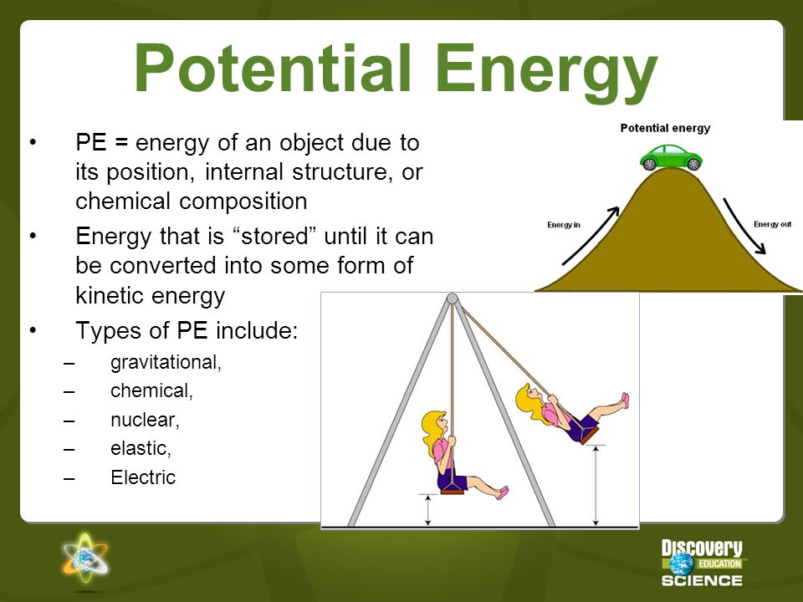
2. Kinetic Energy: Active energy; the energy associated with the movement of objects. Anything that is moving has kinetic energy.
1. Kinetic energy is determined by an object’s mass and velocity (speed).
2. The formula for Kinetic Energy is: KE = ½ mv²
3. The faster an object moves, the more kinetic energy it has. Doubling the velocity of an object quadruples the object’s KE. See the formula- velocity is squared!
4. The greater the mass the moving object has, the more kinetic energy it has. Doubling the mass of an object doubles the object’s KE.
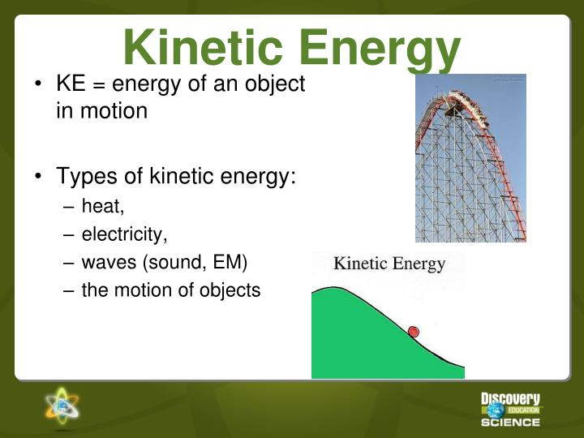
NOTE INTERACTION: Fill out the graphic organizer using what you know about the types of energy.
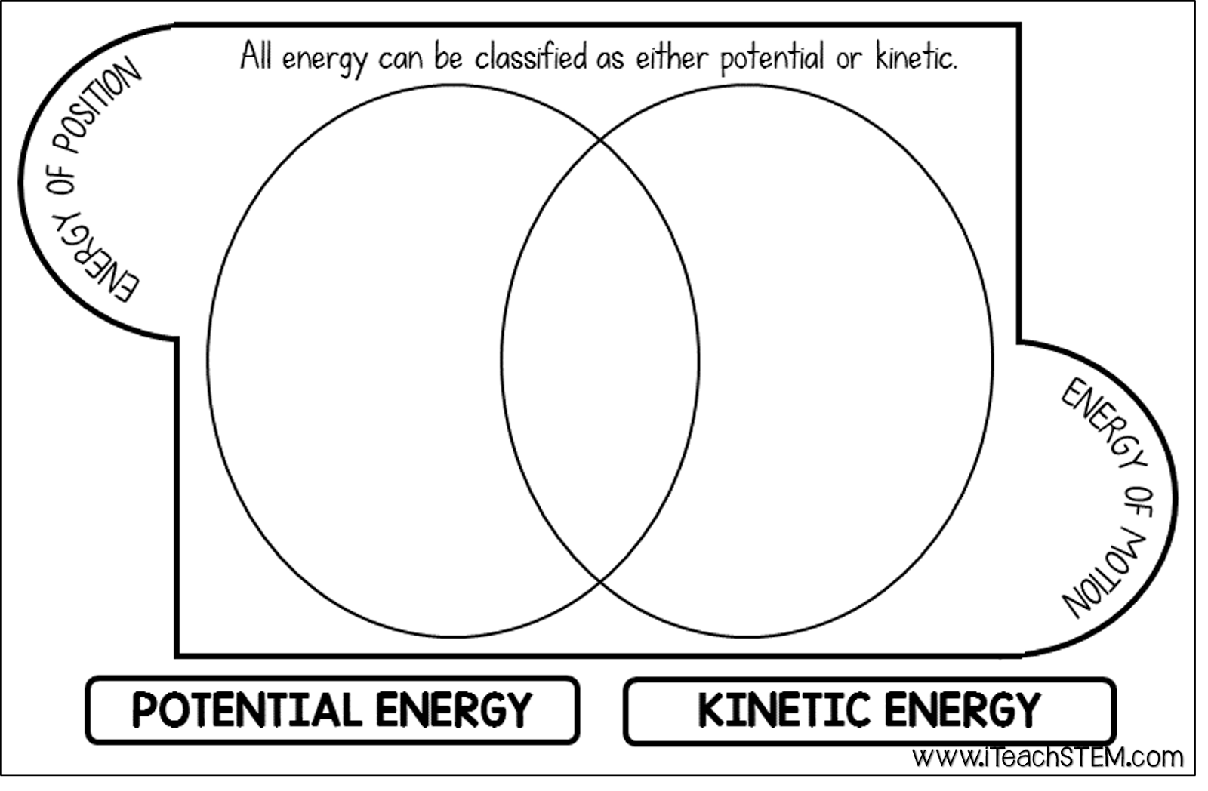

Roller Coaster cars experience a constant alternation between kinetic and potential energy.
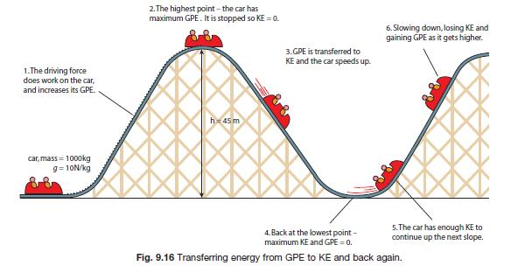

- Other Forms of Energy:
  - Gravitational Potential energy is the energy due to an object’s position above the earth’s surface. When an object is above the surface of the earth, it has the potential to fall or come down. A rock sitting on the ground has no energy. When you lift it up, it now has the energy it needs to fall.
    - GPE= mass x gravity x height or PE_{g}= mgh
    - m = mass; h = height; g = 9.8 m/s² (g is the force of gravity)
    - GPE is affected by its mass, the acceleration due to gravity (9.8 m/s²), and the height above the ground.
    - There is a direct relationship between GPE and the mass and height of an object. An increase in mass of an object or its 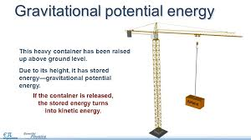

  - Elastic Potential Energy is energy stored in elastic materials such as a spring (when it’s compressed) or elastic object (when it’s stretched). 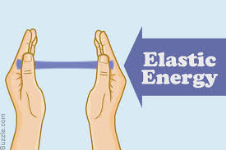

    - Ex. Rubber bands, trampolines, elastic material, sling shots, bows, etc.
    - The amount of elastic potential energy stored is related to the amount of stretch of the object; the more stretch the more energy.
    - The amount of energy stored is equal to the amount of work (force x distance) required to deform the object.
    - https://www.youtube.com/watch?v=7ZnpsCV2GSY Do NOT focus on the equation, only on the concept.
    - Springs are a special instance of a device that can store elastic potential energy by compressing or stretching.
      - Hooke’s Law: For some springs, the amount of force is directly proportional to the amount of stretch or compression, the constant of proportionality is known as the spring constant (k).
      - Robert Hooke was a British Physicist (1678).
      - If a spring is not stretched or compressed it is in equilibrium. Such cases represent 0 potential energy.
      - The equation used to calculate such energy is PE spring= 0.5●k●x²; x=compression distance; k =spring constant.
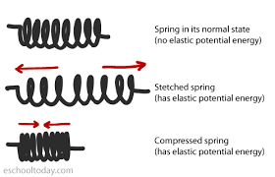
  - Chemical Potential Energy: A ty pe of potential is energy stored in the bonds between elements of a substance (remember studying bonds in chemistry).
    - Energy is stored in bonds of foods, gasoline, chemical in batteries, fireworks, firewood, etc. and later released. 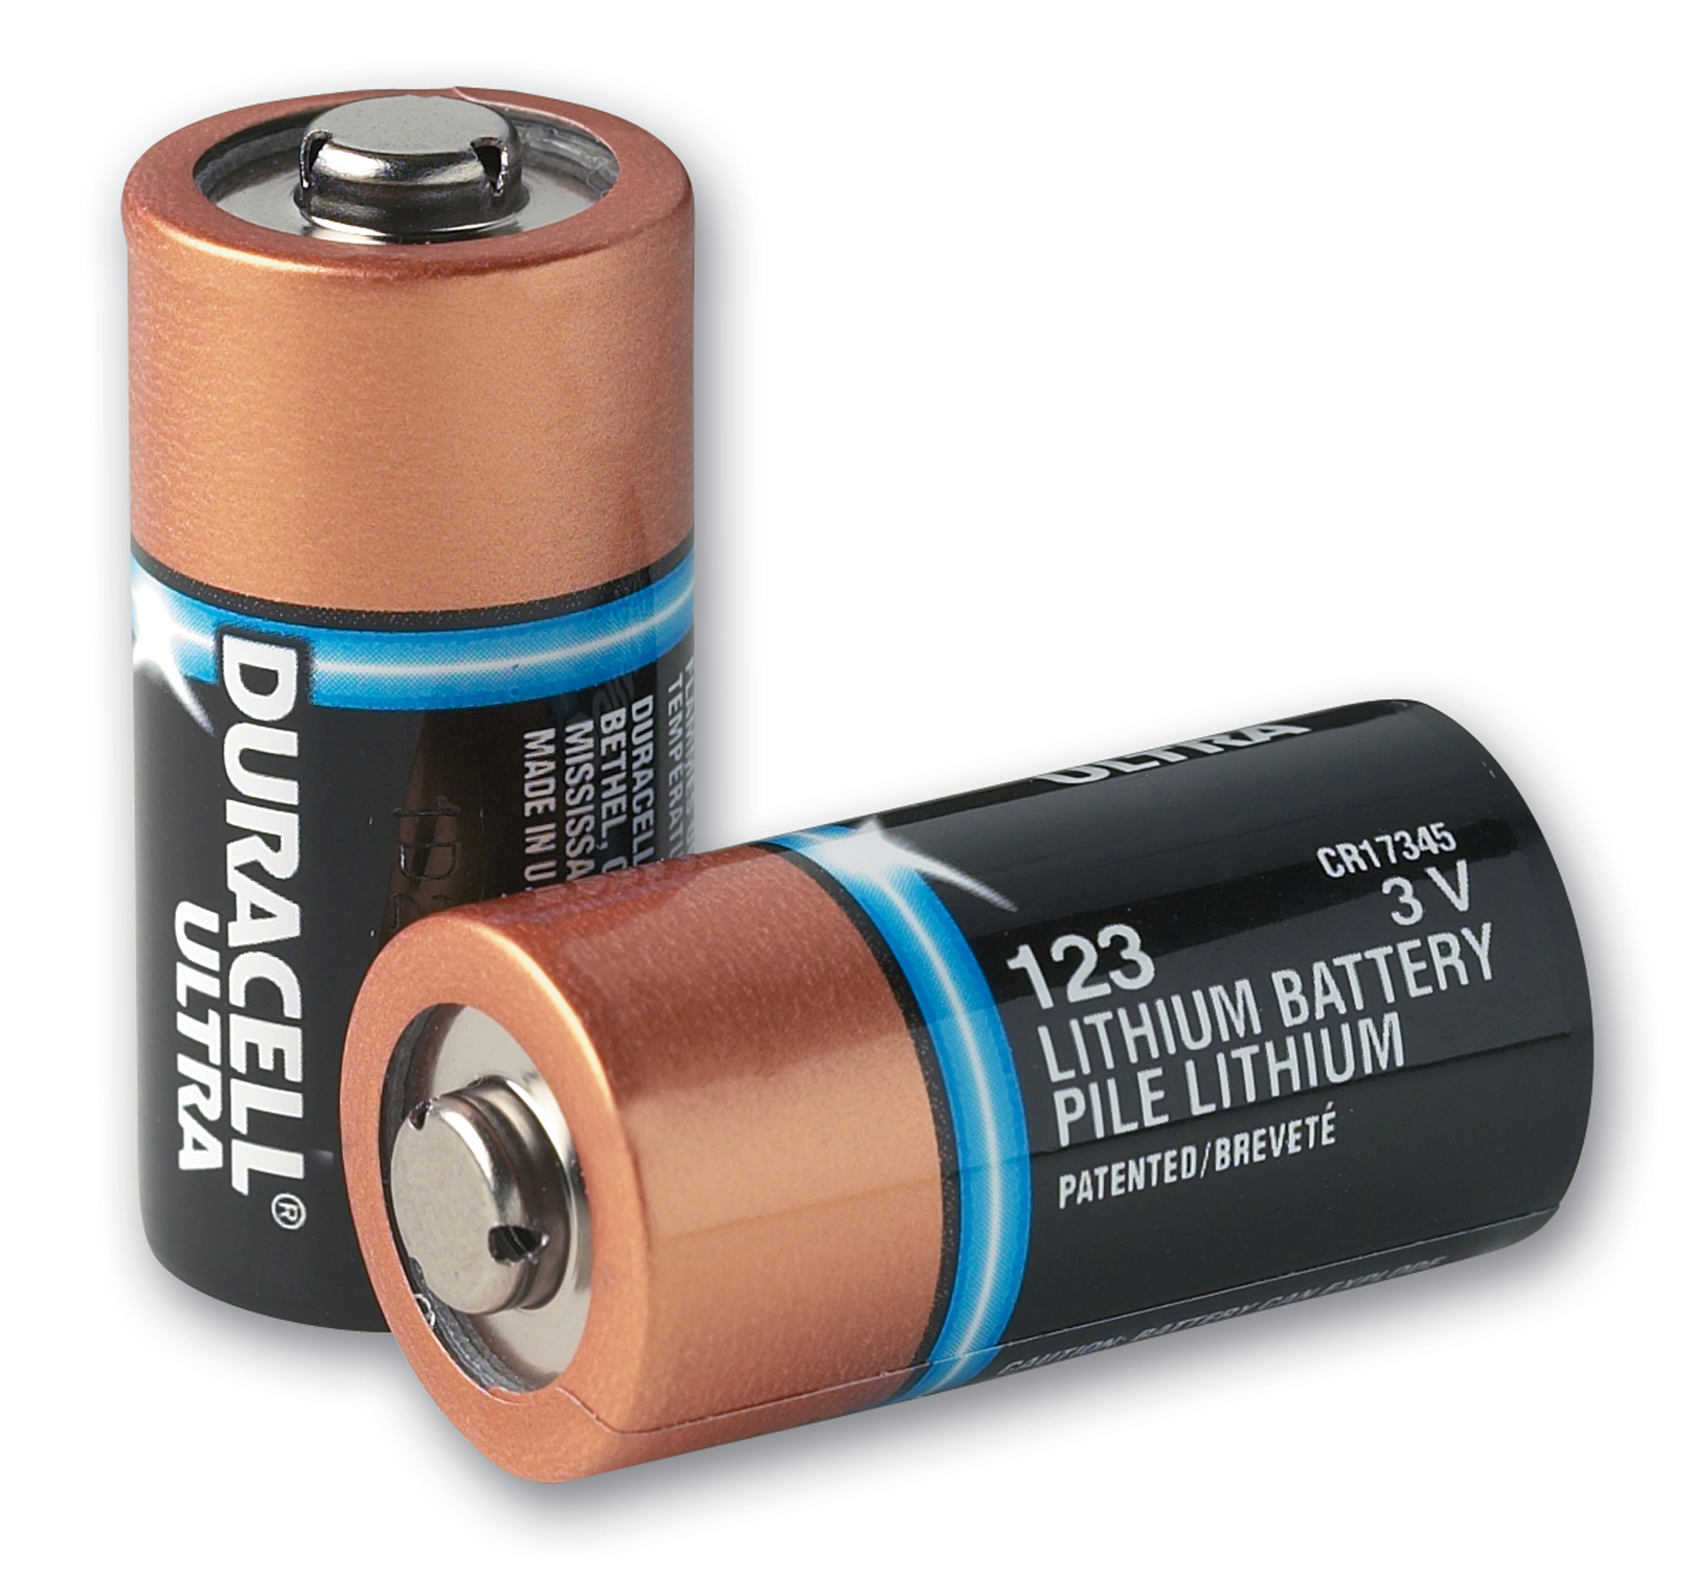
    - When the bonds are broken, energy is released to the surroundings.
    - Stored chemical energy can be seen or felt when it is converted into thermal energy and sometimes light energy during an exothermic reaction.
  - Nuclear potential energy is stored in the nucleus of an atom.
    - Ex. Sun, nuclear bombs, nuclear power plant
    - There are two types of nuclear energy--fission and fusion.
      - Nuclear fission produces energy through the splitting of atoms, which releases heat that can then generate steam and be used to turn a turbine to produce electricity.
      - Nuclear fusion is a nuclear reaction in which two or more atomic nuclei collide at a very high speed and joining to form a new type of atomic nucleus.
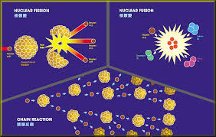

E. Light/radiant energy: Any form of light contains energy. (infrared, visible, ultraviolet, etc.)
1. Light energy often gets converted into thermal energy.
2. It is also converted into chemical energy through the process of photosynthesis.
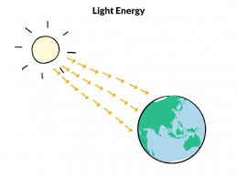
F. Thermal Energy: A type of kinetic energy contained within a substance due to the movement of molecules.
1. If something feels hot or cold to the touch, you know that you have just experienced the transfer of thermal energy, also known as heat. If your feet feel cool or cold, thermal energy is being transferred from your feet to the floor. The thermal energy is leaving your body and moving into the object. That leaves your feet feeling cooler.
If your hands feel warmer, it’s because thermal energy is moving into your hands (from the warmer coffee/mug) to your hands.

G. Sound Energy: Any audible or inaudible sound is sound energy.
1. It is the energy associated with the vibrations of molecules and atoms.
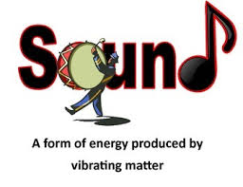
2. Most sound energy is easily detected using our ears (audible).
3. Some sound (inaudible) cannot be heard with our ears.

H. Electrical Energy: A type of mechanical energy associated with the movement and separation of charged particles called electrons.
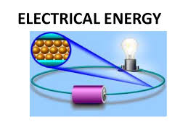
1. Electrical energy can also be associated with the force of attraction or repulsion between positively and negatively charged particles which can do work. This causes “static cling”.
2. Most appliances use electrical energy to function by plugging them into an electrical outlet.
3. Batteries convert chemical energy into electrical energy

I. Mechanical Energy: The energy that is possessed by an object due to its motion or due to its position.
1. Mechanical energy can be either kinetic energy (energy of motion) or potential energy (stored energy of position).
2. Objects have mechanical energy if they are in motion and/or if they are at some position relative to a zero potential energy position (for example, a brick held at a vertical position above the ground or zero height position).
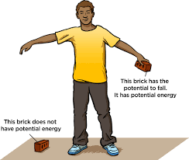
3. A moving car possesses mechanical energy due to its motion (kinetic energy).
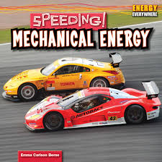

4. A moving baseball possesses mechanical energy due to both its high speed (kinetic energy) and its vertical position above the ground (gravitational potential energy).
5. A World Civilization book at rest on the top shelf of a cart possesses mechanical energy due to its vertical position above the ground (gravitational potential energy).
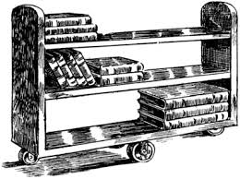
6. A barbell lifted high above a weightlifter's head possesses mechanical energy due to its vertical position above the ground (gravitational potential energy).
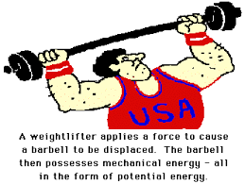
7. A drawn bow possesses mechanical energy due to its stretched position (elastic potential energy).
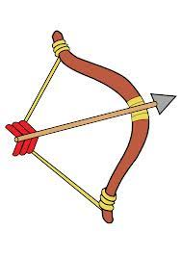

I. Magnetic Energy: The potential energy of a magnetic field.
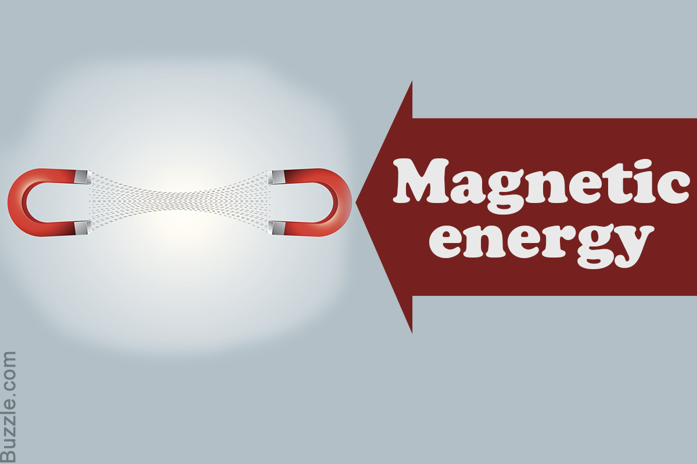

- Energy Conservation/ Energy Transformations:

A. The Law of Conservation of Energy states that energy cannot be created or destroyed, only transformed/transferred.
B. The most common energy conversion is the conversion between Potential and Kinetic Energy.
C. Convert means to change from one form to another.
1. In an automobile engine, fuel is burned to convert chemical potential energy into thermal energy and mechanical energy (the car moved).
The energy transformation would be: Chemical→ Mechanical and Thermal.

- In a flashlight, the batteries contain chemcial potential enrgy. Once the switch or button is turned on, the batteries produce electricity through a chemical reaction. The electricity powers the lightbulb which also gets hot.
The energy transformation would be: Chemical Electrical Light and Thermal.
- Energy conversions may produce unwanted forms of energy, when energy conversions take place the total amount of energy is split between desired (usually some form of work) and undesired energy (usually heat due to friction).
1. Heat/ friction reduce the ability to perform work.
2. Energy efficiency is the measure of usable energy after a conversion has taken place.
3. Technology can improve the efficiency of energy conversions.
a. LEDS convert almost all electricity to light.
b. Hybrid cars increase the fuel efficiency of cars.
4. Formula for energy efficiency: Efficiency =Work Output x 100% Work Input.
a. Theoretical Efficiency can reach 100%.
b. Actual Efficiency will never reach 100% due to loss by friction OR heat.
- Energy, Work, and Power
- Energy required for work to be done or change to happen.
- Work (W) is when a force acts on an object to cause displacement of the object, it is said that work was done on the object.
1. Work is caused by three key things: force, displacement, and cause.
a. For a force to qualify as having done work, there must be a displacement and the force must have caused the displacement. In other words, to do work, a force has to be in the direction of the motion.
b. The formula for work is W (work)=F (force) x d (distance).
C. Power is the amount of time in which the work is done.
1. It is calculated using P(power)=W(work) ÷ t(time).
2. Power is measured in watts(w).

NOTE INTERACTION: Try the following problems using the appropriate formula.

- Sheila applies 55N of force to move her chair 2m, how much work did Sheila do?

2. Two guys lift two 40N rocks up a 5m staircase. Bob does it in 10 seconds. Joe does it in 20 seconds. Compare their work and power.

- Energy Transfer The rate at which thermal energy is transferred from one object/substance to another depends on
      - Surface area
        - The larger the area, the more heat can be transferred through.
        - Ex. More heat will be lost from a home through a larger window than through a smaller window of the same composition and thickness.
      - The material through which heat is transferred. Metals and other good conductors transfer energy well. Insulators, such as wood, plastic, rubber) are poor conductors.
      - The temperature difference between the object/substance and its surroundings.
        - Thermal energy will be transferred as long as there is a difference between two objects/substances. Once the two have reached the same temperature, thermal equilibrium is established, and the heat transfer stops.

