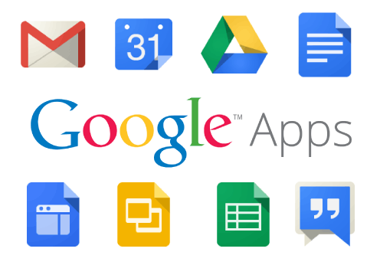

Vidalia City Schools
Parent Usage Agreement

Dear Parent(s),

As a part of Vidalia City Schools Technology Plan, students in grades 6-12 are provided with a Google email account. Use of Google email also includes access to Google Docs and Google Calendar as a means to collaborate with staff and students under the guidelines that have been established for all students.

All students are expected to abide by the District Acceptable Use Policy. You agree to the terms and conditions below by accepting and using your Vidalia City School Gmail account.

• I will not use email to bully, harass, or threaten other students or individuals;
- Unlawful activities
- Commercial purposes (running a business or trying to make money)
- Personal financial gain (running a website to sell things)
- Inappropriate sexual or other offensive content

• I understand that email is provided to me by the district and is district property. The district reserves the right to access a student’s email account at any time if misuse is suspected

• I understand that my email account is filtered and that any message written containing inappropriate language will go through a content filter and may not be delivered

To prepare our students to be college or career ready, we want them to have access to email in order to communicate with others and complete online projects. However, any student violating the terms and conditions listed above may have their email account disabled. Please be sure that all communication is appropriate and used to further one’s education.

I understand and will abide by the above policy and guidelines. I further understand that any violation is unethical and may result in the loss of my email, network and/or laptop privileges as well as other disciplinary action.

Our desire is to provide students’ access to Google Apps for Education which includes Gmail for educational purposes. If you do not wish for your child to be given access to Vidalia City School’s Gmail, please sign and return this form to the school by August 24, 2018.

I would prefer that my child NOT BE GIVEN access to school Gmail.
School Name: Click here to enter text.
Student Name: Click here to enter text. Grade: Choose an item.
Parent/Guardian Signature: ____________________________________Date: _______

