Language Arts Syllabus 2020-2021

Mrs. Demetria Hayes
Room 131
demetria.hayes@hcbe.net
(478) 929-7832 VoIP 33439
Grade: Seventh

Each student is expected to:
-Follow all school and classroom rules
-Complete assignments promptly
-Be respectful
-Be active learners

- The state of Georgia has adopted the Georgia Standards of Excellence. Per GSE, students will be required to read and write daily in their classes and at home. We know that these standards will only benefit our students academically, and we know that as a parent you will embrace these standards, so that your child can succeed at their highest level. Thank you for your continued support!
- Students will be engaged in the Writing Workshop and the Reading Workshop during class. Students will be writing and reading more in every subject, not only Language Arts.
- Students will be required to read an average of 125 pages each week per Teacher’s instructions. Their ELA binder and composition books should come to class every day. Students’ grades will reflect the work completed in their binder and composition books.

Textbook: The Language of Literature *Classroom use only

First Semester

- Rituals & Routines (2 weeks)
- Unit 1: Writing Realistic Fiction (5 weeks)
- Unit 2: Investigating Characterization (5 weeks)
- Unit 3: Writing about Reading (5 weeks)

Second Semester

- Unit 4: Research/Reading Nonfiction ( 4 weeks)
- Unit 5: Art of Argument (5 weeks)
- Unit 6: Test Prep (3 weeks)
- Unit 7: Historical Fiction Book Clubs (5 weeks)

Grading Policy:

MAJOR: (assessments and/or long term 40%
assignments – papers, projects, etc.)

MINOR: (quizzes, mini-assessments) 30%

DAILY: (classwork, homework, 20%
participation, compliance)

FINAL EXAM: Semester 1 & 2 10%
(Final from 18 weeks of content)

Homework:
- Reading and writing at home are essential to developing the skills needed to be a successful, high-achieving student. Throughout the year, students will be expected to read independently at home and jot about what they read. Having a fine at the library is not an acceptable excuse for not reading at home.
- As needed, students will be required to work on writing assignments at home. Many times, this will mean completing or working on an assignment that was started in class.

Supply List:
1 ½ inch binder (to be shared with Social Studies class)
Pack of notebook dividers
2 Composition books (not spiral)
Notebook paper
Pens (blue/black)
Pencils
3 Ring binder pouch (optional)

Wish List:
Kleenex
Hand Sanitizer
Disinfecting Wipes
Disinfecting Spray

Teacher Web Page:
I will be utilizing my HCBOE teacher webpage to keep parents and students informed of what we are doing in class this year. Some of the information you can find on my webpage includes: a calendar of homework assignments, tests, and project due dates; texts and resources used in class; and other helpful links and documents. I hope this will help parents stay “in-the-loop” and avoid the frustration of not knowing whether or not their child has homework, tests, or projects coming up. To access this page, please go to wrms.hcbe.net. Under the “Welcome” tab, click on “School Staff,” then scroll down and click on my name. You can navigate through the different features of the page by clicking on each link at the top of the home page.

I will also be utilizing the Remind 101 app. for important classroom updates/homework reminders. The directions are included below:

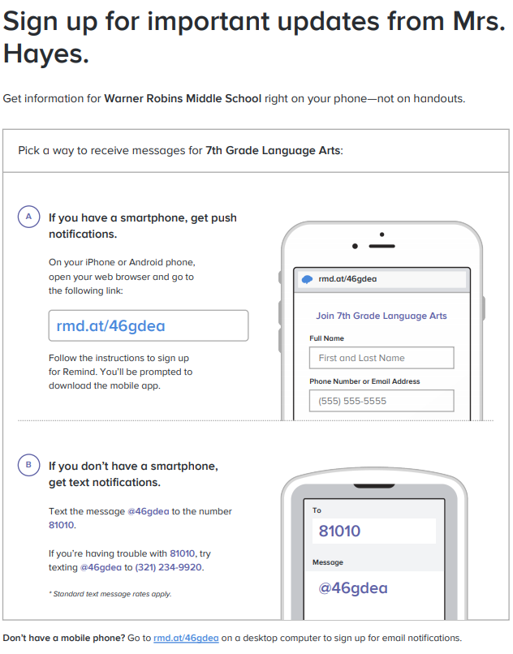

Please sign and return this portion of this syllabus, indicating that you have read and understood the information included:

Student Name
(Print): _______________________________________

Parent Signature: ______________________________

Date: ____________

Class Library and Book Club Library Contract
*based on Kelly Gallagher’s Reading Reasons

Reading is a central focus in my classroom. Reading is a skill. The only way to get better at reading is to read-this holds true for excellent readers as well as reluctant readers. With this in mind, my goal is for the students in my classroom to read with greater volume and stamina this year. I will do my best to challenge your student to read for academic purposes as well as for pleasure. Some of the reading will be assigned, but students will have opportunities to select their own books to read in literature circles and independently.
I have worked hard to develop my own classroom library. This library is available to any student who wants to choose a book to be read recreationally. Research shows that availability of books is a major motivating factor in getting teens to read. Students who are surrounded by books at school and at home read more. Students who read more, read better. I have found that having my own classroom library has dramatically increased the amount of reading my students do.
I want you to know I am sensitive to having appropriate reading material in my classroom. That said, what is considered “appropriate” may vary from one parent to another. For example, some parents do not mind their child reading Stephen King; other parents object to the horror genre. Please be aware that the selections in my classroom library, just like any other public library or school library, range from elementary-level to university level reading material. As a parent, I ask you to remain aware throughout the year of the books your student has chosen to read and assist in gauging appropriateness.
Some students use my library often; others find books elsewhere. Any student who checks books out of my library is asked to have a parent or guardian sign below indicating that this classroom library section has been read and understood.

Let’s get reading! ☺

_____ Yes, I have read this section, and my child has permission to check out books from the classroom library.

_____ No, I would prefer that my child does not utilize the classroom library.

Parent/Guardian Signature: ____________________________________________________

Parental/Guardian Permission for Book Choice for
REQUIRED Reading Assignments

I believe strongly in giving students choice in reading assignments that are required throughout the year. While students are required to participate in book clubs, I want to give them as much choice as possible as to what they will read. According to Ollman (1993), “Real world readers do not wait for a teacher to tell them what to read. They read what interests them, what suits their purpose…When kids define what they care about, they begin to define who they are.” I want to give students the opportunity to build the maturity to do just that.

______ I give permission for my student to read any book he or she chooses throughout the year. I understand by allowing my student the freedom to choose a book, this book may be unique to your child’s book club and may not be one the class or teacher has read.

Parent/Guardian Signature: ____________________________________________________

