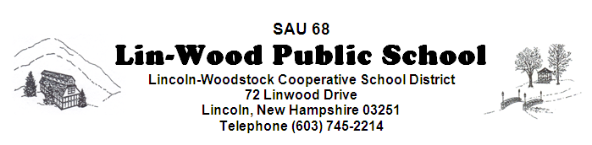

The Policies Committee meets on the 1st meeting of the month at 5:45 pm and the Facilities Committee meets on the 2nd meeting of the month at 5:30 pm in the Elementary MPR. The Lincoln-Woodstock Cooperative School Board will meet in the Elementary MPR at 6:30 pm on May 8, 2019
**Board members are encouraged to arrive early to sign manifests**

AGENDA

- CALL TO ORDER – Tony Drapeau, Chairperson
- PUBLIC FORUM/HEARING – The public is invited to meet with Board members to provide community input regarding:
1. Use of monies from the Equipment Expendable Trust Fund for the following:
a. Cafeteria Garbage Disposal
- ADJOURNMENT TO REGULAR SCHEDULED SCHOOL BOARD MEETING
- CALL TO ORDER – Tony Drapeau, Chairperson
- MINUTES
  - Approval of Minutes of April 17, 2019
  - Approval of Non-Public Minutes of April 17, 2019 – session 1
  - Approval of Non-Public Minutes of April 17, 2019 – session 2
- COMMUNICATION
  - CORRESPONDENCE
  - REPORTS
    - Business Administrator’s Report
    - Superintendent’s Report
    - Principal’s Report
    - Committee Reports
- COMMITTEES
  - Policy Committee
FIRST READING: SECOND READING:
*Please note that Policies are available for your review in the SAU Office and on our school page at www.lin-wood.org
VI. BUSINESS REQUIRING BOARD ACTION
- Staff Nominations, Recommendations and Resignations
- Elementary MPR Flooring Bids.
- Bond Bank Loan Agreement
VII. NEW BUSINESS

- None

VIII. CONTINUING BUSINESS

- Schedule Survey

IX. RECOGNITION OF VISITORS / PUBLIC PARTICIPATION
- Student
- Staff
- Community – Please state your name and address. This agenda item is intended to give citizens a voice and the Board an opportunity to hear directly from citizens. The total time limit is 15 minutes as per policy BEDH. This time is not intended for Q & A. Questions about programs or practices may be directed to respective administrators during the school day.
X. NON-PUBLIC SESSION (RSA 91-A:3) Discussion of matters that are likely to adversely affect the
reputation of a person other than a member of the school board.
XI. ADJOURNMENT

