MATH Work for May 18-22, May 26-28
This packet will take you to the end of the school year. In the fiction story I created many fourth grade standard are used at one time. It is not divided into days so work at your own pace. You will find a mixture of problems so put on your thinking cap!
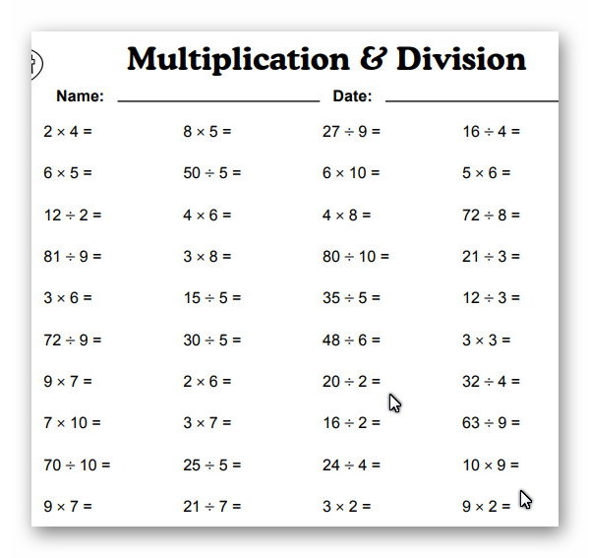
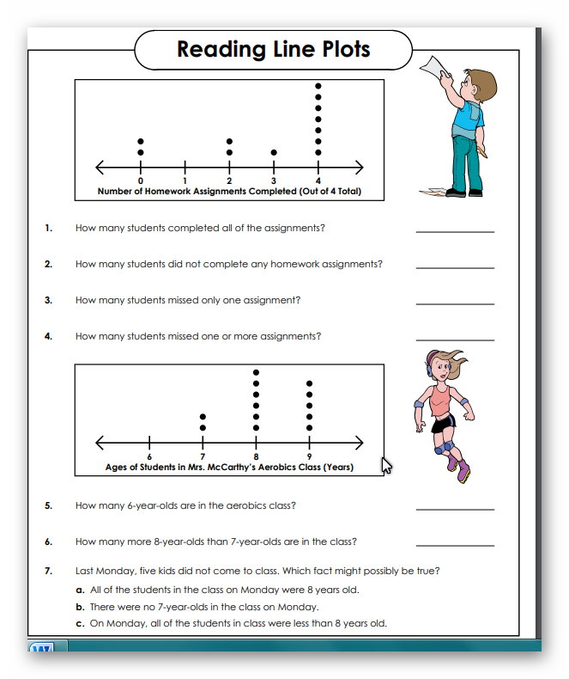

*****Complete STUDY ISLAND “General Review Test” ******
Lastly, do fill in the missing answers!
The FANTASTIC Field Trip
The fourth grade class at Southern Local was very excited. They had done such a wonderful job on their Study Island assignments that the online company had selected them to go on an all-expenses paid trip to Disney World in Florida.
- Mason was looking at a map in Mr. Reese’s classroom. He said, “It is 1,008 miles or about _______ miles to Disney World.”
Mr. Reese smiled and said, “Yes, but we are making a special stop in Charlotte, North Carolina.” Jett said, “Are we going to see the Charlotte Hornets?”
Mr. Reese just said, “It’s a surprise. It is 469 miles to Charlotte.”
- Adelaide thought, “469 is _________ 1,008 (< or>)
- So we will get to _______________ first.
- Khloe added, “My cousin lives 50 miles away. 469 will round to 500 miles so Charlotte is about __________ times farther than my cousin’s house.
- (Think 500 = _____x 50).
- We go through West Virginia, Virginia, North Carolina, South Carolina, Georgia then Florida. Counting Ohio, we will be in _____states.
“It will be a fun trip,” said Mr. Reese. “There is a lot of planning to do. We have 60 students going. If we have one adult going for every 6 kids, how many adults should go?”
7) Emerson raised her hand. “I know 60 divided by 6 equals_____.”
“That’s right,” responded Mr. Reese.
The next few weeks were very busy. They discussed what they would pack.
“I have a beach towel and some flip-flips.” Delaney told Maddy T. when she visited.
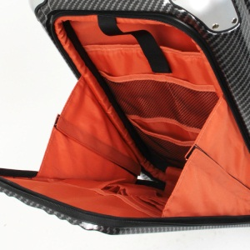>
8) Maddy T. looked at Delaney’s suitcase. It was partially open and reminded Maddy of a __________ angle. 9) Delaney smiled, “ It is open about 60 degrees now but it can open to 90 degrees so it will open ______degrees more.

Meanwhile at her own house, Mary was looking at her suitcase. “I hope it is big enough,” she thought. When she measured the outside, she found the long sides were 16 inches long and the short sides were 12 inches long. 10)She decided it would be fine since the perimeter was ____________ inches.
Maddie Garner and her mom went shopping. Maddie got a new swimsuit for $18.99 and shorts for $10.55. 11) Altogether, they spent ____________.
12) Maddie’s mom paid with $30.00. Her change was _____________.
“I am going to help chaperone. So is Miss Brenda. ” Mrs. Garner said.
Meanwhile, back at school Mrs. Pinkerton and Mrs. Pierce were talking about food with Mrs. Coleman. “I think the students will eat before they get here on the day of the trip,” said Mrs. Pierce.
Mrs. Pinkerton added, “We will need to stop for lunch along the way. It should be somewhere the kids can stretch their legs after sitting so long.”
Mrs. Coleman said, “The cafeteria could pack a lunch and we could stop at a rest area.”
Mrs. Pierce looked online and found a rest area that would be about 200 miles from the school. It had a large grassy field that was 50 yards long and 25 yards wide.
13) She smiled, “That looks good. They will have an area that is ______________square yards to play in.”
The day of the trip was almost here. “You need to be on the bus at 10:30 tomorrow morning,” said Mrs. Coleman. “If you get up 2 hours before we leave, when should you get up?”
14) Landen’s hand went up. “______” he said.
Dylan said, “I had better set my alarm
“Me too!” Andrew and Christian agreed.
“Are there any questions?” asked Mrs. Pierce.
‘Can we bring money?” asked David. Mrs. Pierce nodded, “Yes but you only need it for snacks and souvenirs. Everything else is paid for.”
15) Hannah thought “I have 2 ten dollar bills and 2 quarters. Grandpa is giving me twenty dollars, so I will have ________________”
16) Lilly spelled out $38.00 on a piece of paper and showed it to Zoey. It said (in word form) “I have ___________________dollars.”
17) In her classroom, Mrs. Pinkerton was looking at the seating chart. “I have 19 students. I cannot divide them for 2 in one seat equally because 19 is a prime number. It’s only factors are _______________.”
18) Micah said, “If you put us in groups of two, there would be a remainder of _________”
“What about me?” asked Miss Brenda.
19) “Oh yes, you would make 20 people. If you are sitting with Bella and there are 2 in one seat, then we will need __________ seats”
Brandon wanted to sit by Braxton. Rhiannon wanted to sit by Jessah. After some discussion, all the children had seat assignments.
20) Alex looked at the model of the bus. “It looks like there are 18 seats on each bus. If there are two in each seat, then the bus holds _________ people.”
21) “Good thinking,” said Mrs. Pinkerton. Dominick added, “Since there are 70 people going, we will need _____ buses.”
THE BIG DAY
The day to start the trip had finally arrived. The students got busy and helped the adults. Kyla, McKenley, and Emma Johnson helped carry some lunches to the buses. One third of the sandwiches were ham and one third of the sandwiches were turkey.
22) That meant _____ of the sandwiches are either ham or turkey.
The teachers took attendance. “I don’t see Alexa Kinemond or Jaiden Palmer,” Mrs. Pinkerton worried. Just then a car pulled up. “Here we are!” the two girls smiled as they got out.
The each bus was a special model. It even had a restroom inside! The children’s suitcases went in a special place on the side of the bus.
The bus drivers were friendly. One told Jonah that the bus weighed 25,000 kilograms. “I will give you 5 dollars if you can tell me how many grams that is.”
23) Jonah smiled, “I think you asked the wrong person. I am pretty good in math and I remember that one kilogram equals 1,000 grams so the answer is the bus weighs __________ grams.” The bus driver wasn’t happy but he gave Jonah 5 dollars.
Jensen went up to the other bus driver. He said, “Ask me a question about this bus. I get 5 bucks if I am right.” The bus driver said,”OK, this bus 14 meters long. How many centimeters is that?”

24) Jensen said. “That is easy. One meter is 100 centimeters so the bus is _______centimeters long.”
The bus driver shook his head and handed Jensen the five dollar bill. “No wonder you kids won the Study Island contest!”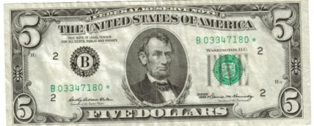
The students all lined up. They boarded the bus and were soon on the bus.
REST STOP
They pulled into the rest stop about 1:oo. The kids were hungry and the food was passed around. Justin ate 4/8 of his cookies and Xavian ate ½ of his cookies.
25) Justin thought he ate more but Xavian knew_____________________________________________________.
Adalyn, Gracie, and Chloee each ate ½ of their sandwich.
26) Altogether the girls ate 3 x ½ or ______ of the sandwiches. 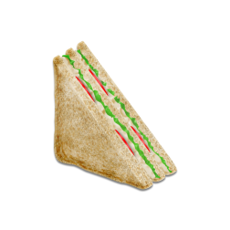
27) Adalyn asked Aiden if he wanted the rest of her sandwich. Aiden looked at the sandwich. ‘Sure,” he said. “This looks like a right triangle. The two sides have __________________lines and form a right angle.”
“Just eat the sandwich,” said Jaylen. “We can play when we finish eating.”
Jada and Lavayiah were helping the teachers clean up. They made a game to see who would clean more the fastest.

28) Hayden was the judge. She said, “Lavayiah cleaned up 1/3 of the mess and Jada cleaned up ½ of the mess, so _____________ cleaned more.”
When the kids got back on the bus, Jeffrey, Ben, Jack and Shiloh decided to have a video game contest. They all had been given special permission to bring handheld devices because it was such a long trip.
Ben said, “Let’s make it the best total score for two games is the winner!”
29) They played for awhile. Shiloh said, “My score is like a pattern, It is 2542542. If I kept going the next numbers would be __ __ __ __ __.”
30) Jeffrey said, “ I got 1,238,980 the first game and 2,134, 098 for the second game so my total is _______________________”
Before they could finish adding the scores, Mr. Reese said, “Look, there is Charlotte, North Carolina. Does anyone know what they are famous for?”
Savyona piped up, “The Charlotte Panthers”
“That’s right. They have the Panthers and they have the Hornets.” said Mr. Reese. “What else?”
No one could think of anything. Emma Jones said, “I give up!” Everyone nodded.
“Well,” said Mr. Reese, “If you can put the population of Charlotte in expanded form then I will tell you what we are doing tomorrow. Ready? The population is 872, 498.”
31)There was silence on the bus for a bit then Gavin said, “I know it is _800,000 + ___________+____________+__________+___________+_________.”
“Perfect” said Mr. Reese and he gave Gavin a fist bump.
Mr. Reese said, “ I am thinking of a shape. It is not a polygon because it doesn’t have straight sides but just curves around.”
Rylie Pugh asked, “An oval?” “Right” smiled Mr. Reese.” In this case, it is an oval cars go around. Professional drivers do.”
“NASCAR!” shouted Rylie Witherow.
Mr.Reese said, “ We are going to go to the NASCAR museum then to a water park called CAROWINDS.”
Everyone was happy. They soon stopped for the night at a hotel.
THE NEXT DAY
Bryce and Emmanuel were the first ones on the bus the next morning. They were excited about the day.
32) “Mr. Reese said the race track in Charlotte is 7,920 feet so if you do 3 laps it is ______________feet.”
Avalyne and Alexa Paczesny got in line to board the bus. “How many people go there at one time?”
33) Emmanuel said, “There used to be 134,000 seats but they took out 41,000 seats so now there are _________________seats.”
The teachers and the students boarded the buses to the museum. Michael and Mr. Reese were the last ones on the bus. Mr. Reese said, “It’s 9:15 now. We will be at the museum for 2 hours and 30 minutes.”
34) “So we will be done at ___________,” Isaih told Serenity.
They had a great time at the museum then they went to the water slides. It was a hot day and they had a blast!
Airianna bought some candy with different shapes at the snack shack. There were hexagons, trapezoids, triangles, rectangles, squares, pentagons, and ovals. She ate the 4 sided candy shapes first.
35) They were these shapes:_________________________________________________
36) Liam bought a hot dog for $2.98 and a drink for $1.98. He paid _______________ in all.
It was soon time to go back to the hotel. Everyone was ready for supper

The next day, they drove to Florida. It was so much fun! They couldn’t wait to get back to Southern Local and tell everyone all about it.
THE END
The school year has come to an end too. Please have a safe and happy summer!

