Parent(s), graded papers go home tomorrow. Please be sure you are checking your child’s backpack and folder daily. Continue to encourage reading and homework completion. Write any comments or suggestions below, send additional note, or email me if needed (karla.thompson@dcsms.org). Thank you for your support!

You can also Stay Connected with Remind. Text @g7fc3f to 81010 Standard text message rates apply.
Visit remind.com to learn more. Thanks to those parents already registered! ☺

Classroom Newsletter February 3, 2020
Mrs. Thompson – 3rd Grade
Living Wax Museum
Friday, February 14, 2020
8:45 – 10am
Teacher Notes: Living Wax Museum will be here in less than two weeks. Please be sure to have your child bring their presentation board no later than the 13th - so we can set everything up. I’m getting very excited to see their presentations of influential figures! Thank you again for all of your help! * Next GATOR CLUBS – Tomorrow: TUESDAY, February 4, 2020

Reading: central message, main idea & details, context clues
Writing: text evidence
Math: equivalent fractions
Social Studies: historical figures

Star Student: l
l
Characteristic: ll

Classroom
Topics

The more we value things, the less we value ourselves. – Bruce Lee
Reading Strategy Focus –
Find the Main Idea
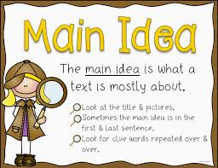

Daily Homework:
- Read, read, read – at least 20 minutes every day; complete daily section of reading homework: Spacesuits
- Practice multiplication facts; complete daily section of homework: Q3:5

Upcoming Tests:
Reading
- Reading Test: 02/06/20
Math
- Math Midterm: 02/04/20
- Equivalent Fractions Quiz: 02/07/20

Equivalent Fractions
