Millbrook Middle School
6th Grade Supply List
- 3 folders with prongs
Students will need to purchase the novels we will be reading in class.
1st Nine Weeks- TBA
2nd Nine Weeks- TBA
3rd Nine Weeks- TBA
4th Nine Weeks- TBA
- Pencils
- Red Pen
- Cap Erasers
- Pink erasers
- Post-It Notes (2 Pack)
- Glue sticks (2)
- 2 packs of Index cards
- Headphones (For Computer Lab)
- Four Function Calculator
- 1 pack sheet protectors
- 2 three ring binder (1 to 2-inch)
- 2 packs of tab dividers
- 1 blunt-end scissors
- 4 packs loose leaf paper (NO COLLEGE RULE)
- 1 pack of colored copy paper, 1 pack of cardstock paper
- 2 reams (packs) of copy paper
- 1 pack of highlighters (Multi-colored)
- 1 Graphing Paper Composition Notebook
- 9 composition notebooks (3 for ELA, Math, Science, & Social Studies)
- Handheld pencil sharpener (with pencil shaving catcher)
- Crayons/Colored Pencils
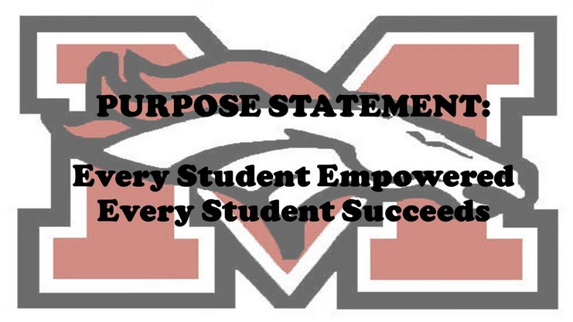
- 1 pack of expo markers

Wish list:
- Paper towels
- Kleenex
- Ziploc bags (Quarts & Gallon Bags)
- Hand Sanitizer
- 1 Disinfectant Spray (Lysol)
- Lysol Clorox Wipes
- Air Wick Plug-in

