Hey There Everyone!
As a result of the Desoto County Schools closing, it is no secret that we all have concerns and questions surrounding these events. As the school counselor, I want to continue to act as a link to community resources that I am aware of as of this time. I also want to continuously offer any and all helpful tips and tricks to allow your student to stay as "on track" and as healthy & happy as possible during these circumstances.
It is my hope that you all will utilize these resources throughout the upcoming days of being out of school. We all miss our kiddos more than ever, and we are hopeful to see them sooner than later! 😊

Kind Regards,
Mrs. Rebecca Dix M.Ed.
School Counselor-Chickasaw Elementary
Email: rebecca.dix@dcsms.org

Food Resources:
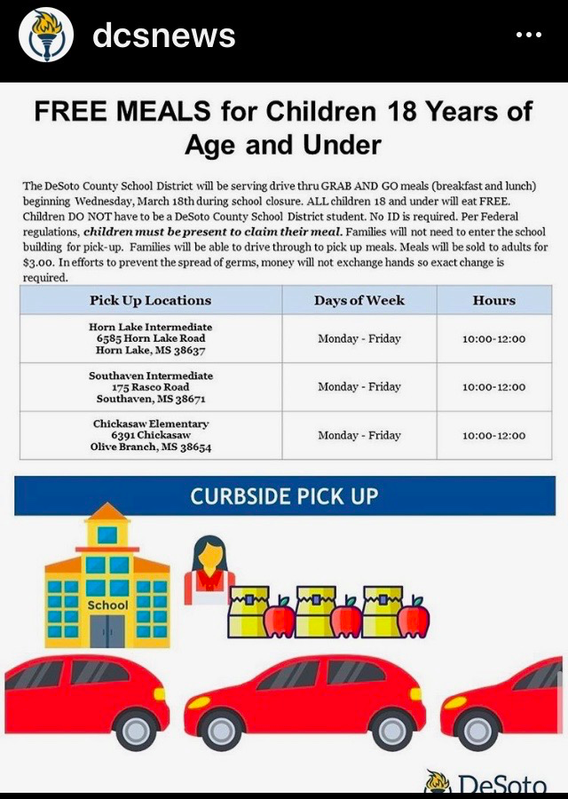
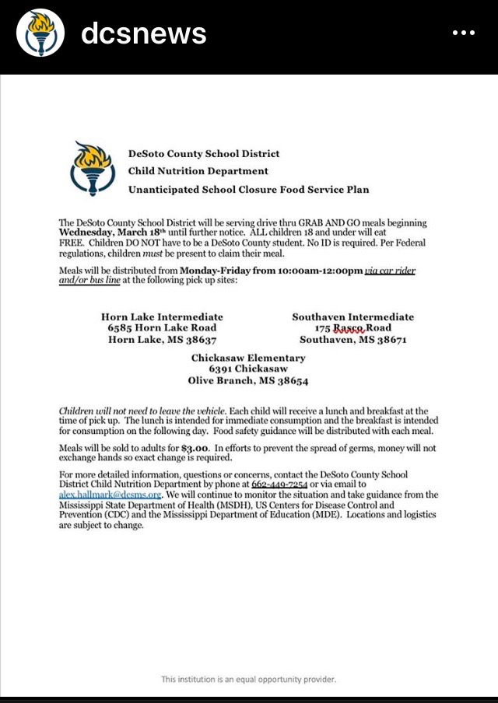
-LaBelle Haven Baptist Church will be offering free lunches to our children who need lunch. They open at 8:30 am and will need to know if you are coming by 11:00am. Please call them @ 662-893-2273.
Address: 4800 Hwy 305 N
Olive Branch, MS 38654
It will work like a drive through.
Please call the church or OBES for any information.
-Olive Branch Food Pantry-10947 MS-178, Olive Branch, MS 38654
Open: Tuesday from 8AM-10AM and Thursdays from 6PM-8PM
Call before going to make sure they are operating normally. (662) 895-2913

Connectivity:
- Charter Communications announced on March 13, 2020 that for 60 days the company will offer free Spectrum broadband and Wi-Fi access to homes with K-12 and/or college students who do not already have a subscription. Installation fees will also be waived for these households. Enroll by calling 844-488-8395. Charter will also continue Spectrum Internet Assist, a program offering low-cost broadband internet of 30 Mbps for low-income households without school-aged children.
- Comcast, which owns Xfinity, will offer 60 days free and increased speeds for new families who join the Internet Essentials program, an internet access program for low income families that is normally $9.95 a month.
- AT&T announced on Friday it would not cancel service and would waive late fees for any wireless, home phone, broadband residential or small business customer experiencing hardships because of the coronavirus pandemic and can't pay their bills. Qualifying low income households can apply for $10 a month internet access through the Access from AT&T program. Fixed Wireless Internet and Wireline customers can use unlimited internet data. AT&T will also keep public Wi-Fi hotspots open.

Keeping Routine At Home:
It is critical to implement a "regular" schedule within your home during this time. Whether you are staying home with your child or hiring a babysitter, there are several easy was to keep a routine in place for your student. Once your child does return to school in the future, keeping this routine will make that process much smoother for you and for the educators at their schools.
EXAMPLE SCHEDULES:
Sample Daily Routine (edit as you see fit)
Rutina Diaria Demostrativa (edite según sus necesidades)
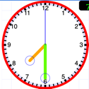 | 7:30-  8:00  AM | Wake up! Despierta! | Brush teeth, make bed, get changed, put away laundry, make it musical! Lávese los dientes, haga la cama, guarda la ropa, hazlo musical!
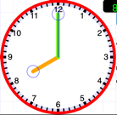 | 8:00-  8:30 AM | Breakfast  Desayuno | No screens  Cero pantallas
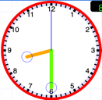 | 8:30-  9:30 AM | Morning walk  Caminata de la mañana | Get outside; walk the dog; yoga/stretching; recess games; Cully Park  Vayanse afuera; caminar al perro; hacer yoga/estirar; juegos de recreo; parque Cully
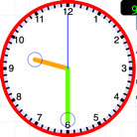 | 9:30-  10:30 AM | Academic time: Reading  Hora académica: Lectura | PPS Clever links; Reading books/leer libros; Lexia; MyOn; newsela;
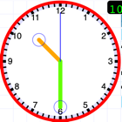 | 10:30-  11:30 AM | Creative time  Hora creativa | Legos; magnets/imanes; drawing; coloring; painting; dancing/baile; music making/hacer música; code.org
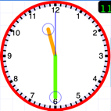 | 11:30-  12:00 PM | Free time  Tiempo libre | Unstructured time builds executive function. Boredom is a vitamin!  El tiempo libre desarrolla funcion ejecutiva. ¡El aburrimiento es una vitamina!
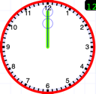 | 12:00-  12:30 PM | Lunch  Almuerzo | No screens  Cero pantallas
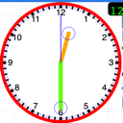 | 12:30-  1:00 PM | Chores  Quehaceres | Dishes; wipe down counters; vacuum; sweep; mop; laundry… Trastes; sacudir las mesas; aspirar, barrer, trapear, lavanderia...
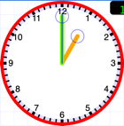 | 1:00-  2:00 PM | Academic time: Math  Hora académica: Matemáticas | Prodigy; Xtramath; analog clock work; Khan Academy
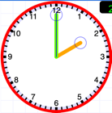 | 2:00-  2:30 PM | Academic time: Writing  Hora académica: Escritura | Journal;typing practice;  Un diario; practica de teclear
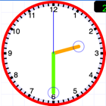 | 2:30-  3:30 PM | Afternoon “recess”  “Recreo” matutino | Get outside; exercise; play catch, walk, run, lift weights  Vayanse afuera; ejercicio; tirar una pelota; caminar; correr; levantar pesas
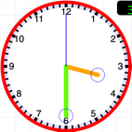 | 3:30-  4:30 PM | Afternoon quiet time/screen time  Hora quieta de la tarde / pantallas | Fun reading; video games; YouTube University-  - learn to solve a Rubik’s cube!  - Magic tricks  - Science experiments  - Crash Courses (science, history, and more!)  - Portaportal  - Puzzle or board games
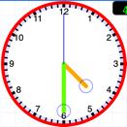 | 4:30-  5:30 | Chores  Quehaceres | Dishes; wipe down counters; vacuum; sweep; mop; laundry...
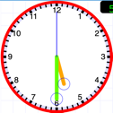 | 5:30-  6:00 | Something new!  ¡Algo nuevo! | “YouTube University”: Learn something new!!! Mr. H’s YouTube Playlist  Aprender algo diferente! Ideas de Sr. H
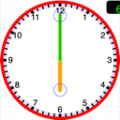 | 6:00-  6:30 | Dinner  Cena | No Screens  Cero pantallas
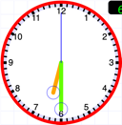 | 6:30-  7:00 | Clean the kitchen  Limpiar la cocina | Add music!  Try Super Cumbias!
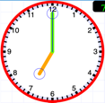 | 7:00-  7:30 | Prep for bed  Alistarse para la cama | Get changed; brush teeth; shower  Cambiarse; lavarse los dientes; bañarse
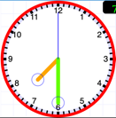 | 7:30-  8:30 | Evening TV ; check in with neighbors  TV de la tarde; chequear con los vecinos | How are your friends doing? Do they need anything?  ¿Cómo están los amigos? ¿Necesitan algo?
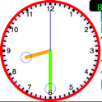 | 8:30-  9:30 | Pre-bedtime routine  Rutina diaria antes de dormir | Dimmer lights; read in bed; read with siblings/adults  Practice gratitude  Practicar agradecimiento
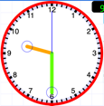 | 9:30 | BEDTIME! Lights out!  Hora de dormir! Apagar las luces! | 10 hours of sleep for children! 8 hours for adults! No screens/devices in children’s bedrooms!  10 horas mínimo para los niños! ¡8 horas para adultos! ¡Cero pantallas en los cuartos de los niños!

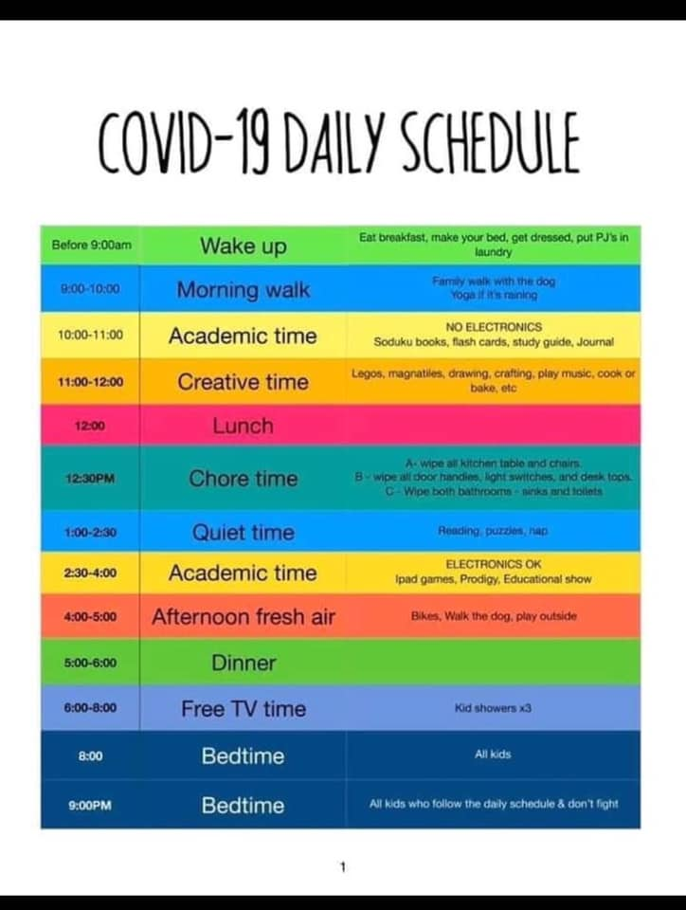

Resources to Stay Sharp @ Home:
http://www.readwritethink.org/
https://www.classdojo.com/

Epic! - Kids' Books and Videos
https://store.mindresearch.org/products/st-math-homeschool?fbclid=IwAR2vCBl7kNUAGdKm_qD_T0dqrQXyzm-ZqNvOUA0mxI0qih7jw9XJVJSoXc8

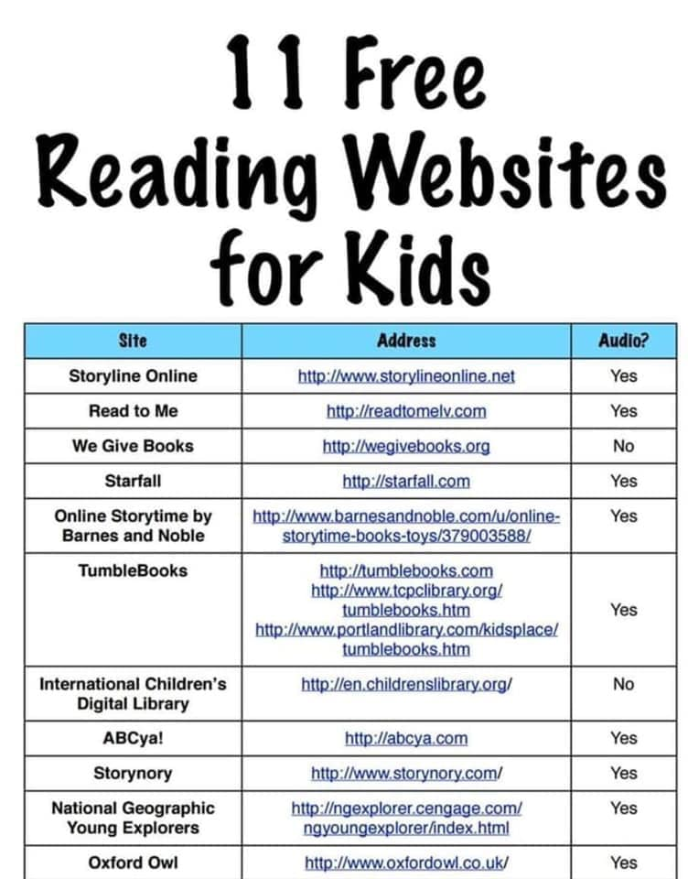

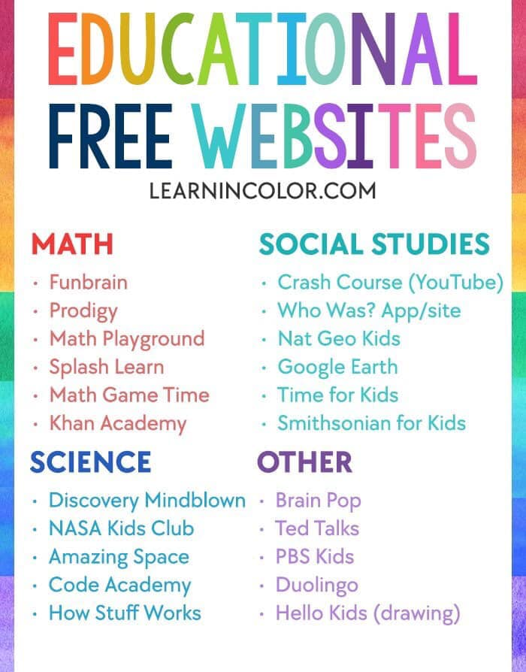

UNPLUGGED Activities:
-Paint/Practice Instruments outside
-Create Artwork
-Practice Math skills with Chalk Outside
-Practice Spelling with Chalk Outside
-Hike
-Walk outside
-Exercise Outdoors
-Bake something together
-Cook meals together
-Chalk outdoors
-Basketball, football, dance,...etc. outdoors
-Read outside for fresh air
-Play Tag
-Plant flowers/garden
-Help with yard work
-Eat meals outdoors on patio/porch/picnic
-Play/Take care of your pets
-Clean the house top to bottom
-Keep up with chores/schedule
-Have face to face conversations with loved ones in the home
-Take Board Games outside to play/play inside

More Ideas:
https://csunplugged.org/en/
https://www.pinterest.com/edinsights/unplugged-play-ideas-for-kids/
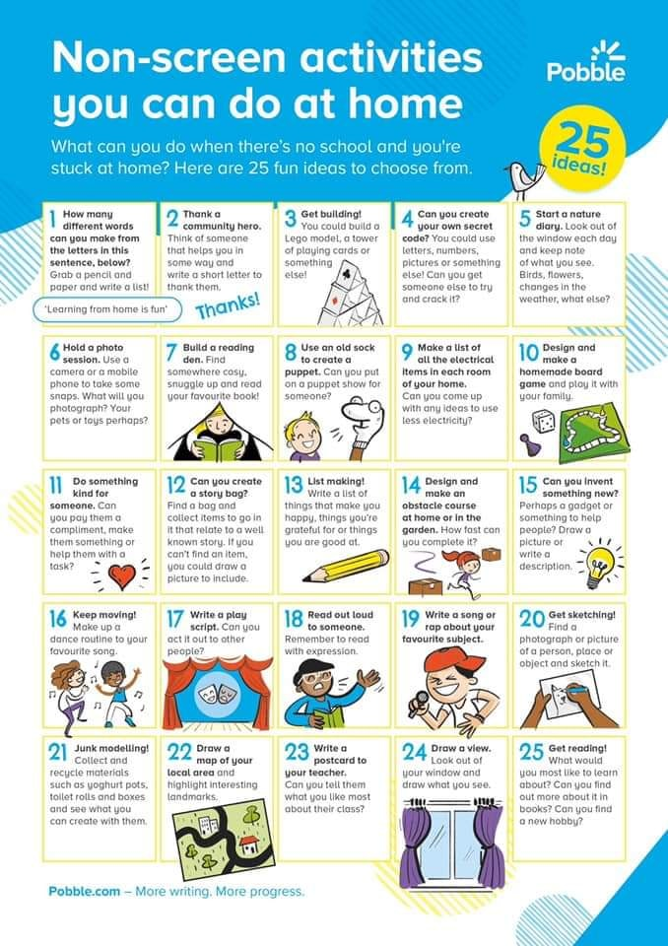

ONLINE LINKS FOR FUN:
https://pbskids.org/games/
https://lol.disney.com/games/

Tips/Safety :
https://firstthings.org/coronavirus-resources-parenting/?utm_source=hs_email&utm_medium=email&utm_content=84823464&_hsenc=p2ANqtz-8mOQm9MMSCSrlW7tgsr_8FWlXsxAHnfoRgYyQ_LAJv0UOXtzJCzLxvJsnD-2MWlBkHx5mLUzceike4j6WUgVbTj7XGXg&_hsmi=84823464
https://www.cdc.gov/
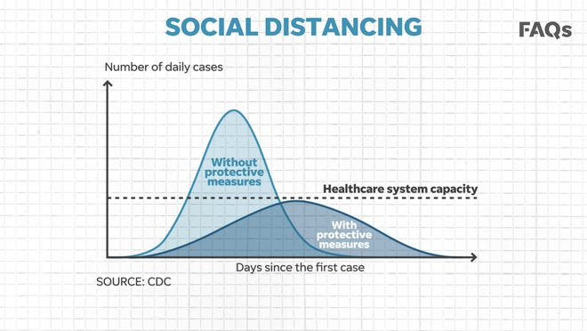
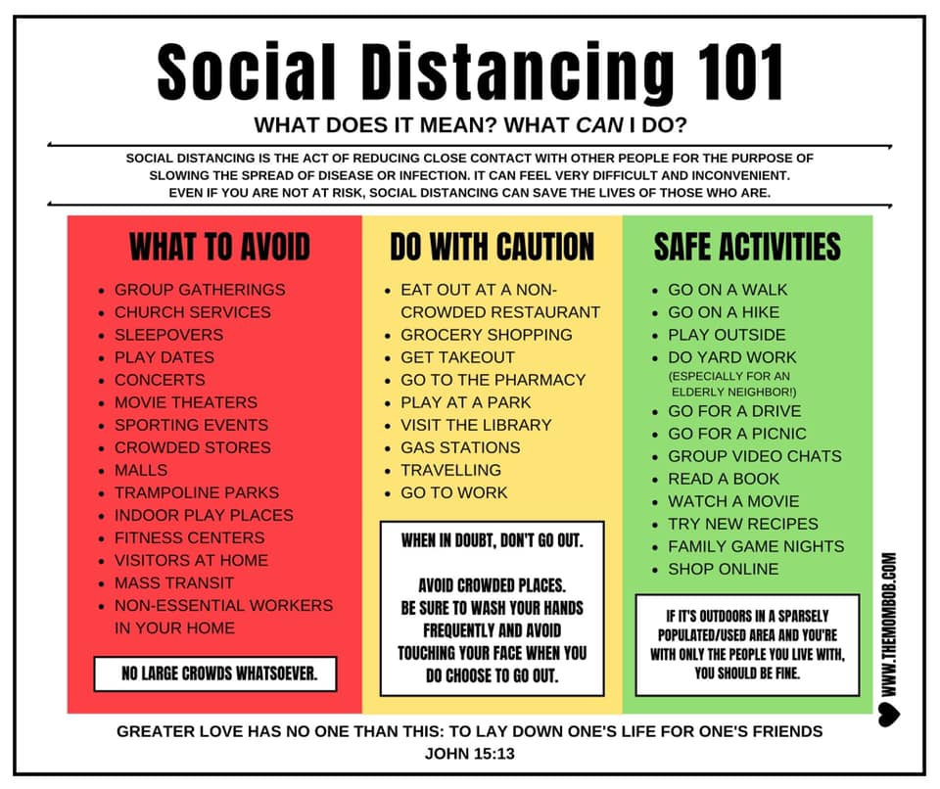

VIRTUAL TOURS:

Over 30 Virtual Field Trips with Links
San Diego Zoo |  | The San Diego Zoo has a website just for kids with amazing videos, activities, and games. Enjoy the tour!
Yellowstone National Park Virtual Field Trip |  | Mud Volcano, Mammoth Hot Springs, and so much more.  Tour Yellowstone National Park!
MARS!!! |  | Explore the surface of Mars on the Curiosity Rover.  They are updating from WEBVR to WEBXR now, but 360 Mode offers a digital view!
Animal Cameras |  | Live Cams at the San Diego Zoo  Monterey Bay Aquarium live cams  Panda Cam at Zoo Atlanta  6 Animal Cams at Houston Zoo  Georgia Aquarium has Jellyfish, Beluga Whales, and more
Virtual Farm  Tour |  | This Canadian site FarmFood 360 offers  11 Virtual Tours of farms from minks, pigs, and cows, to apples and eggs.
U.S. Space and Rocket Museum in Huntsville, AL |  | See the Saturn 5 Rocket on YouTube and more on this tour thanks to a real father/son outing.
Discovery Education Virtual Field Trips |  | A few of the field trip topics include  Polar Bears and the Tundra  Social Emotional Skills  STEM  manufacturing
The Louvre |  | Travel to Paris, France to see amazing works of art at The Louvre with this virtual field trip.
The Great Wall of China |  | This Virtual Tour of the Great Wall of China is beautiful and makes history come to life.
Boston Children’s Museum |  | Walk through the Boston Children’s Museum thanks to Google Maps!  This virtual tour allows kids to explore 3 floors of fun.
Have fun learning at home!

Kids With Questions/Anxiety:
APPS:
- Mindfulness for Children (Free Version and Pro Version $4.99/one time fee) ...
- Relax Melodies (Free Version and Paid Pro Version Available) ...
- Calm (Lite Version, or $4.99/month for the year) ...
- Positive Penguins ($0.99) ...
- Mindful Minutes by Oops Yay ($1.99) ...
- Bedtime Meditations for Kids by Christiane Kerr ($4.99)

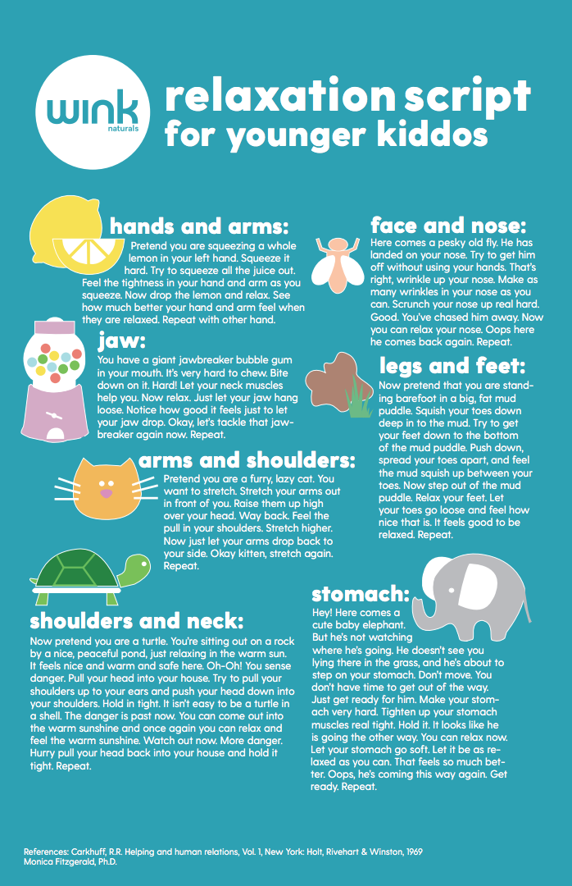
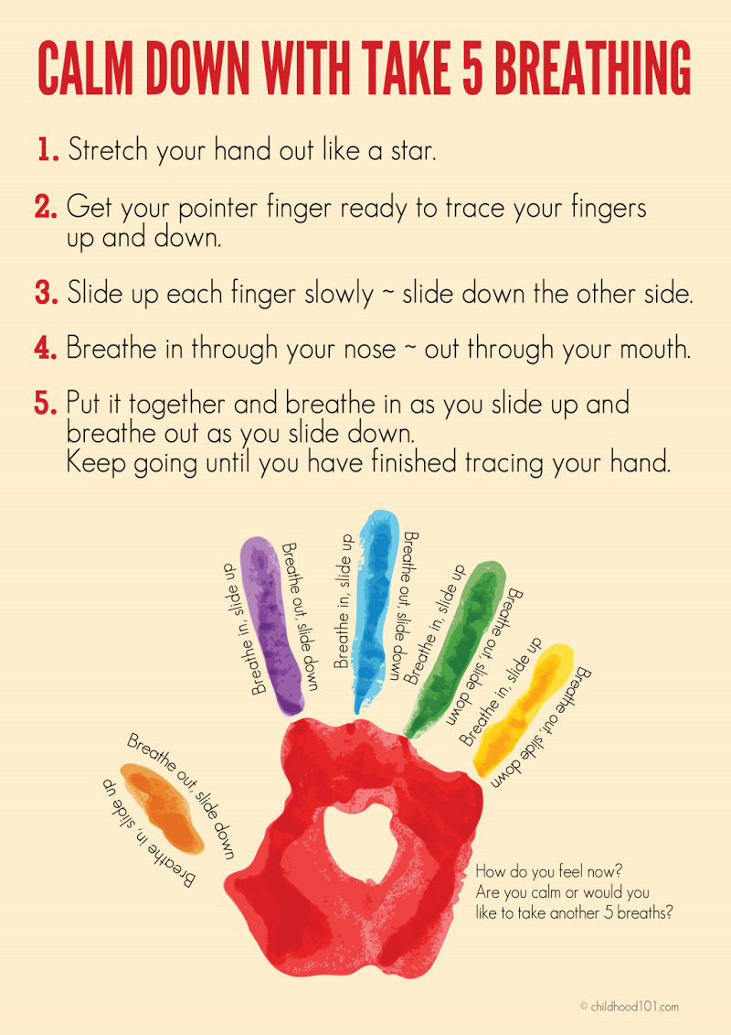
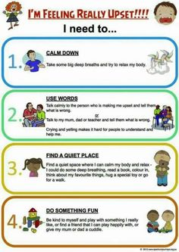

LINKS to Help with anxiety/change:
https://preschoolinspirations.com/kid-yoga-videos/?fbclid=IwAR3041P7zxd_4coF4vz1nQJqaWVrkJjV8vDdnVlswYPXE0WJpXv3-tuk_IY
https://www.centervention.com/social-emotional-learning-activities/?fbclid=IwAR0b1ILJI0U-uvSe_3EuIFLLtI25sX9jzvlQqXYy1QSP1y-LFtUjRh-5S_U
https://childmind.org/article/talking-to-kids-about-the-coronavirus/
https://l.facebook.com/l.php?u=https%3A%2F%2Fwww.brainpop.com%2Fhealth%2Fdiseasesinjuriesandconditions%2Fcoronavirus%2F%3Ffbclid%3DIwAR34bY2DHCdJFZ7xJEKcBaV4NAFCaWZOsyuKvEjO1mFScGBAcAqW6I9IGbk&h=AT3lnbczNl29pe6q4GyOZAiDyIJeMft5DW4ikjkU510sdLCiLb2JnLsJcjinl2X4qEbgJF553OpIpovrrwDFEKWYRhTQNVfcnTlKY3zIA7FXZlcgW7Jwx6qR7jkbQ2FPNESJxbWOrLcI8zQ3QK-uWfr7V1fPP216aJJOqE0DmMGyBCInKN0ocPJXJtJZ-HAl3A
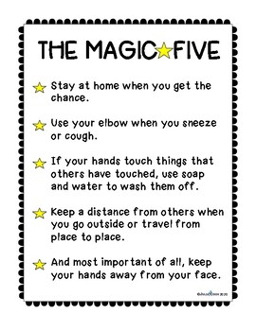
VIDEOS To help explain virus:
https://www.3newsnow.com/news/national/coronavirus/local-author-narrates-childrens-book-explaining-coronavirus
https://www.facebook.com/lookatthemlashes/videos/553846481894745/

It is my hope that you all will utilize these resources throughout the upcoming days of being out of school. We all miss our kiddos more than ever, and we are hopeful to see them sooner than later! 😊

Kind Regards,
Mrs. Rebecca Dix M.Ed.
School Counselor-Chickasaw Elementary
Email: rebecca.dix@dcsms.org

