DCPS 1st Grade Week of 4/14 – 4/20
Parents,
Below you will find an outline of objectives for the week. We have included some links with videos, resources, and/or worksheets to help go along with each topic. We want to be clear that you are not expected to do it ALL. These are simply just suggestions that we know will help benefit your child during this time of distance learning. Thank you all again for everything you are doing at home to ensure that your child is still learning every day. We appreciate you!
First Grade Teachers
------------------------------------------------------------------------------------------------------
- Math- Review subtraction word problems to 20.
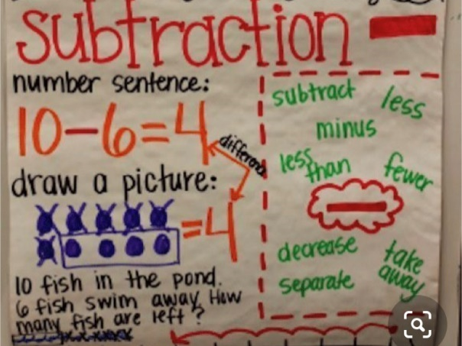
*Helpful videos:
https://youtu.be/FDP0mbsVX9A
https://www.youtube.com/watch?v=9Z2gpbYiEXo
*Follow these links for free word problem printables:
https://www.mathworksheets4kids.com/subtraction/word-problems/sub-standard1.pdf
https://www.education.com/worksheet/article/subtraction-word-problems/
https://worksheetsplus.com/1stGradeAddSubWordProbsWkshtAdap.html
Also, you could have your child write their own subtraction word problems and draw pictures to go with it.
CHALLENGE:
https://www.2nd-grade-math-salamanders.com/image-files/2nd-grade-math-word-problems-subtraction-to-50-2.gif

Reading- Begin making meaning story A Day in the Life of a Garbage Collector (Discuss wonders before, during, and after the story. Identify and discuss non-fiction text features. Identify what they learned and key details from the story.)
*Link to story:
https://www.youtube.com/watch?v=gj1Y0Vfkj0c
*Vocabulary words:
1. contents – words, pictures, and other information in a book; things found inside of something such as a can, box, or bag
2. inspect- look carefully at something
3. dump- empty or unload something in a rough or careless way
4. destination- place that someone or something is going
*Write sentences with each vocabulary word.
- Writing- Write about Community Helpers
*Suggestions:
A garbage collector helps pick up trash. Write about ways you could help keep things clean.
Would you rather be a garbage collector or another type of community helper? Write an opinion piece giving a topic sentence, 3 details and a closing. Make sure you have punctuation marks and capital letters too.
Write a friendly letter to a person of your choice working in the frontlines of this pandemic. Suggestions would be doctors, nurses, any health care professional, grocery store workers, truck drivers, delivery workers.

Spelling-R controlled Vowels ir, er, ur
- nurse
- germs
- church
- shirt
- Burt
- perch
- verb
- fur
- fern
- burn
- before
- last
*Monday- Rainbow write
*Tuesday- Dot write
*Wednesday- Pyramid write
*Thursday- Write all spelling words 3 times. Then, write a sentence with each word.
*Friday- Take a “test” at home.

- Heggerty- Week 29
*Monday- https://www.youtube.com/watch?v=UYDJvbto4Fs
*Tuesday- https://www.youtube.com/watch?v=1ymQducNZpo
*Wednesday- https://www.youtube.com/watch?v=kyYoyDef7NM
*Thursday- https://www.youtube.com/watch?v=m_U-FUoR4YE
*Friday-https://www.youtube.com/watch?v=dHUeIOivy9Y

