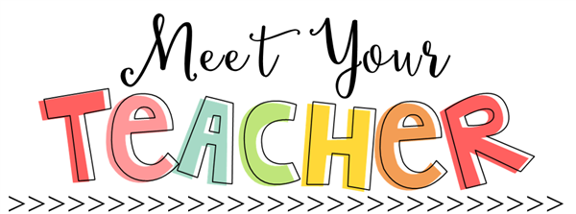

IMPORTANT REMINDERS:

Send a snack every day.

Do not send any cash to school.

Send your child’s red folder in his/her backpack daily.

Sign/initial the behavior sheet every night.

No visitors are allowed in the building.

**My Education**

**High School**: Benjamin Russell

**Bachelor of Science Elementary Education**

*Jacksonville State University*

**Master’s Degree- Library Science**

*Jacksonville State University*

**My Favorites: (I have lots☺)**

Snack- Salt Vinegar potato chips, string cheese, Chex mix, Kind mini bars

Chocolate- Reese cup, anything white chocolate

Drink- Diet Coke, anything Starbucks

Food- Mexican, Shrimp, and Italian

TV- Life time and The Golden Girls

Store- Five Below, Hobby Lobby, Target

Our Classroom

My goal is to help your child learn and grow while having lots of fun, too! In this class, we are a small community of teammates that help and accept one another. I believe that valuable learning occurs when children feel comfortable, safe, and happy in their classroom. I look forward to getting to know you and helping you and your child to be a success this year. I am here to support you and your child and I hope you will support me as well. Everyone has individual needs and goals and I am dedicated to your child’s individual success!

Email Address: knickels@acsk12.net

School Phone: 256-234-8625

“In a world where you can be anything, be

***kind****”*

The Basics

My name is Kimberly Nickels and I am very excited to be your child’s teacher! I live in Sylacauga with my 4 cats and a dog. I enjoy walking, drinking coffee, going to the beach as often as I can, being outdoors, visiting my mom, shopping online, spending time with my pets, planting flowers, and of course WAR EAGLE!

I have taught 17 years. My experiences include: teaching 6th grade, 5th grade, elementary media specialist, and kindergarten. My passion is definitely kindergarten. I love seeing how much these babies can grow and progress in such short time. It’s so rewarding!