STUDY GUIDE - EVALUATING STOCKS

- As an investing strategy, some investors use credit (borrowed money) to purchase securities (like stocks or bonds). What is this strategy called?

- List 2 characteristics of common stockholders as related to voting rights and the receiving of dividends.

- What does “Net Change” compare?

- List 2 characteristics of preferred stockholders as related to voting rights and the receiving of dividends.

- What designates a public corporation from a private corporation?

- What are the benefits of using the strategy called “Direct Investment” (using a Direct Stock Purchase Plan)?

- Are all stockholders considered company owners? Yes or no

- A common stockholder may assign voting rights to someone else. What is this called?

- If a company issues stock, they must also pay dividends to their investors? (True or False)

- What is the marketplace for OTC (over-the-counter) stocks called?

- What is more expensive? Preferred stock or common stock?

- Define “Market Value” as related to stock.

- Define “Par Value” as related to stock

- Who assumes more risk with their investment? (common stockholders or preferred stockholders?)

- What carries more risk? Preferred stock or common stock?

- Market Value and Par Value are the same dollar amount? Yes or no?

- Name the three major stock indices (index’es)?

- Growth stocks reinvest profits so a business can grow and expand? True or false

- Define the term “Buying on Margin” as related to investing

- How are stocks of well-known companies classified? ( growth, blue chip, cyclical, or defensive)

- List 3 things that can have an effect on stock values?

- Is the NYSE considered an auction market? Yes or no

- Is “Buying on Margin” a long-term or short-term investing strategy?

- Income stocks usually pay no dividends to investors? True or false

- Most investors consider stock purchases as long-term or short-term investments?

- Stockholders can lose personal assets when a corporation (they are invested in )goes bankrupt? True or False

- When an investor calculates their “ROI” (Return on Your Investment)..Do they take into consideration what they paid in commission fees? Yes or no
- Which of the following is not an example of a long-term investing technique?

- (dollar cost averaging, buy and holding, short selling, or direct investment) See the notes below to help you determine the answer
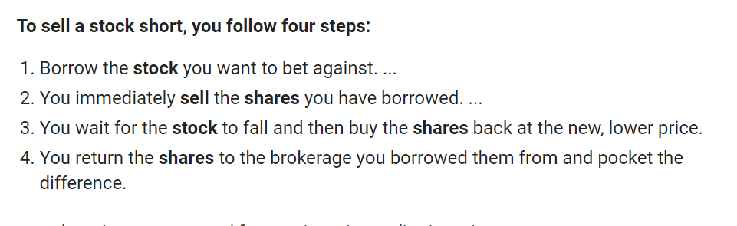

- What is called a market characterised by pessimism and the selling off of shares?
(bull or bear market?)

Cyclical stocks bull market bear market defensive
Growth stocks preferred floor brokers blue chip
Stock exchange common stock OTC Recession
Speculator Income

- ___________People who buy and sell stock on the exchange

- ___________Stocks of large well-established businesses

- ___________A stock trade that is made through a stock exchange

- ___________An organized market where stocks and bonds are traded

- ___________Person who buys and sells stock within a short period of time

- ___________A stock that remains stable during declines in the economy

- ___________Companies reinvest their profits so the business can grow and expand

- ___________Stocks that pay regular dividends to investors

- ___________The type of stock that has a voting right

- ___________The type of stock with a fixed dividend

