PHS Library Choice Board- Week Three
Choice #1 – Read a book! | Make a blanket fort and read a good book in the fort with a flashlight. Don’t forget your stuffed animals.
Choice #2 – Explore one or more of our online resources. | Visit Mrs. Hill’s library site and explore one or more of the sites listed on the website page.  Mrs. Hill's Library Website  https://sites.google.com/ccschools.k12tn.net/khill/websites
Choice #3- Create a book cover | Think of your favorite book. Draw a new book cover for the book that includes your favorite characters and your favorite parts of the book.
Choice #4-Create a research report on an animal or insect | Answer questions in your report about the animal or insect. What does it look like? What does it eat? It is helpful or harmful or both? What is its habitat?  You can look up information here:  https://kids.britannica.com/
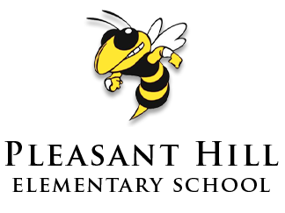
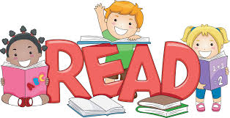
Please select at least one of these (hopefully fun!) activities to complete. Please email me if you
Have questions or just want to say hi!
hillk8@ccschools.k12tn.net

