Algebra One Review Quiz 2 #1-5 Monday April 20th
#6-10 Tuesday April 21st

- What is the solution to the system $\left\{\begin{aligned}x+y=5 \\ x-y=3\end{aligned}\right.$?
- $\left(8,-3\right)$
- $\left(6, -1\right)$
- $\left(5, 2\right)$
- $\left(4, 1\right)$

- What is the solution to the system $\left\{\begin{aligned}x+3y=0 \\ 2x-y=-7\end{aligned}\right.$?
F. $\left(10.5, -3.5\right)$
G. $(-3, 1)$
H. $\left(-3,\frac{1}{3}\right)$
J. $(3, 1)$

- What is the solution to the system $\left\{\begin{aligned}y=5x-9 \\ y=x+3\end{aligned}\right.$?

- What is the solution to the system $\left\{\begin{aligned}3x+y=11 \\ y=x+3\end{aligned}\right.$?
- $\left(4, 7\right)$
- $(\frac{1}{2},\frac{7}{2})$
- $\left(2, 17\right)$
- $(2, 5)$

- What is the solution to the system $\left\{\begin{aligned}y=-3x-2 \\ 6x+2y=-4\end{aligned}\right.$?
F.$\left(6, 2\right)$
G. $(-1, -5)$
H. No Solution
J. Infinite Solutions

Algebra 1 Quiz 2 continued #6-10 Tuesday April 21st

- Keesha bought 11 binders and notebooks from the store and spend $45. Binders cost $6 each and notebooks cost $2.50 each. Which two equations can be used to find the number of binders, b, and notebooks, n, she purchased?
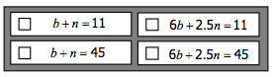
- Which graph represents the solution to the inequality $x-4y≤-12$?

- Which inequality represents the graph?
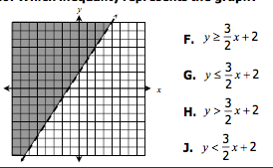

- Which inequality represents the graph?
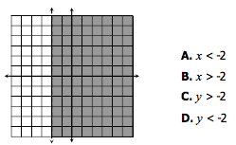
- Which graph represents the solution to the system of inequalities $\left\{\begin{aligned}5x-4y>4 \\ x+y<2\end{aligned}\right.$?

Algebra One Review Quiz 3 Tuesday April 28th:

- Which is equivalent to the expression $\left(3x^{2}-2x+5\right)-(2x^{2}-5x+1)$?
- $x^{2}+3x+4$
- $x^{2}-7x+6$
- $x^{2}-3x-6$
- $x^{2}-7x+4$

- Which is equivalent to $(-2ab^{3})(-3a^{2}b^{5})$?
F. $-5ab$
G. $6a^{2}b^{15}$
H. $6a^{3}b^{2}$
J. $6a^{3}b^{8}$

- Which is the simplified form of the expression $\left(xy^{3}\right){\left(xy\right)}^{4}$?
- $x^{2}y^{7}$
- $x^{4}y^{12}$
- $x^{5}y^{7}$
- $x^{5}y^{12}$

- Which is equivalent to $\left(2x^{2}y\right)∙\left(8x^{3}y^{3}\right)?$
- $\frac{16}{x^{5}y^{2}}$
- $\frac{16}{x^{6}y^{2}}$
- $\frac{10}{x^{5}y^{2}}$
- $10x^{6}y^{2}$

- Which is equivalent to ${\left(\frac{-2m^{2}n^{3}}{m^{2}n^{4}}\right)}^{2}$?
F. $\frac{-4m}{n^{2}}$
G. $\frac{-4}{n^{2}}$
H. $\frac{4m}{n^{2}}$
J. $\frac{4}{n^{2}}$

- Fill in the boxes with the values that make the statement true.
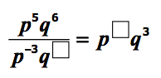

- Which expression is equivalent to $2x^{3}y(x^{2}y-3xy^{2})$
F. $2x^{5}y^{2}-6x^{4}y^{3}$
G. $3x^{5}y^{2}-5x^{4}y^{3}$
H. $2x^{6}y^{2}-6x^{3}y^{2}$
J. $2x^{6}y-6x^{3}y^{3}$

Algebra One Review Quiz 4 Monday May 18th:

- Which of the following binomials is a factor of $x^{2}-13x-30$?
- $\left(x+15\right)$
- $\left(x-3\right)$
- $\left(x-10\right)$
- $\left(x+2\right)$

- If the polynomial $64x^{4}y-36x^{2}y$ is completely factored, which expressions represent its factors? Check all that apply.
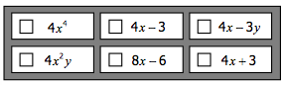

- Given Polynomial A and Polynomial B below, which binomial factor do they have in common?
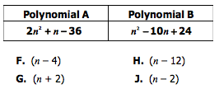

- If the area of a rectangle can be represented by the expression $x^{2}+10x-24$, which two binomials could represent the length and width of the rectangle?
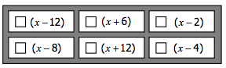

- Which polynomials are prime? (Prime means that it cannot be factored.) Check all that apply.
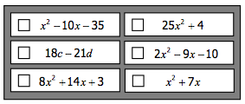

- Which quadratic equation has a vertex located at $(4, -3)$?
F. $y=4x^{2}+3$
G. $y={\left(x+4\right)}^{2}-3$
H. $y=x^{2}-8x+13$
J. $y=x^{2}+8x-3$

- Which statement is false regarding the quadratic equation $y=-{\left(x+1\right)}^{2}+4$?
- The axis of symmetry is $x=-1$.
- The range is $y≤4$.
- The x-intercepts are $\left(1,0\right)$ and $(-3, 0)$.
- The y-intercept is $(0, 4)$.

- Which two transformation can be used to obtain the graph of $y=3{\left(x-5\right)}^{2}$ from the graph of $y=x^{2}$?
F. A vertical compression (wider) and a translation 5 units left.
G. A vertical stretch (skinnier) and a translation 5 units left.
H. A vertical compression (wider) and a translation 5 units right.
J. A vertical stretch (skinnier) and a translation 5 units right.

- Which of the following function below have exactly two distinct real zeros?
- $f\left(x\right)=-x^{2}+14x-45$
- $f\left(x\right)=4x^{2}+4$
- $f\left(x\right)=2x^{2}+12x+18$
- $f\left(x\right)=3x^{2}-4x-4$
- I and IV
- I, II, and III
- II and III
- III and IV

- If a quadratic function has binomial factors of $\left(x-3\right)$ and $(x+1)$, which graph could represent this function?

- Which is a solution to the quadratic equation $x^{2}-8x-48=0$?
F. -12
G. 12
H. -8
J. 6

- What are the solutions to the equation $3x^{2}-7x=20$?
- $\left\{-5,\frac{4}{3}\right\}$
- $\left\{-\frac{4}{3},5\right\}$
- $\left\{-4,\frac{5}{3}\right\}$
- $\left\{-\frac{5}{3},4\right\}$

- What are the solutions to the equation $16-2x^{2}=-64$?
F. $\{±2\sqrt{6}\}$
G. $\{±2\sqrt{10}\}$
H. $\{±4\sqrt{6}\}$
J. $\{±4\sqrt{10}\}$

- The width of a rectangle is fifteen feet less than its length. If the area of the rectangle is 54 square feet, find the width.

- 3 feet
- 6 feet
- 9 feet
- 18 feet

