**Health Education Today’s Theme:**

*Mastering Skills, Choices, and Responses!*

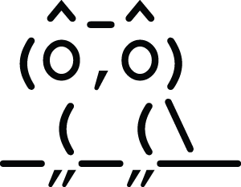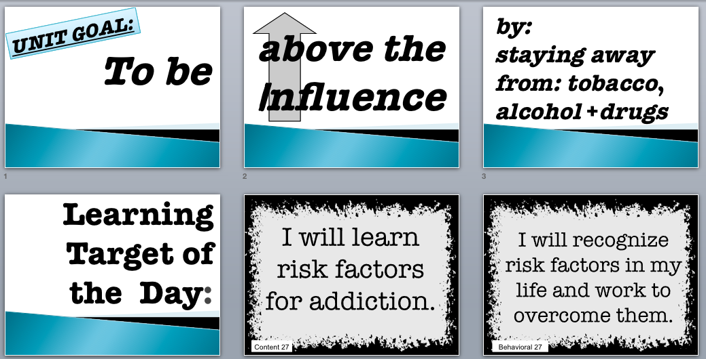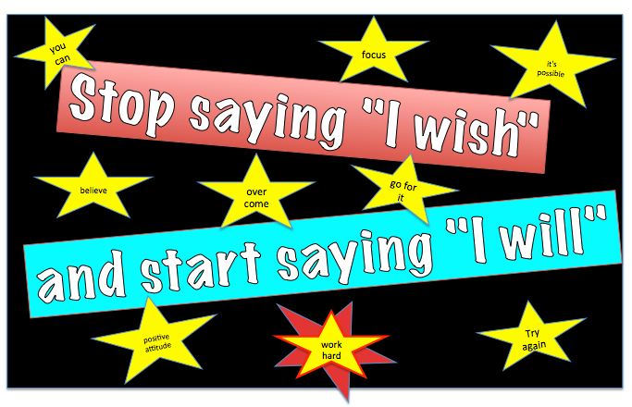

***A Health teacher has an influential role. This curriculum will give you the tools to positively impact the teens you work with!***

**The “Above the Influence” theme:**

* Is part of each unit, daily lessons, and even art projects
* Is incorporated into classroom wall posters for daily reinforcement
* Is integral to the way the daily “Learning Targets” are designed
* Is a way for students to self-assess

Every lesson challenges students to make healthy choices. The “Learning Target Posters” and the “Success Criteria

Check-off Sheets” (where students write the content target at the beginning of class and self-assess the behavioral target at the end of class) help clarify the purpose for each day's lesson.

**"Health Education Today" empowers students to choose an "I will" attitude in making healthy life choices. Many circumstances are beyond a teen's control, but they can control their response to those events!**

**They have the POWER to make positive choices and find success in life, even in the face of overcoming personal hardships or peer pressures. They can master these skills!**

***“Life is 10% what happensand 90% how I react to it... we are in charge of our attitudes.” -Chuck Swindoll***

**A Health teacher has an influential position! This curriculum will give you the tools to positively impact teens.**