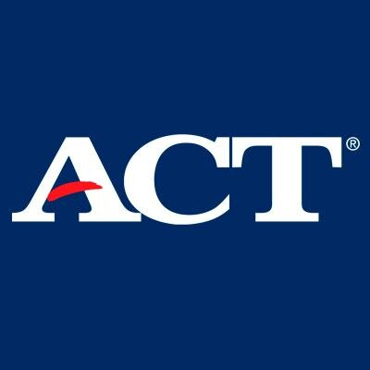
2020-2021
*The ACT is designed for traditional college-bound Juniors & Seniors.*

Visit www.act.org to learn more about the ACT!!!

2020-2021 National ACT Dates
(* indicates required online registration at www.act.org)

Test Date | Online Registration Deadline
October 10, 17, 24, & 25, 2020* | September 25, 2020
December 12, 2020* | November 6, 2020
February 6, 2021* | January 8, 2021
April 17, 2021* | March 12, 2021
June 12, 2021* | May 7, 2021
July 17, 2021* | June 18, 2021

*If you are a student with disabilities requiring test accommodations, be sure to complete the steps necessary to submit accommodations, with plenty of time for approval.

National ACT Registration Fees:
The ACT (no writing) $55.00
The ACT with Writing $70.00
Late Registration Fee $35.00 (on top of regular fee)
Test Fee Waiver Only for 11th & 12th Graders who are Eligible for Free/Reduced
Lunch (pick up from your counselor)

2020-2021 District ACT Dates – *test given at NHS*
*Test Fee required to register. Register with Ms. Chambers in Counselors’ Suite. (No fee waivers!) Only 33 seats are available for each date.
(No accommodations for Students with Disabilities are offered for the dates listed below.)

Test Date (at NHS) | Registration Window (at NHS) | Test Fee | Registration Location
October 6, 2020 | September 14th – until full | $42.00 | Counselors’ Suite
January 15, 2021 | Dec 7th – until full | $42.00 | Counselors’ Suite

