Prattville Junior High School Band

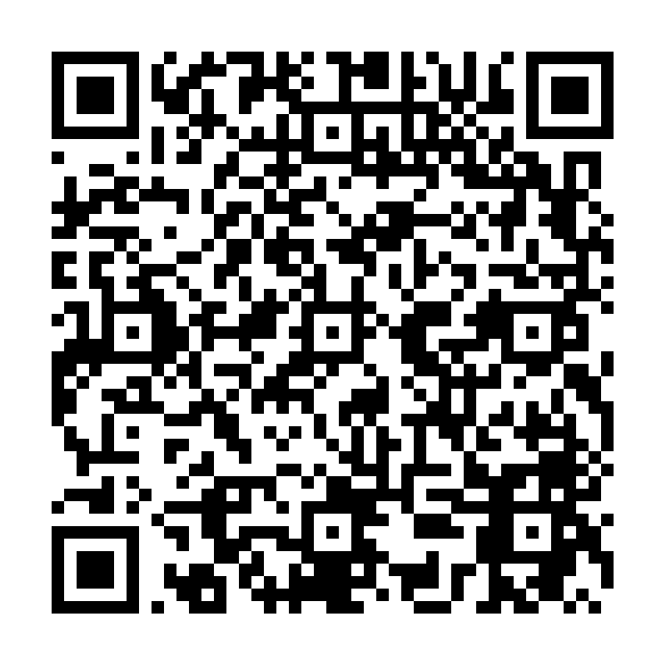

Scan (or click) this to reserve your spot for the PJHS Instrument Testing.

