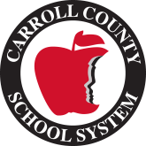

Mount Zion Elementary School
2021-2022
Kindergarten Supply List

2 boxes of 24 count crayons
1 pack of post-it notes
8 glue sticks
1 glue bottle
3 -3 prong plastic folder (red, yellow, and blue)
1 plastic pencil/crayon box
1 box of Kleenex
1- 1 inch binder
1 pack of Pink Pearl erasers
1 pair of over the headphones: *Not the ones that go inside their ears.
Wish list:
- Ziploc bags-snack, sandwich, quart, and gallon
- Baby wipes
- Magic Erasers for cleaning
- Lysol wipes
- Hand sanitizer

