How to Access your Student Email Account

1. Go to www.desotocountyschools.org.

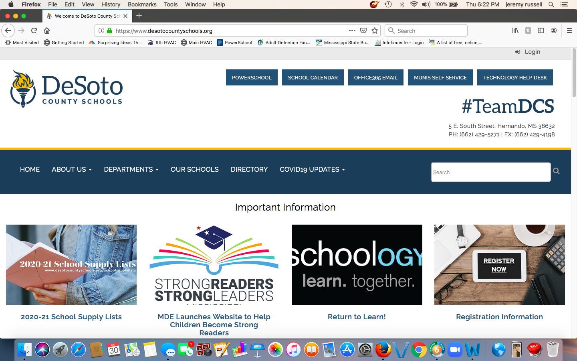

2. Choose Office 365 Email.

3. Enter your DCS Student email address. Students’ email addresses are constructed using the following formula:
- First initial of first name + first initial of last name + last 6 digits of their lunch number followed by @dcsms.org.
- Example: If Amy King’s lunch number is 1234567, her DCS student email address would be ak234567@dcsms.org.
- Password is setup as your school mascot + your date of birth (mmddyy).
- Example: Your school is Southaven High School and your birthday is July 8, 2004, your password is Chargers070804. (Capitalize only the first letter!)
- Note: you will enter email address and password on separate screens.

4. The next screen will list all of the applications within Microsoft Office 365. Choose Outlook.

