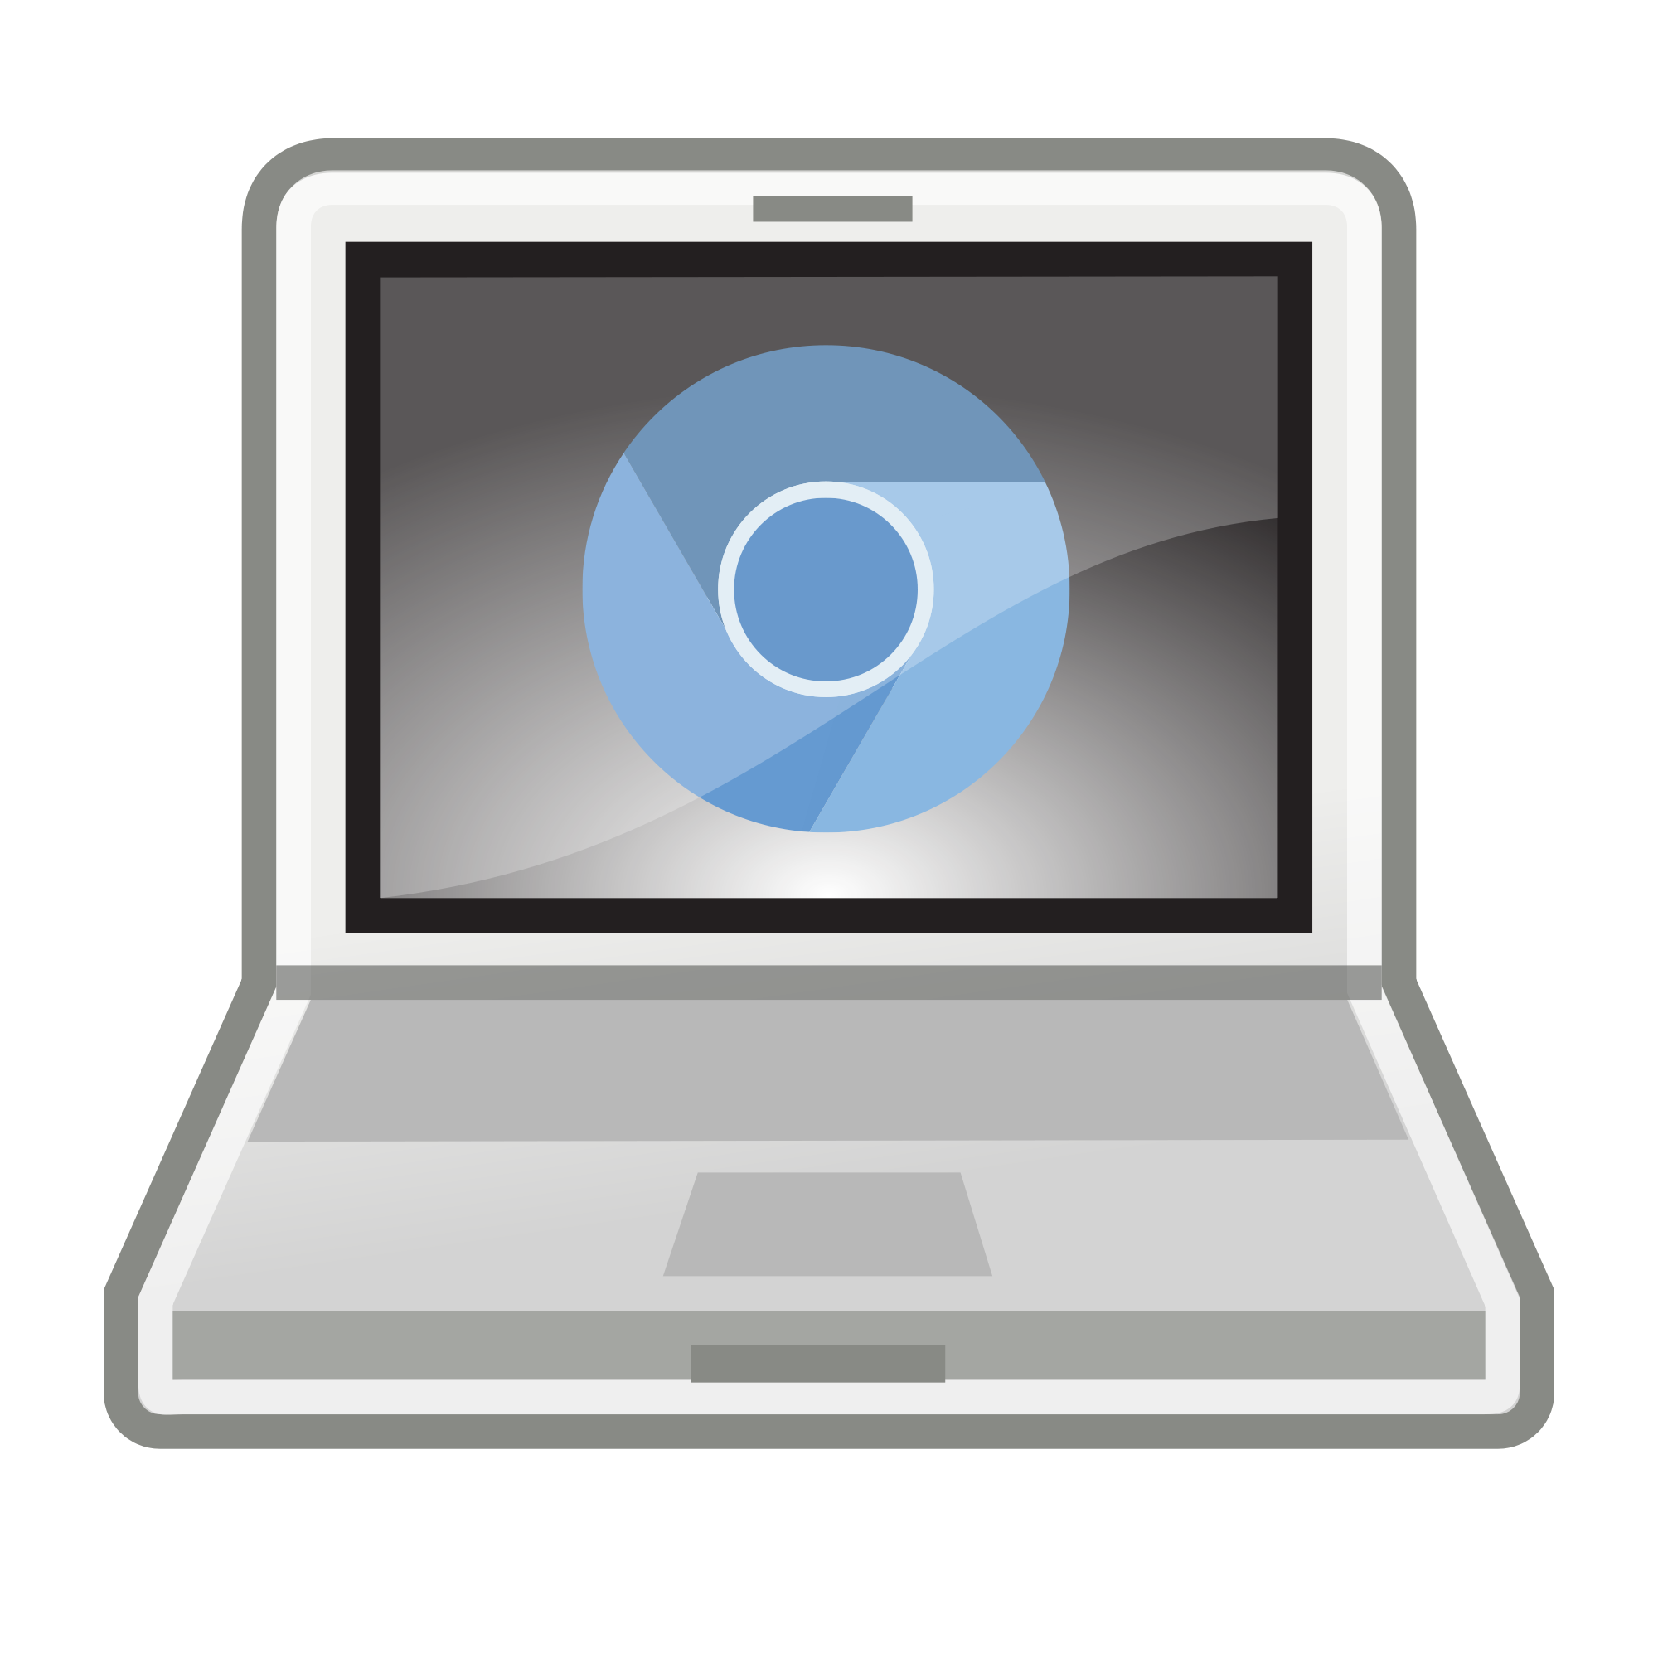

Tech Tip - Screencasting

October 12, 2020: Screencastify
Screencasting can be one of the most powerful tools in the educator’s tech toolbox. It may sound complicated and “tech-y”, but a screencast is simply a video and audio recording of your computer screen. Educators and students can use screencasting to create step-by-step tutorials, record demonstrations, or narrate presentations. For students using Chromebooks, one of the best screencasting tools is a Chrome extension called, Screencastify. Keep reading to find out how to use it with your students. More information may be found at our Fall Learning Journey Website from Lucie DeLabruerre.

Table of Contents
Install the Screencastify extension in Chrome
Adjust settings
Start a screencast
View your video
Share your video
Additional Features/Notes
Integration Ideas

How to use Screencastify…

STEP #1

Install the Screencastify extension in Chrome

Screencastify (Screen Video Recorder) - Chrome Web Store
- Click on the link above
- Click Add to Chrome
- Click Add Extension
- The Screencastify icon will be added to your extension toolbar (to the right of the address bar/omnibox)

STEP #2

Adjust settings

Allow Camera Access:
- Open Chrome
- Click in the extension toolbar
- Click SETUP CAMERA ACCESS
- Click Allow

Allow Google Drive Storage:
After you have allowed camera access, under Choose Where to Store Your Recordings:
- Select Google Drive
- Click SIGN IN
- Choose your account
- Click Allow
NOTE: Chrome extensions are associated with Google accounts. If you would like to use Screencastify with another Google account on the same device, you will have to follow the steps above to add it to each additional account.
Click here if you’d like to learn more about the difference between an app and an extension.

Allow Tab Recordings (optional):
After you have allowed Google Drive Storage, under Tab Recording (optional):
- Select SETUP TAB RECORDING
- Click Allow
NOTE: Even if you choose not to set up tab recording, you must click the checkmark to continue.

STEP #3

Start a screencast

Select recording type:
- Open Chrome
- Click in the extension toolbar
- Select TAB, DESKTOP, or CAM
  - TAB - if you only want to record the contents of one tab in your browser
  - DESKTOP - if you want to record everything on your desktop
  - CAM - if you want to record from your webcam

Select audio settings (optional):
- Select Microphone if you want to include your voice in the video
  - Click on the dropdown menu to select the microphone you’d like to use (choose Default if you’d like to use the built-in microphone on your laptop or Chromebook)
  - Click on the microphone icon to adjust the volume (opens slider)
- Select Tab/System Audio if you want to include any audio that would be played through your speakers
NOTE: If you intend to play a video in your screencast, do not select both options, as this will create an echo effect.

Select video settings (optional):  - Click on the 3 dots to the right of Video if you want to open the Advanced Options  - Limit Resolution - higher resolutions will result in a clearer picture and a larger file  - Countdown - adjust the length of the countdown timer (3, 5, or 10 seconds)  - Show tab drawing tools - tools include:  - Focus Mouse  - Hide cursor when not moved  - Pause/Resume recording  - End recording  - Mouse pointer  - Pen  - Eraser  - Wipe screen clear  - Embed webcam  - Hide tools  - Select Embed webcam if you want to include a picture-in-picture effect while recording from your webcam  - Click on the icon to the right to select where the webcam should be embedded in the video | 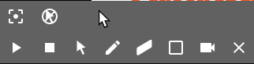  Tab Drawing Toolbar
Start recording:
- Click Record Tab/Desktop/Webcam

STEP #4

View your video

- Open Chrome
- Click in the extension toolbar
- Select Your Recordings
- (Optional) Rename your video by clicking on the name in the upper-left hand corner
- (Optional) Open the video from your Google Drive

NOTE: The ability to crop/edit your video is not available in the free version of Screencastify. If you’d like to edit your video, you can use the video editing tools in YouTube.

STEP #6

Share your video

From the Your Recordings window:
- Click
- Choose where you’d like to share:
  - Share on Google Drive
    - Click GET LINK
    - Adjust privacy settings
    - Copy link
    - Click Close
  - Share on YouTube
    - Add account
    - Select channel
    - Click Upload
  - Share to Classroom
    - Choose the class you’d like to share to
    - Choose the type of post
    - Click Go

Additional Features/Notes
- You can turn on an option to notify you if you are recording another tab than the one you are viewing
- You can configure shortcuts for using Screencastify. For example, Alt+Shift+S will open Screencastify and Alt+Shift+P will pause/start a recording while in Chrome.
- You can choose to optimize microphone audio for voice, which will eliminate background noise.
- Screencasts recorded with Screencastify Lite (free version) are limited to 10 minutes in length.

Integration Ideas
Teachers:
- Record lessons and post to Google Classroom for students who are absent or need reteaching.
- Record a lesson or directions to leave for a substitute when you are out.
- Record yourself editing student work as an exemplar of useful feedback.
- Create a screencast of a think-aloud while solving a problem and share with students on Google Classroom.
- Create a screencast of a demonstration for a new app or tool that you are introducing to students.
- Use screencasts to support your flipped classroom. Click here for more ideas.

Students:
- Record a Google Slideshow or other presentation with a voiceover.
- Create a screencast of a think-aloud, explaining reasoning while solving a problem.
- Record a vlog (video blog) on content you are learning in class.
- Create a screencast of a book review.

Additional Resources:
- Dozens of Tips and Techniques for Creating High Quality Engaging Screencasts
- Screencasting Resources and Rubrics (Kathy Schrock)
- Screencasting to Engage Learning

