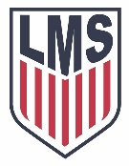
LMS Patriot Soccer ’20 – ‘21

Coach Acevedo
#13 Robert Becker
#5 Aiden Booth
#18 Jake Clayton
#21 Taylor Cook
#14 Logan Correro
#4 Ben Ellis
#15 Henry Gaschk
#9 Jake Hampton
#7 Asher Jackson
#17 Ben Lageman
#10 Miller Lashlee
#20 David Moore
#3 Om Patel
#19 Britton Purvis
#16 Cody Roberts
#11 Braxton Sharp
#6 Deyton Tedder
#1 Tyler Thorne
#2 Cal Wier
#22 Brody Williams
#8 Colby Williams
#23 Brody Whittaker

