Helpful Apps to Download
Here are some helpful apps for students I would highly recommend they download when using an iPad or a phone.

- Download the Microsoft Office app. This will give you access to your email. Through this app, you can quickly access your schoology account and your OneDrive.
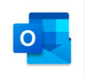

- Download the OneDrive app. This will help tremendously when downloading and submitting assignments. All students are given a OneDrive when given their school email. Through this you can save documents from Schoology and open them to edit. This also makes submitting the assignment much easier as you can uplaod directly from your OneDrive account.
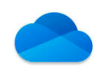

- Download the Microsoft Word app. Using the Word app, you will be able to open and edit word documents directly off your phone from your OneDrive and Schoology.
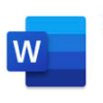

- Download the Schoology App. This will allow you to quickly get to your Schoology courses. You can use the app to post in discussions, look at assignments, and submit them.

