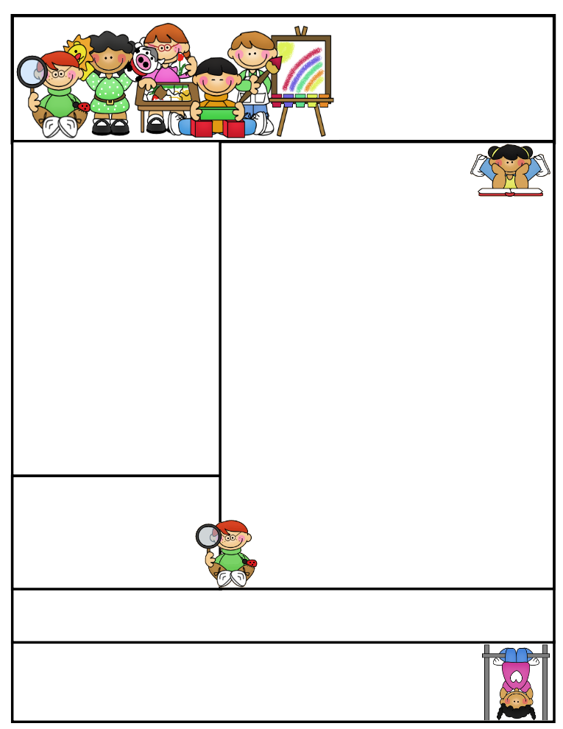

Classroom News

**This is our last full week before the Thanksgiving Holidays! We want to make sure that we make the most of each minute of the five instructional days we have left. Let’s strive for perfect attendance this final week of school in November!**

**Please remember to read each night. The last day to earn A.R. points for the second nine weeks is Friday, December 20th.**

Created by Ashley Magee Graphics © ThistleGirlDesigns.com

Mrs. James’

Second Grade

November 18 – November 22, 2019

**November Birthdays**

Addy- 16

Felicity- 18

Important Dates

**November 18th**

**November 19th**

Unit 3: Week 1 Skills Test

Math Mid-Chapter

**November 20th**

**Early Dismissal @ 12:30**

**November 21st**

Vocabulary and Selection Test

Language Test

**November 22nd**

Spelling and Dictation Test

Weekly Reading Test

**November 25th- 29th**

**Thanksgiving Holidays**

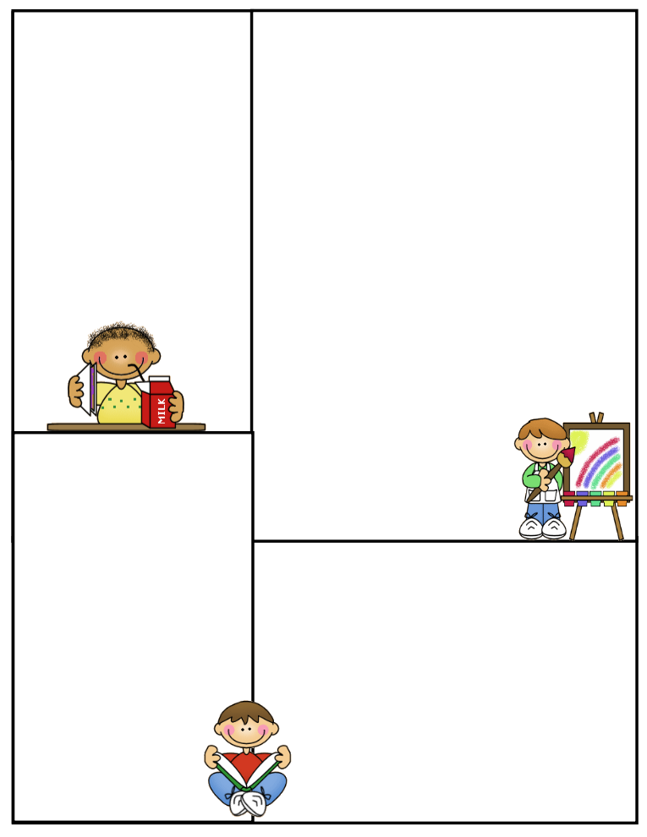

Menu

Breakfast/ Lunch

**Tuesday: 11/19**

Pop Tart/ Ham and Cheese

**Wednesday: 11/20**

Yogurt/ Hotdog

**Thursday: 11/21**

Breakfast Burrito/ Turkey and Dressing

**Friday: 11/22**

French Toast/ Chicken Nuggets

**Monday: 11/25**

NO SCHOOL

**Sweet Water High School**

**440 Main Street**

**Sweet Water, AL 36782**

**Phone: 334-994-4263**

**Brittany L. James**

[**bjames@marengo.k12.al.us**](mailto:bjames@marengo.k12.al.us)

**Cell: 251-978-9374**

Homework

**Monday, November 18th -**

**Reading:** Study Vocabulary Words (p. 196-197 R/WW), Review High Frequency Words (HFW), Read Starry Night (p.198-203 R/WW)

**Spelling:** Study Words

**Language:** Present Tense Verbs

**Math:** Lesson 4.6, Fact Practice

**Tuesday, November 19th -**

**Reading:** Study Vocabulary Words (p. 196-197R/WW), Review High Frequency Words (HFW), Mr. Putter and Tabby See the Stars (p. 232-251 LA)

**Spelling:** Study Words, Spelling Activity

**Language:** Present Tense Verbs

**Math:** Lesson 4.7, Fact Practice

**Wednesday, November 20th -**

**Reading:** Study Vocabulary Words (p. 196-197R/WW), Review High Frequency Words (HFW), Mr. Putter and Tabby See the Stars (p. 232-251 LA)

**Spelling:** Study Words, Spelling Activity

**Language:** Present Tense Verbs

**Math:** Lesson 4.8, Fact Practice

**Thursday, November 21st -**

**Reading:** Study Vocabulary Words (p. 196-197R/WW), Review High Frequency Words (HFW), Day to Night (p. 252-255 LA)

**Spelling:** Study Words, Spelling Activity

**Language:** Present Tense Verbs

**Math:** Lesson 4.9, Fact Practice

**Note:**

R/WW (Reading Writing Workshop)

LA (Literature Anthology)

**Newsletter Template**

Customize the newsletter template to meet your classroom needs. Click inside a box to type your information. Change the boxes to whatever you’d like to include!

Visit my blog for more freebies and lesson ideas:

<http://firstgradebrain.blogspot.com>

Visit my TeachersPayTeachers store for more products:

<http://www.teacherspayteachers.com/Store/Mrs-Magee/Products>