EQT Alignment Sheet – Quarter 3
Course: Math 8

 | ALCOS Standard |  | # of Questions |  | Textbook Alignment
 | 16. Verify experimentally the properties of rotations, reflections, and translations. [8.G.1]  - Lines are taken to lines, and line segments are taken to line segments of the same length. [8. G.1a]  - Angles are taken to angles of the same measure. [8.G.1b]  - Parallel lines are taken to parallel lines. [8.G.1c] |  | 2  2  2 |  | Lesson 18
Sample Problems for Standard #16 (8.G.1)

1. A line segment has endpoints at (1, 3) and $(3,1)$ . If the line segment is translated 2 units up and 2 units to the right, what are the new coordinates of the second point?
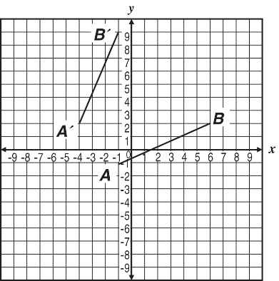
2. Segment $\overline{A'B'}$ is a transformation of segment$\overline{AB}$ . How could you describe that transformation?

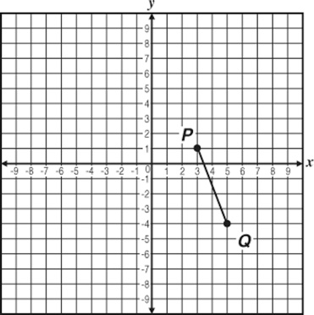
3. Given line segment $\overline{PQ}$ shown at right, what is the result of reflecting the line segment over the x-axis?

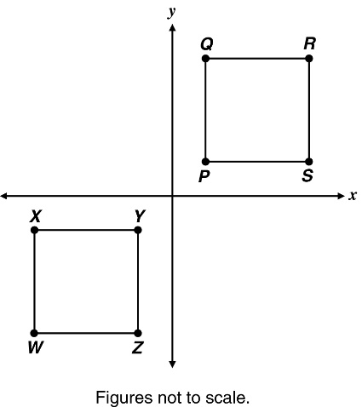
4. Quadrilateral PQRS is rotated 180° about the origin. Which angle in Quadrilateral WXYZ must necessarily measure the same as Angle Q?

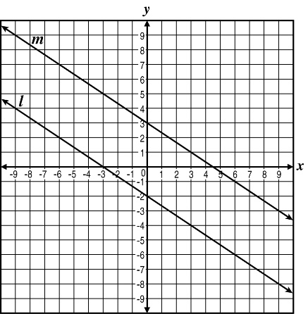
5. Line l was mapped to Line I as shown in the graph below. What transformation was applied to line l to produce line m?

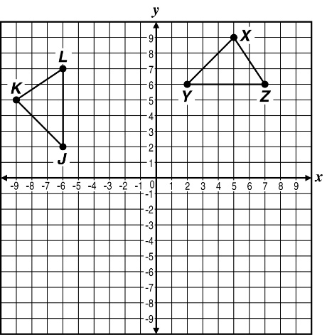
6. Triangle XYZ is rotated 90° counterclockwise about the origin to form triangle KJL as shown below. Which angle in triangle KJL must necessarily measure the same as angle Y?

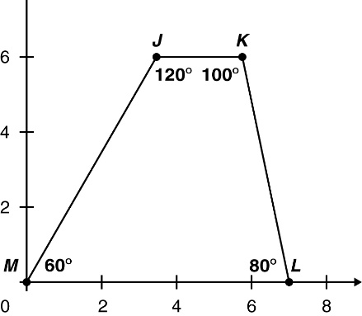
7. Quadrilateral JKLM is rotated 90° clockwise about the origin to produce Quadrilateral J'K'L'M'. What is the measure of angle M′?

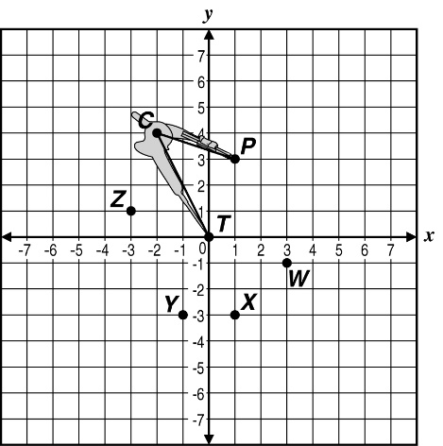
8. An architect is planning part of a new construction project using a compass as shown below. If the architect rotates the compass 90° clockwise about the tip, T, to which point on the graph will the endpoint, P, rotate?

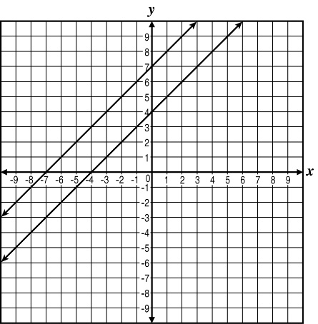
9. Two parallel lines are shown on the coordinate plane. If these lines are rotated 90° clockwise about the origin, which statement is true?

I. The points where the two lines intersect the x-axis remain the same.
II. The points where the two lines intersect the y-axis remain the same.

 | ALCOS Standard |  | # of Questions |  | Textbook Alignment
 | 17. Understand that a two-dimensional figure is congruent to another if the second can be obtained from the first by a sequence of rotations, reflections, and translations; given two congruent figures, describe a sequence that exhibits the congruence between them. [8.G.2] |  | 3 |  | Lesson 19
Sample Problems for Standard #17 (8.G.2)

1. Given $∆ABC$ with vertices A(-5,-1), B(-2,3), and C(5,-1) is translated to $∆DEF$ with vertex E located at the origin, describe the translation.
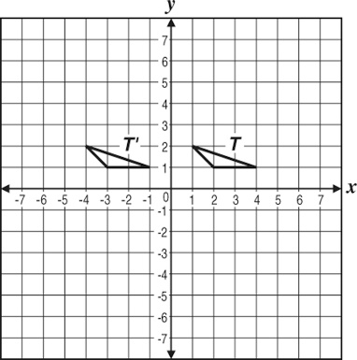
2. Triangle T is translated to triangle T′. What is the translation from T to T′?

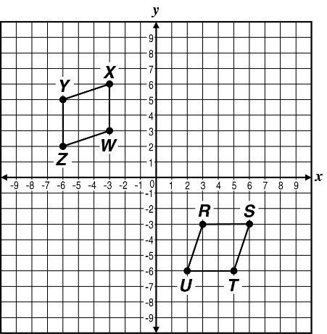
3. Describe the set of transformations on figure RSTU that would result in figure WXYZ.

ALCOS Standard |  | # of Questions |  | Textbook Alignment
18. Describe the effect of dilations, translations, rotations, and reflections on two-dimensional figures using coordinates. [8.G.3] |  | 5 |  | Lessons 19 & 20
Sample Problems for Standard #18 (8.G.3)

1. The image of rectangle PQRS reflected across the y-axis is rectangle P′Q′R′S′. If point P is located at (-10,3), what will be the coordinates of point P′?

2. Triangle JKL has vertices J(-3,5), K(-1,-4), and L(2,4). If triangle J′K′L′ is the result of the dilation (x,y) → (3x,3y), what would be the coordinates of point J′?
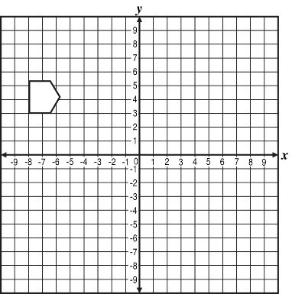
3. The pentagon in the graph will be reflected about the y-axis and then translated 8 units down. Graph the pentagon after the sequence of transformations.

4. Quadrilateral ABCD has vertices A(-8,4), B(2,8), C(8,-4), and D(-4,-2). If ABCD is dilated about the origin using a scale factor of ½ to make quadrilateral A′B′C′D′, what will be the coordinates of A′, B′, C′, and D′?

5. Triangle ABC has vertices at A(-5,4), B(-5,1), and C(-2,1). If ABC is translated 6 units to the right and 5 units down, what will be the coordinates of the vertices of the translated image of triangle ABC?

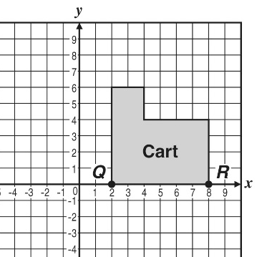
6. Triangle ABC has vertices at A(3,4), B(5,4), and C(3,8). After a single rotation of triangle ABC, the image has point C′ located at (7,4). Describe the rotation that was made.

7. Chef Carson had a moveable cart in his kitchen. A top view of the cart’s location within the kitchen is shown on the grid at right. Chef Carson rotated the cart to move it next to his vegetable baskets. On the grid, this would be represented by a 90° counterclockwise rotation of the figure around point R. What are the coordinates of the location of point Q after this rotation?

ALCOS Standard |  | # of Questions |  | Textbook Alignment
19. Understand that a two-dimensional figure is similar to another if the second can be obtained from the first by a sequence of rotations, reflections, translations, and dilations; given two similar two-dimensional figures, describe a sequence that exhibits the similarity between them. [8.G.4] |  | 3 |  | Lesson 20
Sample Problems for Standard #19 (8.G.4)

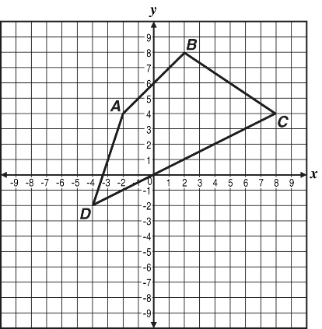
1. Triangle ABC has points A, B, and C located at (3,6), (-2,2), and (6,-4), respectively. Triangle DEF is a dilated image of triangle ABC. Point D is located at (9,18). What is the scale factor for the dilation of triangle ABC?

2. Quadrilateral ABCD is dilated about the origin to form A′B′C′D′ with A′ located at (-3,6). What is the scale factor?

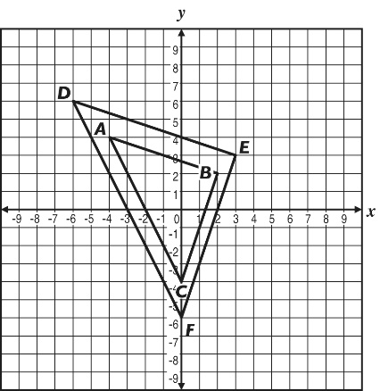

3. What is the scale factor from triangle ABC to its image DEF?

4. Right triangle ABC is similar to right triangle DEF. If the side lengths for triangle ABC are 15, 20, and 25, respectively, find values that could represent the side lengths of triangle DEF.

5. The front of a box and the sticker label on it are similar rectangles. The front of the box has a width of 9 inches and a length of 12 inches. Find values that could represent the dimensions of the sticker label.

ALCOS Standard | # of Questions | Textbook Alignment
20. Use informal arguments to establish facts about the angle sum and exterior angle of triangles, about the angles created when parallel lines are cut by a transversal, and the angle-angle criterion for similarity of triangles. [8.G.5] | 5 | Lesson 21 & 22
Sample Problems for Standard #20 (8.G.5)
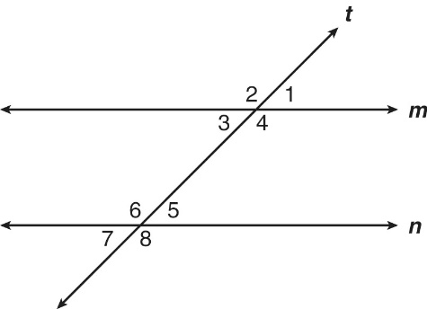
1. Parallel lines m and n are cut by transversal t as shown. Identify the following.
(A) All pairs of congruent angles.
(B) All pairs of supplementary angles.

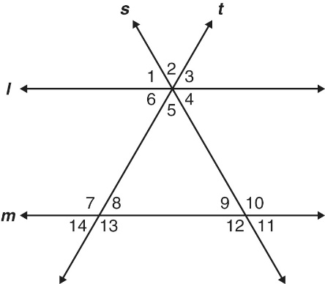
2. Given l || m and lines s and t are transversal through both l and m. Identify the following.
(A) Two pairs of vertical angles.
(B) Two pairs of corresponding angles.
(C) One pair of alternate interior angles.
(D) The angle whose measure is equal to the sum of the measures of angles 5 and 9.

3. What is the relationship among $m∠$BCD, $m∠$A, and $m∠$B in the figure below?

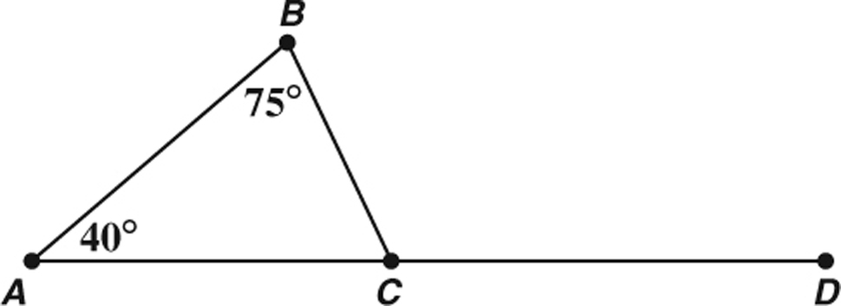

ALCOS Standard | # of Questions | Textbook Alignment
21. Explain a proof of the Pythagorean Theorem and its converse. [8-G6] | Not tested on this assessment. | Lesson 23
ALCOS Standard | # of Questions | Textbook Alignment
22. Apply the Pythagorean Theorem to determine unknown side lengths in right triangles in real-world and mathematical problems in two and three dimensions. [8-G7] | 5 | Lesson 24
Sample Problems for Standard #22 (8.G.7)

1. Is it possible for a 48 inch piece of glass to fit through a window measuring 36 in by 27 in? Justify your answer.

2. A triangle has sides that 5 ft, 7 ft, and 8 ft. Is this triangle a right triangle?

3. What is the length of a diagonal of a square that has sides that are 60 ft long?

4. The length of the hypotenuse of a right triangle is 2.0 ft. The length of one of the legs of this triangle is 1.2 ft. What is the length of the other leg of the right triangle?

5. Mr. Torres is building a rectangular patio with side lengths of 8 ft and 15 ft. What should be the length of the diagonal to ensure that the corners are perpendicular?
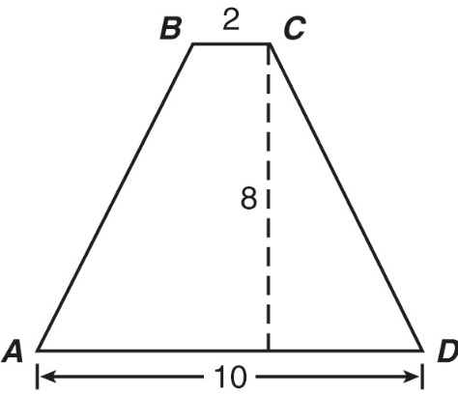
6. The figure at right is an isosceles trapezoid with an altitude of 8 in. What is the length of $\overline{AB}$?

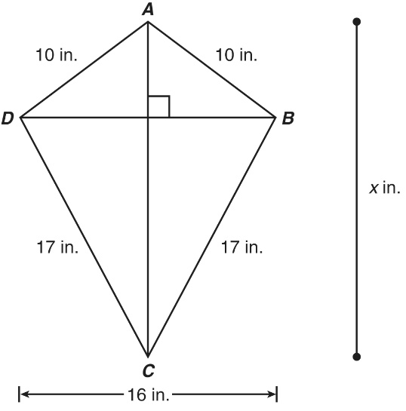
7. In kite ABCD at right, AB = AD = 10 inches, CB = CD = 17 inches, and DB = 16 inches. Find $\overline{AC}$.

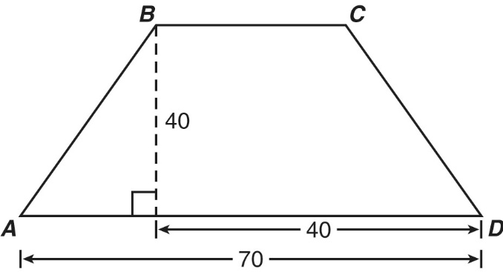
8. Trapezoid ABCD is shown at right. What is the length of $\overline{AB}$ ?

9. A ladder is leaning against a building. The base of the ladder is 5 feet from the building, and the top of the ladder reaches 10 feet high on the building. What is the length of the ladder?

