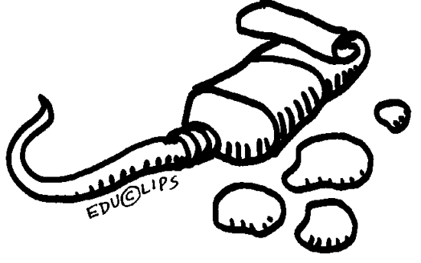
Mrs. Boggs’s 4th-8th
Art Class Contract

I, _______________________________________, in _________________________________________
(Your Name PRINTED) (Your Homeroom)
understand that I will receive grades for my work based on different variables in the art classroom. These may include but are not limited to:
- In Class Projects (such as drawings, paintings, sculptures, etc.)
- In Class Assignments (Art Starts, worksheets, BrainPOP activities, Exit Tickets, etc.)
- Homework (If assigned, I will have ONE WEEK to return it by my next art class or will have my grade lowered unless other arrangements are made with Mrs. Boggs PRIOR to the due date.)
- Class Participation (Do I answer questions? Clean up my work area? Follow Directions? Am I respectful of others? etc.)
I also understand that by not doing or not turning in these assignments by the due date can result in a lowering of my overall grade. My art grade WILL affect Honor Roll (4-6) or Beta Club (7-8). I will receive a letter grade on my grade card every six weeks.

Other Expectations:
- I understand that trying to pass other people’s work off as my own is considered CHEATING and is a serious offense, thus resulting in a zero for that assignment and appropriate disciplinary action. (This includes doing someone else’s work for them!)
- I agree to respect the materials provided for my use by not wasting, damaging, or misusing them. I understand that misuse refers to the use of materials that I have been given to use or using the materials as toys, projectiles, or weapons or using materials to create items other than those assigned.
- I agree to ask questions when something doesn’t make sense or to seek help when I feel overwhelmed or confused.
- I understand that clean up is an important part of art class and I am responsible to clean up my own mess.

I have read ALL the above information and agree to work hard and do my best during my time in Mrs. Boggs’s classroom.

__________________________________________ ____________________________
Your Signature Mrs. Boggs

