Monday April 27th
Mini-lab
GET OUTSIDE, but use social distancing!!!
Today we want you to get outside and take 2-4 pictures of things in nature. Then label which process (photosynthesis/Cellular Respiration) the organisms in your pictures MAINLY use. Then post on Twitter
@CoachColemanLHS
@TheBurgScience #TeamDCS

OR send it directly to me by Remind or Email

Example: Lilah – Cellular Respiration
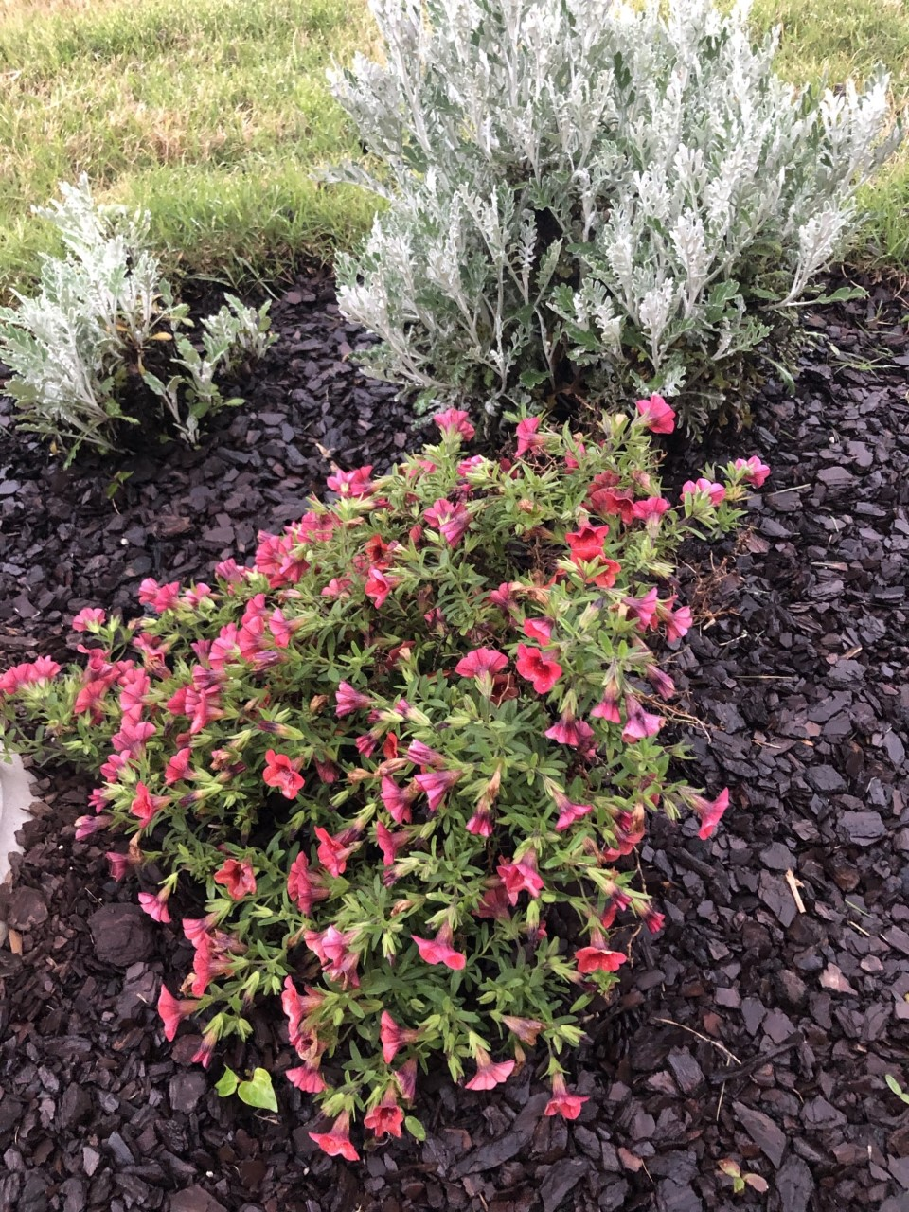 Photosynthesis

