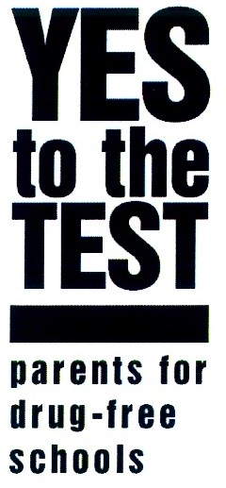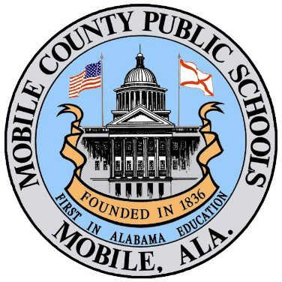

**Drug Free Schools Program**

**Consent and Release Form**

I, (Print student’s name), have read the

Drug Free Schools information provided and agree to abide by the Mobile County Public School System’s Drug Free Schools Program rules and regulations. I understand that I will not be penalized in any way for participating in this program.

(student Initials) I volunteer to submit to drug testing in accordance with the rules and

regulations of the Drug Free Schools Program.

I do hereby give my consent to the Mobile County Public School System to collect a specimen from me,

and I further give my consent to the Mobile County Public School System to forward the sample(s) to the testing laboratory for its performance of appropriate tests thereon to identify the presence of drugs and then to transmit the results to the Mobile County Public School System’s Medical Review Officer (MRO).

I authorize the testing laboratory or MRO to release test results to the Mobile County School System Drug

Free Program Liaison.

I also expressly authorize the Mobile County Public Schools System or its MRO to release any test-related

information, including positive results as directed by my specific, written consent authorizing release of the information to an identified person.

I understand that refusal to submit to testing or a positive adulterated test result will be reported to the

parent and principal.

Student Printed Name

Student Signature

School Name

Parent Signature

Date