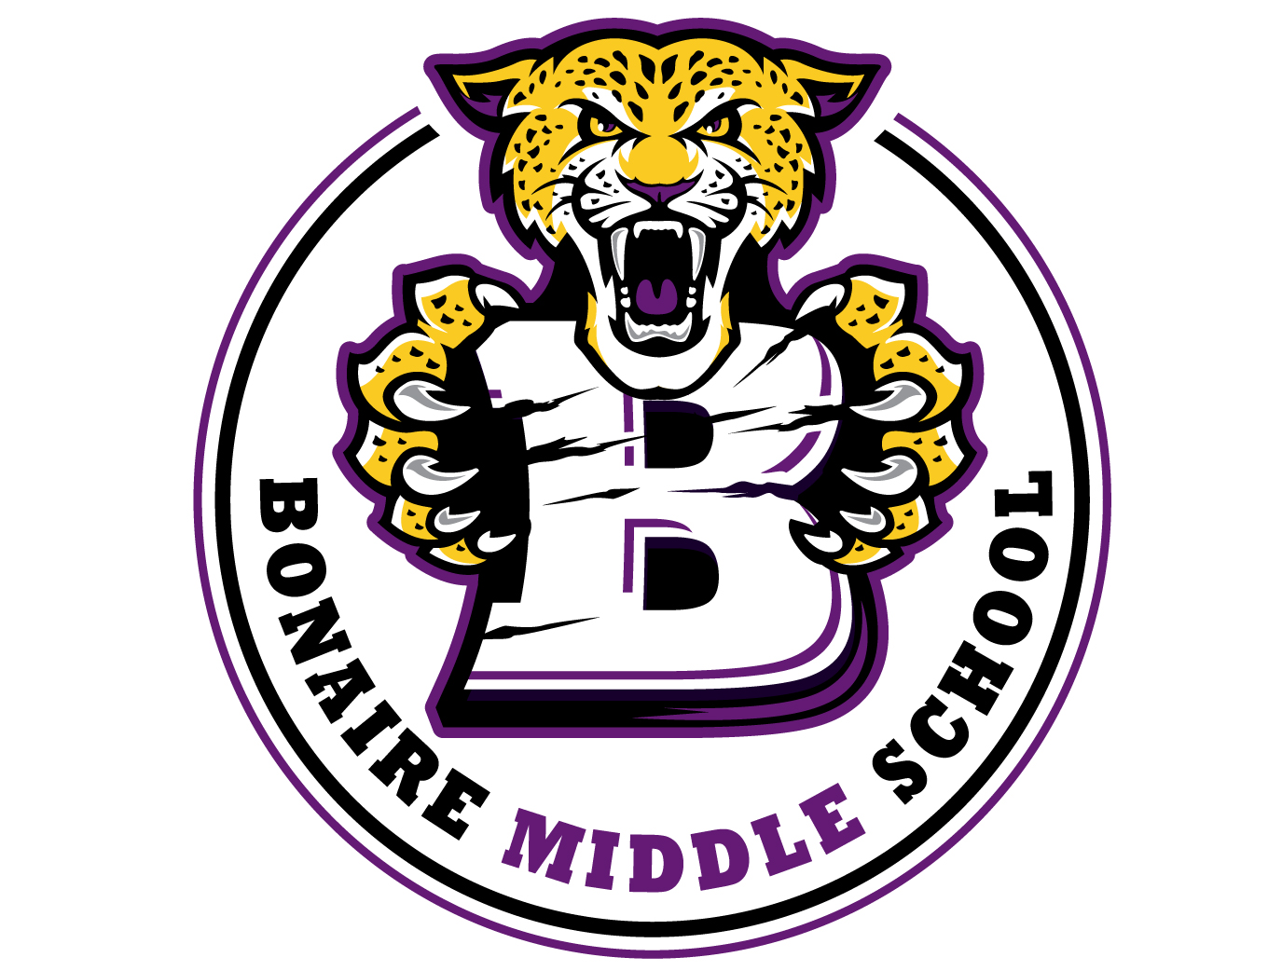
Bonaire Middle School
October 5 – 8 (Friday Student Holiday)
8th Grade Virtual Learning
**Be sure to check in at BMS Virtual Homeroom weekly**
**Be sure to check Odysseyware Messages DAILY**

 | Lessons in Odysseyware | Zoom Lesson & Topic | Google Classroom
1st Period  Science  7:30 – 9:00 | 8th Grade Gifted Lessons:  Thermodynamics and Entrophy  Specific Heat Capiacity  Heat Flow  8th Grade Science Lessons:  Unit 2 Test | Ms. Rollins – 8th Grade Gifted Science  Heat Flow/ Conduction, Convection, and Radiation  Monday and Thursday 8:00 – 8:30 am  Ms. Rollins - 8th Grade Science  Unit 2 Test Prep  Monday and Thursday 7:30 – 8:00 am  Mrs. Shore – Monday through Friday 7:30-8:15  Mrs. Shore - 8th Grade Science  Monday through Friday 8:15-9:00  Ms. Knowland - 8th Grade Science  Unit 2 Test Prep  Tuesday 12:20 – 12:50 pm | No  No  No  See Google Classroom for notes and reviews.
2nd Period  Language Arts  9:00 – 10:20 | Monday, 10/5 - 10/6:  Lesson 17: Elements of Speech and Spellings  Wednesday, 10/7 - 10/8:  Lesson 18: Homophones  Friday, 10/9:  NO SCHOOL | Mrs. Kessler and Mrs. Ethridge --  Tuesday, 9/29 and Friday, 10/2  9:00-9:30  Tuesday Zoom Topic: Using Text Evidence  Friday Zoom: NO SCHOOL/ZOOM TODAY  (Group A students you will stay until 9:45 on Tuesdays and Fridays, and you will meet every day for attendance, feedback, and help navigating lessons.)  Mrs. Ethridge’s meeting ID and Passcode for classes that are not cotaught were emailed separately. They will also be posted in students OW. We meet every day for attendance, feedback, and help navigating lessons 9:45-10:30.)  ~~~~~~~~~~~~~~~~~~~~~~~~~~~~~~~~~~~~~~~~~~~~Mrs. Chapman 9:30am  Tuesday: Using Text Evidence  Friday: NO SCHOOL/ZOOM TODAY  *Meeting ID and Passcode were sent via OW. | For all 8th ELA classes in Google Classroom:  Recorded instruction for Monday’s concept on conjunctive verb mood.  Additional resources for the lessons assigned also available on Google Classroom.  ~~~~~~~~~~  Mrs. Chapman:  8 ELA Gifted/ Honors:  Please See Google Classroom Posts and Supplements
3rd Period  Social Studies  10:20 – 11:45 | Continuing of Unit 4: STATEHOOD  Monday (10/5): “Georgia’s Growth: Pt. 1”  Tuesday (10/6): “Georgia’s Growth: Pt. 2”  Wednesday (10/7): “Review”  Thursday (10/8): “Unit 4 Test”  Friday (10/9): No School | Mrs. Chapman 10:30am  Tuesday: Discussing Georgia’s Growth Pts. 1 & 2 & Review for Unit 4 Test (this meeting will be longer than usual)  Friday: NO SCHOOL/ZOOM TODAY  *Meeting ID and Passcode were sent via OW.  Mrs. Washington & Mrs. Ford  Monday & Thursday  11:15 – 11:45 a.m.  *Meeting ID and Passcode was sent in a message in OW.  Monday: Discussing Georgia’s Growth Pts. 1 & 2  Thursday: Review for Unit 4 Test | Mrs. Chapman:  8 Soc St. Gifted/Honors:  Please See Google Classroom Posts and Supplements (Posts for this week’s GC tasks were made the prior week to give you extra time due to holiday.)  _______________  Unit 4 Test Review Notes on GC will be uploaded Thursday morning
4th Period  Connections and Lunch  11:45 – 1:15 | BCS: BUSINESS TECHNOLOGY & COMPUTER FUNDAMENTALS  Finish up with Unit 3  Lessons:  9/28 through 10/02  Lab Safety  Equipment Maintenance  Quiz 1  Health 8A:  All course work must be completed by 10/7/20  PE 8A:  All course work must be completed by 10/7/20 | BCS Last names beginning with A-L will Zoom at 12:00 p.m. & M-Z at 12:30 on Wednesdays  Wednesdays 12:00PM-12:30PM & 12:30PM-1:00PM  Health 8A: Wednesdays: 1:00  PE 8A: Wednesdays: 1:15 | Wednesday Only:  Complete the Second Step Video
5th Period Math  1:15 – 2:40 | 8th Math Lessons: Due by 10/9  Exponents, Scientific Notation, Roots Unit 2  - Exponents  - Exponents  - Exponents 1  - Exponents 2  - Exponents 3  - Exponents and Order of Operations  - Exponents and the Order of Operations  - Quiz 2: Operations with Exponents  Algebra Lessons:  Slope Intercept Form  Writing Linear Equations (1)  Writing Linear Equations: Slope Intercept and  General Form  Writing Linear Equations with Given Points | Mrs. Batdorf  8th Math Zoom: 2:00 – 2:30 On Monday and Thursday  Exponents, Scientific Notation, Roots  Use the Zoom ID sent in Odysseyware  Ms. Knowland – Algebra  Writing Linear Equations  Tuesday 12:50 – 1:20 pm | See Google Classroom for REVIEW Notes, Videos and Assignments.  See Google Classroom for reviews
- Only complete the assignments listed for the week. Please do not follow the due date listed in Odysseyware.

