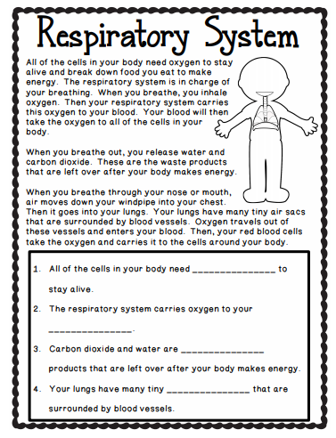
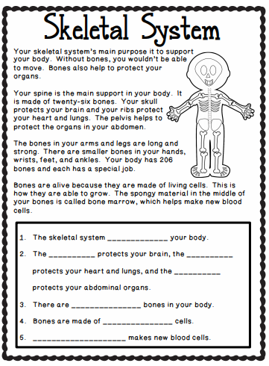https://www.youtube.com/watch?v=orBPWc1rze8 (skeletal system) https://www.youtube.com/watch?v=mOKmjYwfDGU (respiratory system)
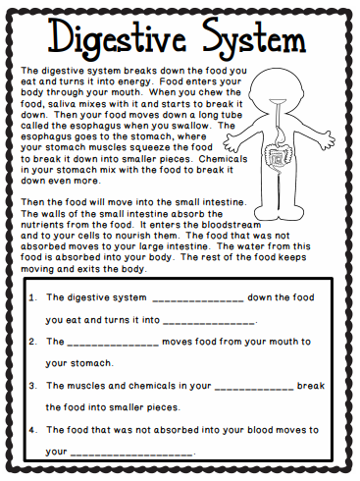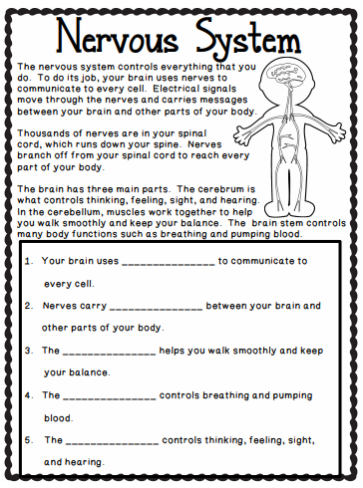
https://www.youtube.com/watch?v=ZBZWgrfZFbU (the digestive system) https://www.youtube.com/watch?v=FssFyeKRCic (the nervous system)

