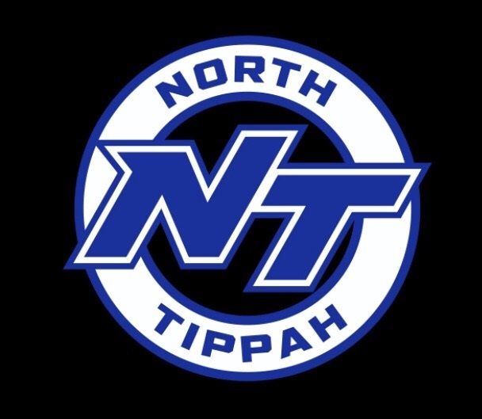

North Tippah School District
Safe Return to In-Person Instruction
and
Continuity of Services Plan
2021-2022

ACADEMIC PROGRAMMING
- North Tippah School District will offer traditional face-to face instruction Monday-Friday as its main method of teaching.
- Credit recovery; tutoring, both during and after school; summer school; and extended school year will be offered to assist students who may need additional support and help outside the normal classroom setting due to absences as a result of COVID-19.
- Remediation methods and strategically organizing content to correct gaps in learning levels.
- In the event of closure, NTSD will continue academic learning and instruction delivery through Google Classroom or other similar services for lower-elementary students, upper-elementary, middle and high school students.
- All services to Special Education will be provided in accordance with applicable laws and guidelines.

PROGRESS MONITORING
• The District will monitor student progress with the use of universal screeners in math and reading in grades K-8 and universal screeners in behavior, state assessment data and benchmark assessments in grades K-12.
• The District will send progress reports in the middle of each 9 weeks.

OPERATIONS
Transportation
- Schools in the NTSD will return to a five-day schedule.
- Bus transportation will continue. Students will be separated on the bus where feasible. Siblings or children living in the same household will be seated together where feasible.
- Buses will have hand sanitizer.

Cafeteria
- Parents are strongly encouraged to use My School Bucks for cafeteria payment in an effort to reduce the need to exchange money and reduce the spread of germs.
- Hand washing opportunities and hand sanitizer will be available before and after breakfast and lunch.
- Students will eat breakfast and lunch in shifts that will encourage social distancing.
- Cafeterias will be appropriately disinfected after each use.

Academic Calendar
● Teachers will begin school on August 2-4, 2021.
● Students will begin school on August 5, 2021.
● The last day of school for students will be May 23, 2022.
● Graduation will be announced at a later date.
● Professional Development days for teachers (no students) will be on August 2-4, 2021; October 13, 2021; January 3, 2022; February 21, and May 24, 2022.

● Holidays will be as follows:
- Labor Day – September 6, 2021
- Fall Break – October 11-13, 2021
- Thanksgiving Holidays – November 22 – 26, 2021
- Christmas Holidays – December 18, 2021 – January 3, 2022
- Martin Luther King, Jr. Holiday – January 17, 2022
- President’s Day – February 21, 2022
- Spring Break - March 7-11, 2022
- Good Friday – April 15, 2022.

FAMILY AND COMMUNITY SUPPORT
- The district will maintain communication through its website, Facebook, and AIM messages. Teachers and administrators will provide assistance as requested by parents.
- The District will provide academic support to families by providing tutoring, parent nights and/or PTO meetings at each school.
- Feedback will be gathered via surveys through its website, and Facebook page.

COMMUNICATION
- The district will maintain communication through its website, Facebook, and AIM messages. Schools will also send home printed letters as needed.
- The District will utilize local media news outlets and social media networks, including websites and Facebook, AIM messaging, letters, emails and newsletters to communicate health and safety issues or necessary changes to the District’s regular operating schedule.

HEALTH AND SAFETY
- School districts must follow all guidance issued by the Mississippi Department of Health regarding quarantines. No guidance for the 2021-2022 school year has been issued at this time from the Mississippi Department of Health.
- Students are encouraged to bring their own water bottles from home. During the 2021-2022 school year, all schools will utilize water bottle filling stations.
- Due to a waiver from the United States Department of Agriculture (USDA), all students will be eligible for free breakfast and lunch during the 2021-2022 school year.
- The District will only require masks or other face coverings if mandated by the Governor of the State of Mississippi or local authorities in conjunction with suggestions from the CDC and the Mississippi State Department of Health.
- All parents, students, and faculty will immediately notify the district if they have tested positive for coronavirus or been exposed to someone with coronavirus.
- Students or faculty with a 100 plus temperature will be isolated from the general population, and it will be mandatory that they wear a mask that the school will provide. Parents will be contacted to come pick the child up from school, and faculty members will be sent home immediately. It is at the parent’s discretion that the child be tested for COVID-19. Students and faculty will not be allowed back to school until after the fever is gone for 24 hours. Students will be required to wear the mask until they leave the building.
- If there is a high number of coronavirus cases at one time, then the district may choose to quarantine the class or close school for 14 days or CDC guidelines. If this happens we will transfer to distance learning for the time school is closed, and all extra-curricular activities will be suspended until we return to school.
- Hand sanitizer stations will be available on buses, in classrooms, and in restrooms.
- The District is replacing HVAC systems at each school. The new systems will include air purification systems that kill the virus that causes COVID-19 as well as other viruses.
- The District is replacing carpeting in areas to improve air quality and reduce the amount of pollutants in rooms.
- Restroom flush valves and sinks will begin to transition to hands free.
- Counselors will be available at each school to help address the social, emotional, mental health, and other needs of students and staff.
- Healthy behaviors to prevent virus spread will be promoted via the district website, social media and via posters in hallways and in classrooms.
- Teachers will review periodically with students healthy behaviors in the classroom and school environment.
- Facility areas and buses will have assignments to be cleaned regularly.

TECHNOLOGY
- All students and faculty will have access to technology to support in-person and remote learning.
- The District has Chromebooks for each student’s use.
- The District will identify the professional learning needs of staff in utilizing technology to enhance in-person learning and support remote learning via feedback from surveys.
- The District provides professional development based on these surveys.
- The District uses Google’s array of programs, such as Google Classroom, Google Docs and email.

EXTRACURRICULAR ACTIVITIES
- The North Tippah School District will follow the guidance of the Mississippi High School Activities Association, the Mississippi Department of Education, and the Mississippi Department of Health in reference to extracurricular activities.

CONTINUITY OF SERVICES
- The North Tippah School District will continue services such as school breakfast and lunch, academic interventions, and social/emotional support should a school close for outbreaks or other circumstances.

REVISION OF PLAN
- This plan will be reviewed every six months and revised as appropriate.

