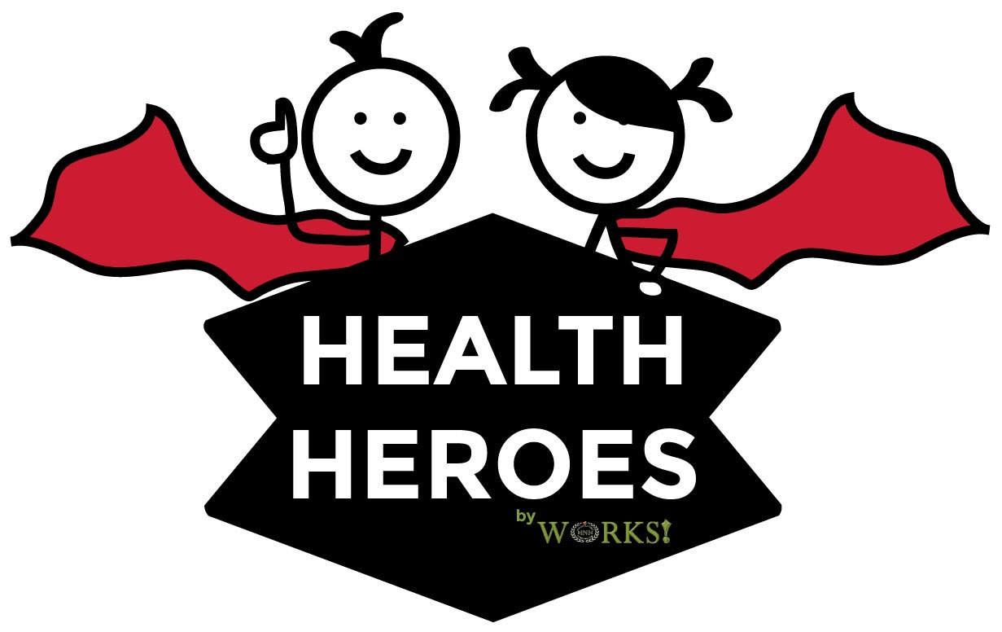

2019-20 School Year

Dear Parent/Guardian,

In partnership with Health Heroes USA, it is our pleasure to offer on-site flu vaccinations to students this year on October 23rd-25th 2019. Flu clinics will be offered at each school location (on one day only during this period) during school hours. Health Heroes flu vaccination clinics are completely voluntary. Baker High School is scheduled for October 23, 2019.

Why get a flu vaccine?
The best way to minimize or avoid the spread of flu is to get an annual flu vaccination. Each year the vaccine protects against new strains, therefore, the vaccine should be administered annually.

Who is Health Heroes, Inc.?
At Health Heroes, we specialize in on-site vaccination clinics. Vaccines are provided at NO COST to students, parents, schools or local/state government. We bill both Medicaid and private insurance; however, we never bill students or parents for any out-of-pocket expenses or deductibles. Qualifying uninsured students will be given the vaccine, free of charge. Although student participation is voluntary, these vaccinations are recommended to help keep schools healthy and cut down on high absenteeism.

Students under PEEHIP will not be given the flu vaccine through Health Heroes. See note below.
What type vaccines will be given?
IIV-4 injections will be available to all consented children who do not have any contra-indicators. All vaccines given are preservative-free, mercury-free, Thimerosal-free and administered by state-licensed nurses.

What do you need to do to participate?
If you wish for your child to participate, please COMPLETELY fill out and sign a consent form. These forms need to be returned to school as soon as possible to secure a dose for your child.

If you have additional questions or concerns, please contact the School Nurse. You can also find more information at www.healthherousa.com. We hope to see your child in clinic!

Thank you!

Note:
Employees who want their child to be given the flu shot will need to have the PEEHIP permission form filled out and turned in. PEEHIP will send their own staff, using the same schedule to administer these vaccines.

