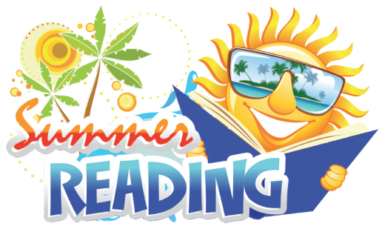 **4th Grade Summer Reading List**

We want to encourage all of our students to read, read, and read! Below is a list of suggested books for your child to read this summer. Your child will be able to get a head start on earning AR Points, by taking AR tests on the books they read when school begins in August.

The Magic Tree House Series, Mary Pope Osborne 2.0 - 3.5

Freckle Juice, Judy Blume 3.1

How to Eat Fried Worms, Thomas Rockwell 3.5

I Survived Series, Lauren Tarshis 3.9

Because of Winn-Dixie, Kate DiCamillo 3.9

Satch & Me, Dan Gutman 4.1

Charlotte’s Web, E.B. White 4.4

The Chocolate Touch, Doris Gates 4.7

The Family Under the Bridge, Natalie Carlson 4.7

Henry Huggins, Beverly Cleary 4.7

Strawberry Girl, Lois Leenski 4.8

Where the Red Fern Grows, Wilson Rawls 4.9

The Lion, the Witch, and the Wardrobe, C.S. Lewis 5.7

Diary of a Wimpy Kid or Dork Diaries 5.0 - 6.0