Twirling Skills to Master by Friday
See the Majorette page on pjhscats.com under “Clubs and Organizations” under “Social” for helpful video links to master these skills by Friday!

- Forward Verticals
- Reverse Verticals
- Horizontals
- Finger Twirls
- Vertical Finger Twirls
- Horizontal Finger Twirls
- Flash
- Eagle
- Big Eagle
- Box Toss
- One Turn

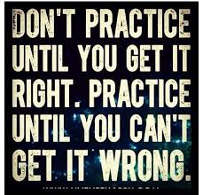

Twirling Skills to Master by Friday
See the Majorette page on pjhscats.com under “Clubs and Organizations” under “Social” for helpful video links to master these skills by Friday!

- Forward Verticals
- Reverse Verticals
- Horizontals
- Finger Twirls
- Vertical Finger Twirls
- Horizontal Finger Twirls
- Flash
- Eagle
- Big Eagle
- Box Toss
- One Turn

