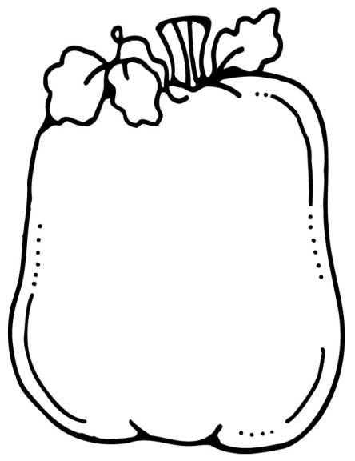M

**Upcoming Events:**

1. **Thanksgiving Break is November 25-29.**
2. **Our Thanksgiving Feast will be November 21st. Lunch will be provided.**
3. **Polar Express day will be December 6th. We will be able to wear pj’s.**
4. **Christmas party will be December 19th.**
5. **We will shop at Santa’s Workshop on December 2ND.**
6. **A big thanks to everyone who gave money for our turkeys last week! Thank you for all that you do.**
7. **A BIG thanks to our room moms for getting our feast together.**

**Spelling Words***:*

*like, slime, hive, bike, dime, time, kite, bite, gripe, drive, please, say*

Star Student:

Dylan Johnson

*Homework:*

*Monday: Write 10 sentences using your spelling words.*

*Tuesday: Comprehension worksheet.*

*Wednesday: Red test folder signed/Reflex*

*Thursday: Math worksheets*

*Friday: NO HOMEWORK*

**Objectives:**

Reading: TTW read “The Snowy Day”. TSW draw a mental image of our book.

Vocabulary: appetite, pout, commotion, chomp, adventure, firm, frigid, pile.

Writing: TSW write about a wish they have.

Language: TTW introduce adding “s” or “es” making a noun singular to plural. TSW review alliterations and common and proper nouns.

Math: TSW focus on Subtraction & Addition word problems.

Phonics: Heggerty/ long “I” sound

November 18,   
2019

Important

Information: 