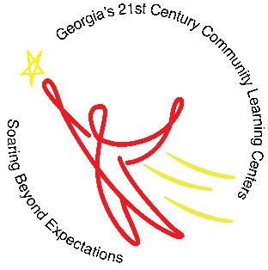
Mrs. Deirdre Brown Ms. Ashley Smith
Program Director Program Coordinator
Quitman County School System 21st Century S.O.A.R. Program
After School Program K-8

When: August 20, 2018 – May 7, 2019
Days: Monday – Thursday
Time: 3:00 p.m. – 6:00 p.m.
Where: New Quitman Elementary/Middle School
Homework assistance, Reading/ELA, Math enrichment, project-based learning activities, and youth development. Snack provided.
