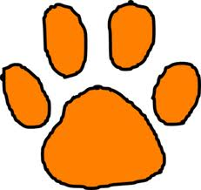
Mrs. Perrett and Mrs. Holmes’
Weekly Report

November 9-13th, 2020

Reading: We will determine the connection between a series of historical events, scientific ideas or concepts, or steps in technical procedures in a text.
Determine the meaning of words and phrases in a text relevant to a grade 2 topic or subject area.
Vocabulary:
There will not be any new vocabulary this week.
Language:
We will review nouns.
Social Studies – identifying locations on a map
Math: Tell and write time from analog and digital clocks to the nearest 5 minutes using a.m. and p.m.
Assessments:
Spelling Test Language Test on Nouns
Fact Fluency Math Test on Telling Time

Special Notes

- Fact Fluency tests will be every Friday. Please work on addition and subtraction facts daily.
- Homework is due on Fridays.
- Because of early lunch, we do not have snacks.

- Thank you for all that you do!!

Spelling Words

ham, plot, stamp, grit, frog, thump, crash, tuck, theft, rich, shin, dart, storm, bus, lost, turn, curb, burst, hurt, burn

Wish List
Small items for treasure chest

Thank you so much to the parents that brought in treasure box items!!!

