EL Folder – How to put your folder together

- If you receive a new student or a transfer student, you will need a new yellow folder. If not, the student will use the same yellow folder each year.
  - Nom-Phlote Folders, FEL Exited Folders, and folders of students who have moved can be given to the EL Specialist to keep at Chapter One.
- Inside the student’s cumulative folder, please place a yellow “ATTENTION!!! Please see the school’s EL Contact for additional paperwork. DO NOT REMOVE!!!” sheet. If a student moves or transfers, this will let the registrar know that there is an additional file that needs to be sent along with the cum folder. *I have attached a copy of this yellow sheet to this paper.
- The folder tab should read as follows: Student’s Last Name, First Name – Language on a white folder tab sticker. If you let me know, I can make these for you or send you some if you need them.
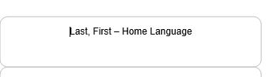
- On the outside of the folder, you will place a new sticker each year. This sticker gives the school year, Student’s EL Status, and the student’s grade in school. 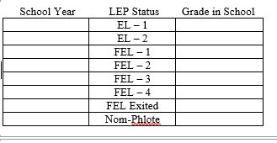
- Inside each folder, you will use a half sheet on card stock (folded in half). This helps organize the student’s folder by the school year.
- Inside each half sheet card stock section, you will have an “EL FOLDER CHECKLIST” sheet. This is the checklist that you will use for students each year. Brand new students will not have an ACCESS for ELLs 2.0 Report or FEL Monitoring Form. Transfer students will have an ACCESS report. If it is not in the transfer paperwork from the previous school, we will need to request it. *This folder checklist is attached to this handout.
- If you have any questions, need any supplies, or would like the EL Specialist to check your EL Folders, please do not hesitate to contact Christina Thurman by email at Christina.thurman@acboe.net or at her office at Chapter One at 334-361-3840, Extension 12010.

*Attachments mentioned above plus a sample folder should be attached to this handout. All handouts are available on the “English as a Second Language Program” page which is found under “Federal Program” on the www.acboe.net website.

