EQT Alignment Sheet – Quarter 3
Course: Middle School Algebra I Honors

ALCOS Standard |  | # of Questions |  | Textbook Alignment
8. Use the structure of an expression to identify ways to rewrite it. [A-SSE2] |  | 4 |  | 7-1, 7-2
Sample Problems for Standard #8 (A-SSE2)

1. Simplify the following expressions:
(a) ${(2w^{4})}^{3}$ (b) ${(6y^{3})}^{2}$ (c) ${(3x^{3}y^{4}z^{2})}^{3}$ (d) ${(\frac{x^{2}}{x^{-4}})}^{5}$ (e) $\frac{r^{3}s^{-2}}{t}$

(f) ${\left(-4x^{3}y^{2}\right)}^{2}{\left(2xy^{2}\right)}^{-2}$ (g) $\frac{12x^{-2}y^{3}}{4x^{4}y}$ (h) ${\left(\frac{3a^{2}b^{3}}{6a^{-2}b}\right)}^{-2}$

ALCOS Standard | # of Questions |  | Textbook Alignment
32. Write a function defined by an expression in different but equivalent forms to reveal and explain different properties of the function. [F-IF8]  - Use the process of factoring and completing the square in a quadratic function to show zeros, extreme values, and symmetry of the graph, and interpret these in terms of a context. [F-IF8a] | 3 |  | 8-6, 8-7, 8-8, 8-9
Sample Problems for Standard #32a (F-IF8a)

1. Find an expression that is equivalent to $-16x^{2}+36x$ in factored form.

2. Factor the following polynomials completely: (a) $6x^{2}-x-15$ (b) $4x^{2}-12x+9$

3. The solutions to a quadratic equation are 6 and $\frac{2}{3}$ . Find the quadratic equation.

4. The area of a rectangle is $2x^{2}-11x-63$ square units, and the length is $2x+7$ units. What is the perimeter, in units, of the rectangle?

5. The quadratic expression $x^{2}-2x-35$ can be factored into $(x+5)(x-7)$. Find the ordered pairs that represent the zeros of this expression’s related quadratic function?

6. A graph of a quadratic function has x-intercepts of$(6,0)$ and$(-4,0)$. Find a quadratic function that could be represented by this graph?

7. A financial analyst determined the cost in thousands of dollars of producing bicycle frames is $C=0.000025f^{2}-0.04f+40$, where f is the number of frames produced? Find the number of frames that minimizes the cost, and then determine the total cost for that number of frames.
ALCOS Standard | # of Questions |  | Textbook Alignment
40. Interpret the parameters in a linear or exponential function in terms of a context. [F-LE5] | 2 |  | 7-5. 7-6
Sample Problems for Standard #40 (F-LE5)

1. The number of kilograms, y, of a radioactive element that remains after t hours can be modeled by the equation $y=0.23{\left(0.91\right)}^{t}$. What is the rate of decrease of this radioactive element?

2. A medical device uses the radioactive isotope cesium 137. The function $f\left(t\right)=28{\left(0.5\right)}^{\frac{t}{30}}$ gives the number of grams of the isotope that remain t hours after its introduction to the device. Interpret the meaning of the values 28 and 0.5 in f (t) in the context of the problem.

3. Many times a tweet will be tweeted and then retweeted with the possible number of retweets growing exponentially. Manny modeled this phenomenon with the function $f\left(x\right)=3{\left(2\right)}^{x}$, using x to represent the number of intervals in which the tweet was retweeted. What does the 2 in the equation represent?

ALCOS Standard | # of Questions |  | Textbook Alignment
38. Construct linear and exponential functions, including arithmetic and geometric sequences, given a graph, a description of a relationship, or two input output pairs (include reading these from a table). [F-LE2] | 3 |  | 7-5. 7-6
Sample Problems for Standard #38 (F-LE2)

1. A population of 2500 frogs increases exponentially at an annual rate of 25%. Write an equation that represents the population of frogs (P) in t years. Then use the equation to predict the number of frogs in 6 years.

2. The value of a car decreases at an annual rate of 7%. If the car was originally priced at $35,000, write an equation that represents the value of the car (V) after t years. Then use the equation to predict the value of the car after 10 years.

3. Write an exponential function to model the following geometric sequence: 3, 12, 48, 192, …

4. In the year 2010, a scientist determined there were 3000 of a certain type of fish in a lake. The table shows the fish population in the lake increased exponentially at a rate of 10% each year. Based on this information, write an equation that can be used to predict the value of N, the fish population, in years since 2010, t. Then use the equation to find the fish population 3 years after 2010.

NUMBER OF YEARS  SINCE 2010 (t) | FISH POPULATION (N)
0 | 3000
1 | 3300
2 | 3630

ALCOS Standard | # of Questions |  | Textbook Alignment
37. Distinguish between situations that can be modeled with linear functions and with exponential functions. [F- LE1]  - Prove that linear functions grow by equal differences over equal intervals, and that exponential functions grow by equal factors over equal intervals. [F- LE1a] | 2 |  | 7-5, 7-6
Sample Problems for Standard #37 (F-LE1)

1. The values for the function g(x) are shown in the table. Does the function represent a linear function or an exponential function? Justify your answer.
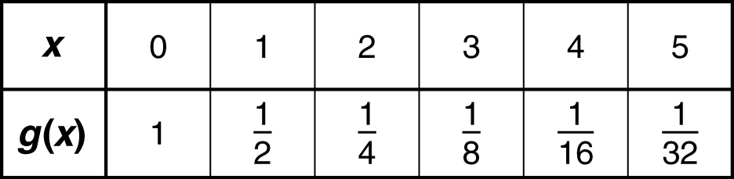

2. A function is shown in the table below. Is the function linear or exponential? Justify your answer.

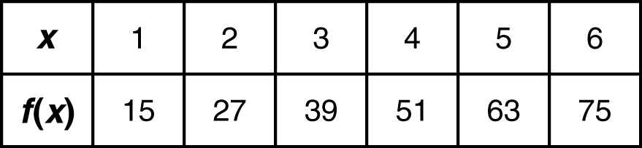

ALCOS Standard | # of Questions |  | Textbook Alignment
12. Create equations and inequalities in one variable, and use them to solve problems. Include equations arising from linear and quadratic functions, and simple rational and exponential functions. [A-CED1] | 3 |  | 7-6, 7-7
Sample Problems for Standard #12 (A-CED1)

1. In an experiment investigating the growth of spores in varying soil conditions, a certain spore colony grew an average of 3 times larger during each 24-hour period. If the colony contained 50 spores at the beginning of the experiment, how many spores were there at the end of the 4th day?

2. An economist predicts that the number of employees with a certain company will increase by 50% each year. There are 600 employees now. According to the economist’s prediction, how many employees will be with the company exactly 3 years from now?

3. A copier was purchased for $16,000. Its value each year is 75% of what it was the preceding year. How long will it take for the copier’s value to be reduced to $9,000?
4. The amount of a radioactive substance decreases by 50% every 1.5 days. Right now the amount of substance is 8000 grams. How many grams of the substance will remain 6 days from now?

5. The initial number of bacteria cells in a culture is 1000, and this number increases by 6% every hour. Approximately how many bacteria would be in the culture after 4 hours?

ALCOS Standard | # of Questions | Textbook Alignment
2. Rewrite expressions involving radicals and rational exponents using the properties of exponents. [N-RN2] | 4 | 10-2, 10-3, 10-4
Sample Problems for Standard #2 (N-RN2)

1. Simplify the following:

(a) ${16}^{\frac{3}{4}}$ (b) $\sqrt{18}-\sqrt{50}$ (c) $\frac{\sqrt{12x^{2}y}}{\sqrt{18x^{3}y^{2}}}$ (d) $\frac{4-\sqrt{3}}{5+\sqrt{3}}$ (e) $\sqrt{72a^{3}b^{4}}$ (f) $\sqrt[3]{128x^{6}y^{2}z^{8}}$

2. Solve the following equations: (a) ${\left(2x-4\right)}^{\frac{1}{2}}+6=10$ (b) ${\left(4x\right)}^{\frac{1}{2}}+3=28$

ALCOS Standard | # of Questions | Textbook Alignment
18. Solve quadratic equations in one variable. [A-REI4]  - Solve quadratic equations by inspection (e.g., for x2 = 49), taking square roots, completing the square and the quadratic formula, and factoring as appropriate to the initial form of the equation. Recognize when the quadratic formula gives complex solutions, and write them as a ± bi for real numbers a and b. [A-REI4b] | 5 | 8-6, 8-7, 8-8, 8-9, 9-5
Sample Problems for Standard #18 (A-REI4)

1. What is the solution set for the equation $x^{2}+12x+20=0$ ?

2. Find the solution set to the equation $3n^{2}-8n-1=0$.

3. Find the solution set to the equation $3x^{2}-9x-5=0$.

4. What is the solution set for the equation $2x^{2}-5x-12=0$ ?

5. Find the x coordinates where the graph of $4x^{2}+7x-2=0$ crosses the x axis.

6. A man drops a ball from the top of a 500-foot cliff. The height of the ball is described by $h(t)=-16t^{2}+500$ where h is in feet, and t is in seconds. How many seconds have passed when the height of the ball is 356 feet?

7. The length in inches of each side of a square is given by the expression $x+2$ . The area of the square can be represented by ${(x+2)}^{2}-16=0$ when the area is 16 square inches. What is the value of x?

8. A farmer has 50 feet of fencing to enclose a rectangular garden with an area of exactly 144 square feet. The area of the garden can be modeled by the equation $x(25-x)-144=0$ where x represents the length of the garden. Which could be a possible length of the garden?

