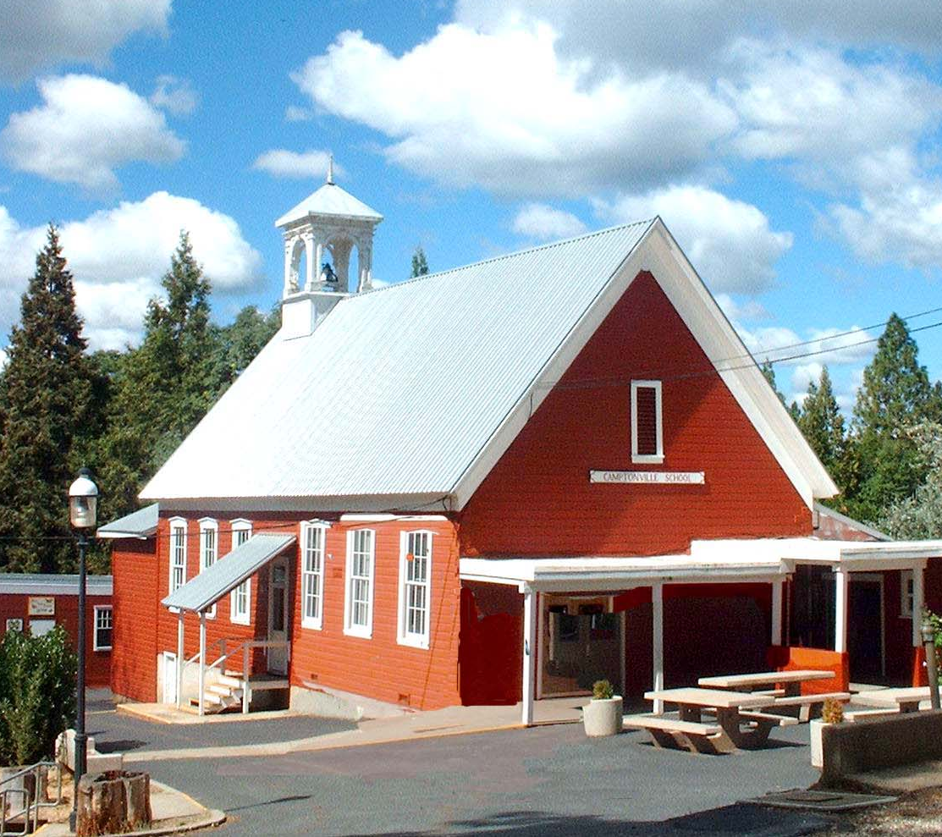 Camptonville Union Elementary School Site Council
Wednesday, May 30, 2018 3:00 p.m.

AGENDA

Present:

Approval of the Agenda: Motion__________________2nd________________Pass

Approval of the Minutes: Motion__________________2nd________________Pass

Old Business: Info/Action 1. Review 2018-19 LCAP Draft
- District Advisory Committee Input and Approval

New Business: Info/Action
1. MTSS SUMS Grant
2. Stakeholder Engagement and Family Involvement Surveys
2. Consolidated Application Reporting System
- District Advisory Committee Review

Committees/Reports: Info/Action
- Safety
- Superintendent
3. Title I
4. Wellness/Parent Liaison
5. Parents Club
6. Community
Items for Next Meeting:
1. ______________________________ 2.______________________________
3. ______________________________ 4.______________________________
5. ______________________________ 6.______________________________

Motion to Adjourn:__________________________ Second:_______________________

Posted 05/27/2018

