Library FuN
Mrs. Christa
 | KinderGarten and 1st grade
Option 01
Log into EPIC with the class code: xyd6811 Read as much as you like!

Option 02
Read something you have at home! Show me with a picture of what you have been reading or submit a picture. Tell me your favorite part! Get creative!
 | Assignments
 | Select one of the 3 options listed on the right. You may complete one or as many as you like. I look forward to hearing from all of you! Stay Safe!  You may submit any projects you complete on Google Classroom or show me on Zoom |  |  |  |  | Option 03  Follow the links posted below and let me know what you enjoyed with a video or a picture!

 | I would LOVE to hear from the OBE Quistors!
 | Pete the Cat misses You!  You can follow this link  http://www.petethecatbooks.com/songs/  to Pete’s website for videos and activities! |  |  |  | 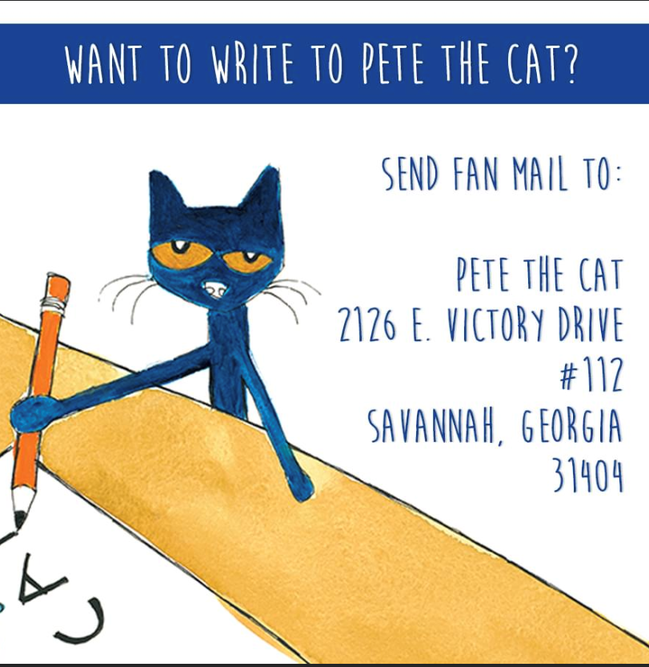
https://youtu.be/tJCG1Ls7a9c
https://youtu.be/W42oHAqM9N8
https://classroommagazines.scholastic.com/support/learnathome/grades-prek-k/daily-reading-quest.html
l

Follow these links to complete your Weekly Reading Quest!

 |  |  |  |  |  | Contact Mrs. Christa

Want more Books to read?
Email me to get the passwords for vooks and bookflix!
Email me by clicking on my contact link on my webpage!
Send my pictures or messages on the Facebook Olive Branch Elementary PTO page!

