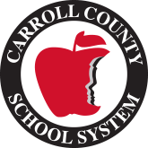
2021-2022 School Supplies List

3rd Grade

2 packs of 24 count pencils
1 pack of 24 count crayons
2 packs of wide ruled paper
2 glue sticks
1 pair of scissors
1 pack of large pink erasers
1 pencil pouch or box
Earbuds or headphones
1 binder: 1.5 inch size (clear front pocket with inside pockets; any color)
1 pack of Expo dry erase markers (4ct)
3 plastic folders with pockets and prongs (red for Take Home Folder, blue for Homework Folder, green for Classwork Folder)
1 pack of 5 dividers

Other Items Desired
Tissues
Hand Sanitizer
Hand Soap
Clorox Wipes
Baby Wipes
Ziplock Bags (Gallon and Sandwich sizes)

