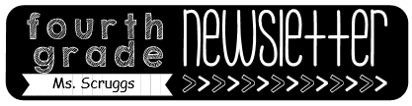

Reminders

-**Masks** need to be worn at school.

-October 13-16: PTO selling Boo Grams

-October 15: Report Cards

-October 16: Honor Roll Breakfast

-October 19-23 Homecoming Week

**Mon: pajama day**

**Tues: old folks day**

**Wed: camo day**

**Thurs: “Out of this world day”**

**Fri: Mustang spirit day**

-Oct. 21: National Bullying Prevention day **(wear orange)**

-October 26-30: Red Ribbon Week

**Mon: team jersey day**

**Tues: pajama day**

**Wed: Hawaiian day**

**Thurs: Western day**

**Fri: Book character day**

October 12th – 16th

Homework

Monday:

* Columbus Day

Tuesday:

* Study guide #s 1-18
* Study math facts

Wednesday:

* Study the study guide

Thursday:

* None

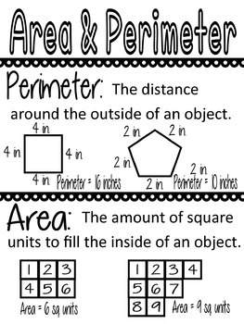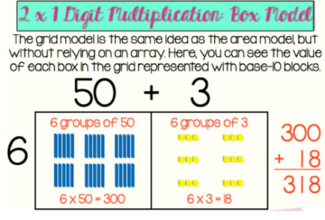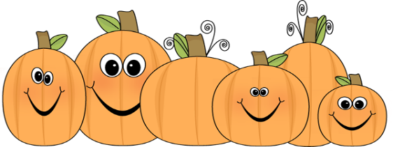

What we are learning…

Tests/Projects

-Timed Test 10/14

- Unit 3 math test 10/15