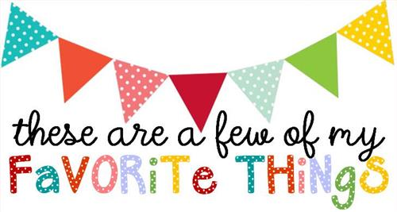

Name: Lisa Lloyd
T-shirt Size: large
Birthday: 08/30/73
Monogram: lLg
Favorite Color: pink
Favorite Flower: daisy
Favorite Scent: cinnamon
Favorite Candy: Dove Chocolate
Favorite Drink: coffee
Favorite Food: pizza
Favorite Snack: trail mix
Favorite Fruit: bananas
Favorite Restaurant: Buon Cibo
Favorite Places to Shop: Commerce Street Market
Things I collect: pottery
Favorite Author/Book Series for my own personal reading: Devotionals
Wish List for Classroom: kindle gift cards and sensory items

